Jan 24, 2018
9:00 – 9:15 AM Registration
9:15 - 9:30 AM Welcome:
Adam Bradford, Associate Dean, Arts and Letters, FAU
Richard Shusterman and Kenneth Holloway
Center for Body, Mind, and Culture, FAU

9:30 - 10:15 AM
The Interaction Between Design, Art and Technology
Else Marie Bukdahl, Art and Technology, Aalborg University

10:15 - 11:00 AM
Perfuming Gestures for Young Generations Through
Embodied Design Ideation Techniques
Oscar Tomico, and Anna Maria del Corral,
Barcelona School of Design and Engineering

Break 11:00-11:15

11:15 - 12:00 PM
The Hyper-Unreal: Somaesthetics, Augmented Reality, and Digital Dysmorphia
Francis Altomare, Department of English, University of Miami

12:00 - 2:00 PM Lunch

2:00 - 2:45 PM
Technologies of the Basketball Body:
Adventures Between the Science of Moving Dots and Somaesthetics
Yago Colas, English Professor and Assistant Men’s Basketball Coach, Oberlin College

Break 2:45-3:00

3:00 - 3:45 PM
Technology and Human Phronesis
Falk Heinrich, Head of Research Laboratory of Art and Technology and Professor, Aalborg University

3:45 - 4:30 PM
Designing User Experiences for Learning and Transformation:
From Erlebnis to Erfahrung
Dag Svanaes, Professor of Computer Science, Norwegian University of Science and Technology

Break 4:30-5:00
5:00 - 6:00 PM: Keynote
Designing with the Body: Somaesthetic Interactive Design
Kristina Höök, Professor of Interaction Design, KTH Royal Institute of Technology, Stockholm

6:00 - 7:00 PM Reception in the Schmidt Center Gallery

Jan 25, 2018

9:30 – 10:15 AM
Beauty, Body and Design
Lu Yang, Professor, Chinese Department, Fudan University Shanghai China

9:15 - 10:30 AM Break

10:30 - 11:15 AM
Immersed in Reading / Reading as Immersion
Lindsey Drury, PhD Candidate, Freie Universität

11:15 - 12:00 PM
Concluding Discussion

Conference will be held at
CULTURE AND SOCIETY BUILDING (CU), 3rd Floor Seminar Room

The Center for Body, Mind, and Culture is an interdisciplinary initiative dedicated to promoting research, programming, and teaching of topics concerning the body-mind-culture nexus. The Center’s motivating logic affirms that the three terms constituting its name are essentially interdependent rather than separate entities and that they therefore need to be studied in terms of their interrelations and through interdisciplinary research.
Contact Us
Email: bodymindculture@fau.edu
Web: www.fau.edu/bodymindculture



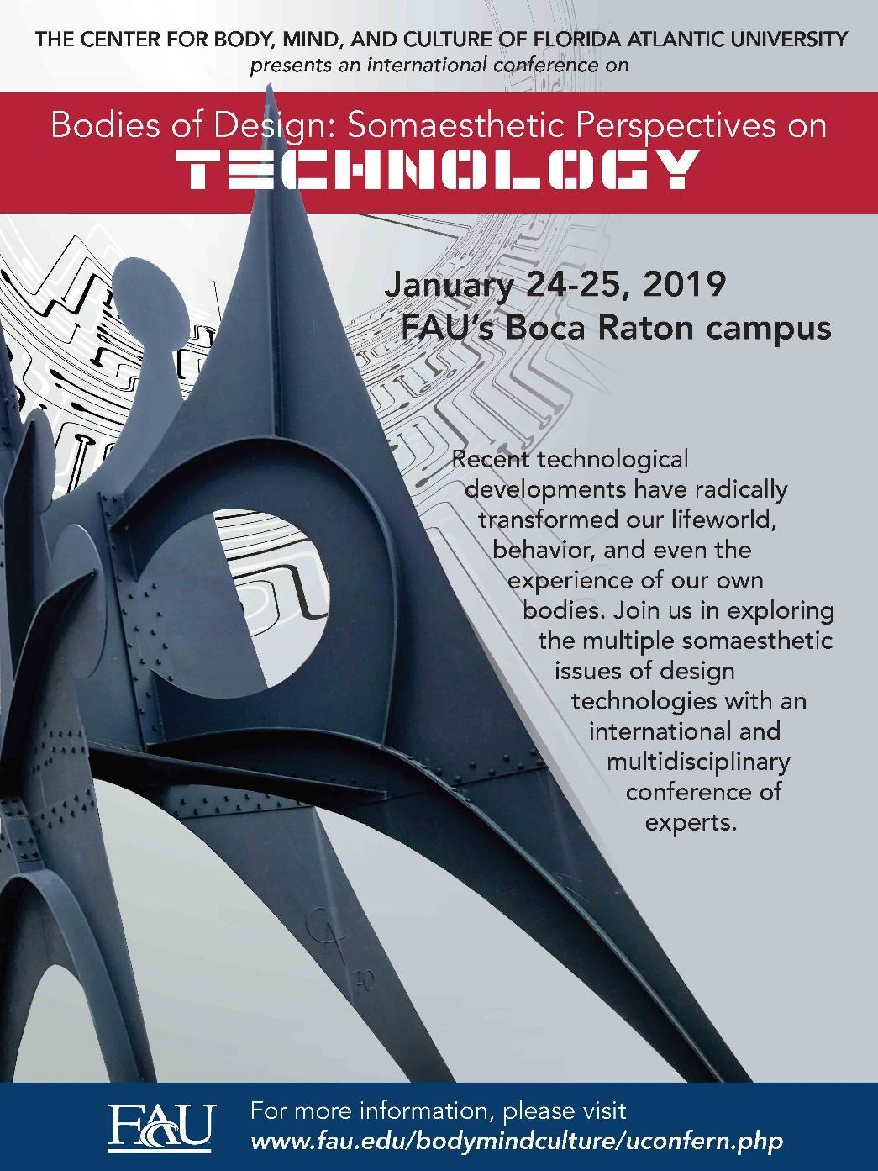

THE CENTER FOR BODY, MIND, AND CULTURE

