January 24, 2019
9:00-9:15 a.m. – REGISTRATION

9:15-9:30 a.m. – WELCOME – Adam Bradford, Associate Dean, College of Arts & Letters; Richard Shusterman & Kenneth Holloway, Center for Body, Mind, and Culture, FAU

9:30-10:15 a.m. - The Interaction Between Design, Art and Technology - Else Marie Bukdahl, Art & Technology, Aalborg University

10:15-11:00 a.m. - Perfuming Gestures for Young Generations Through Embodied Design Ideation Techniques - Oscar Tomico & Anna Maria del Corral, ELISAVA Barcelona School of Design and Engineering

11:00-11:15 a.m. - BREAK

11:15 a.m.-12:00 p.m. - The Hyper-Unreal: Somaesthetics, Augmented Reality and Digital Dysmorphia - Francis Altomare, Department of English, University of Miami

12:00-2:00 p.m. - LUNCH

2:00-2:45 p.m. - Technology and the Basketball Body:
Adventures Between the Science of Moving Dots and the Somaesthetics of Wonder - Yago Colas, English Professor and Assistant Men’s Basketball Coach, Oberlin College

2:45-3:00 p.m. – BREAK

3:00-3:45 p.m. - Technology and Human Phronesis - Falk Heinrich, Head of Research Laboratory of Art and Technology and Professor, Aalborg University

3:45-4:30 p.m. - Designing User Experiences for Learning and Transformation: From Erlebnis to Erfahrung - Dag Svanaes, Professor of Computer Science, Norwegian University of Science and Technology

4:30-5:00 – BREAK

5:00-6:00 p.m. - Keynote Speaker - Designing with the Body: Somaesthetic Interactive Design Kristina Höök, Professor of Interaction Design, KTH Royal Institute of Technology, Stockholm

5:30-7:00 p.m. - Reception at the Schmidt Gallery

January 25, 2019

9:30-10:15 a.m. - Immersed in Reading / Reading as Immersion - Lindsey Drury, PhD Candidate, Freie Universität

10:15-10:30 a.m. - BREAK

10:30-11:15 a.m. - Beauty, Body and Design - Lu Yang, Professor, Chinese Department, Fudan University Shanghai China

11:15 a.m.-12:00 p.m. - Concluding Discussion

Conference held at the:
CULTURE AND SOCIETY BUILDING (CU)
3rd Floor Seminar Room
Room 301

The Center for Body, Mind, and Culture is an interdisciplinary initiative dedicated to promoting research, programming, and teaching of topics concerning the body-mind-culture nexus. The Center’s motivating logic affirms that the three terms constituting its name are essentially interdependent rather than separate entities and that they therefore need to be studied in terms of their interrelations and through interdisciplinary research.
Contact Us
Email: bodymindculture@gmail.com
Web: www.fau.edu/bodymindculture



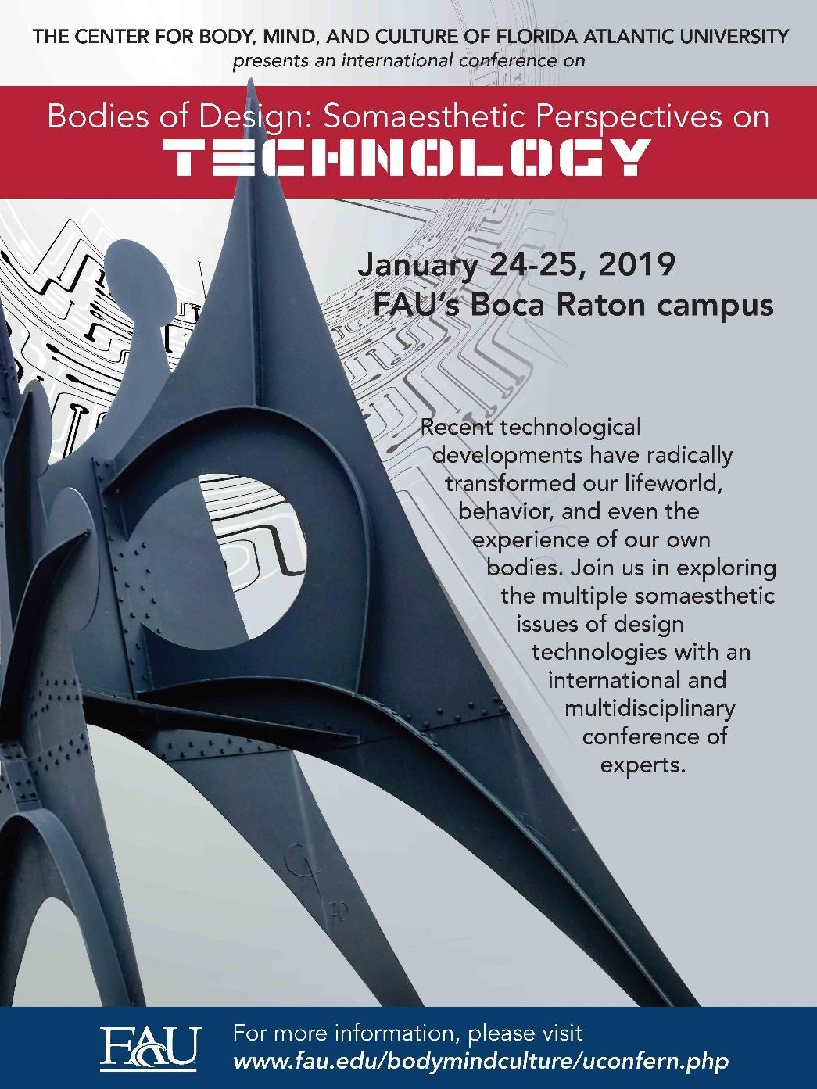

THE CENTER FOR BODY, MIND, AND CULTURE

