Chair Stepping Down
- Create a new faculty position for the chair that is stepping down.
- Create a Job Requisition for that position
  - In the Reason field, click on Create Job Requisition > No Recruitment Required > No Recruitment Required > Faculty Stepping down
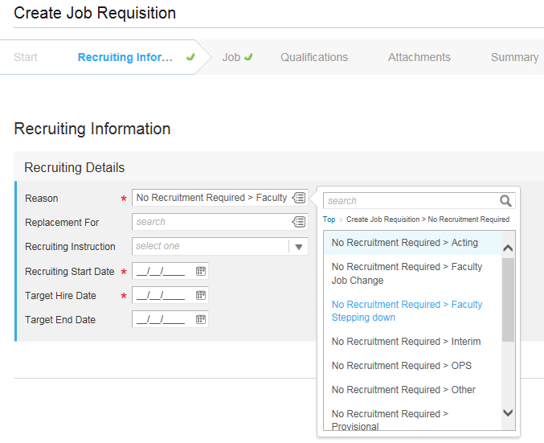
- Select the Chair that is stepping down by searching the faculty name in the search box.
- Click the related actions button next to the employees name and select Job Change > Transfer, Promote or Change Job.
- Complete all information under Start Details
  - In the Why are you making this change field, select Faculty Stepping Down
- Click Start.
- Edit the Job, Location, and Details to the new position and Job Profile information if needed.
- Click Submit.

Faculty Moving to Chair
- Select the faculty member that is moving to chair by searching the faculty name in the search box.
- Click the related actions button next to the employees name and select Job Change > Transfer, Promote or Change Job.
- Complete all information under Start Details
  - In the Why are you making this change field, select Faculty Moving to Chair
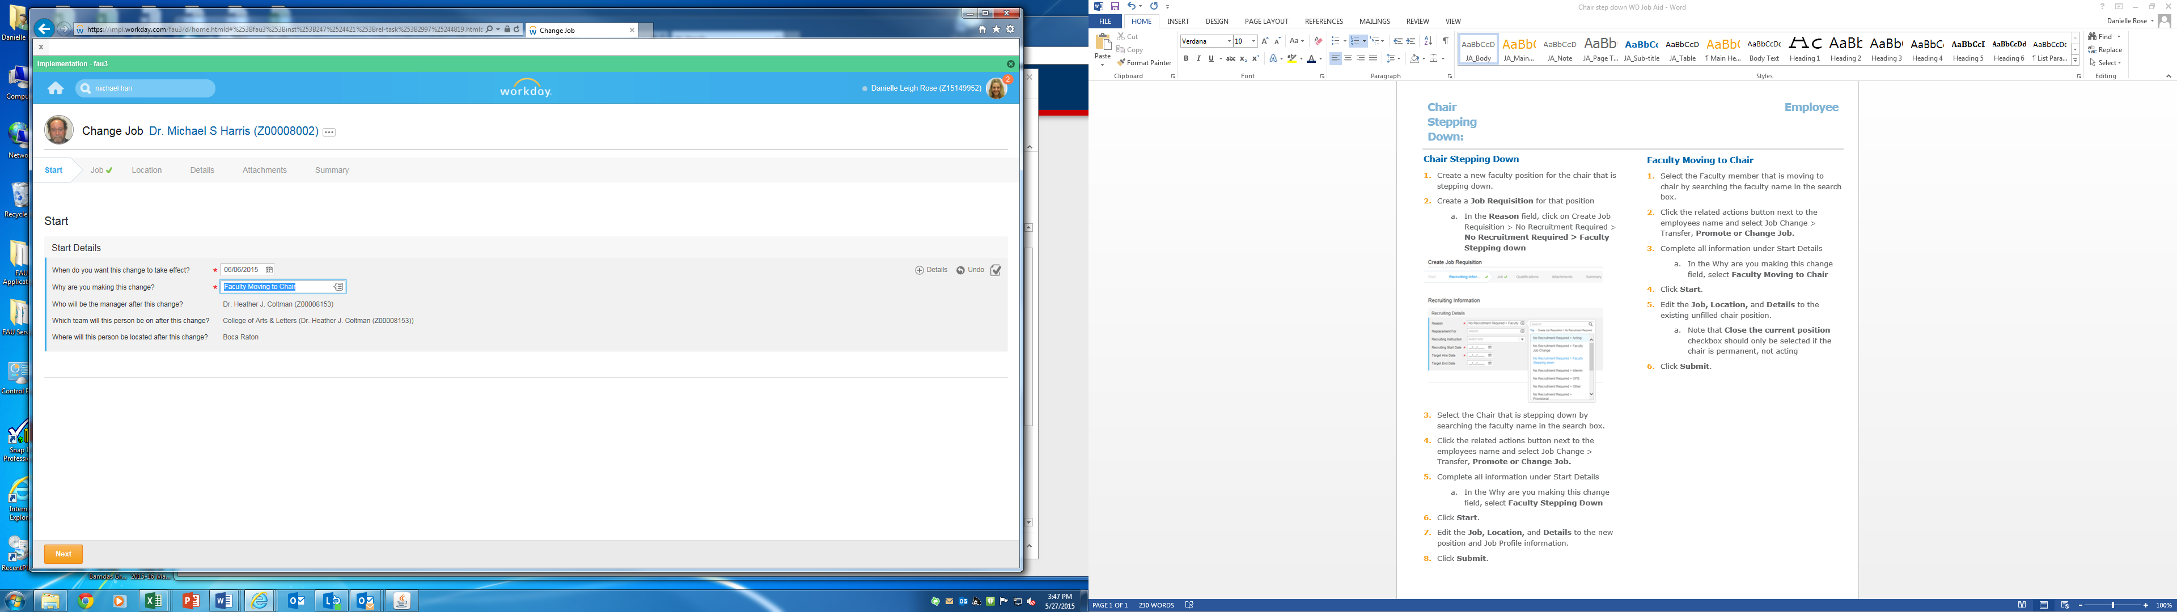
- Click Start.
- Edit the Job, Location, and Details to the existing unfilled chair position if needed.
  - Note that Close the current position checkbox should only be selected if the chair is permanent, not acting
- Click Submit.
Faculty Promotion (Excluding Chair Position Changes)
- Select the faculty member by searching the name in the search box.
- Click the related actions button next to the employees name and select Job Change > Transfer, Promote or Change Job.
- Complete all information under Start Details
  - In the Why are you making this change field, select Faculty Promotion
- Edit the Job, Location, and Details to the new position and Job Profile information if needed.
- Click Submit.

