CLAS 3002
INTRODUCTION TO CARIBBEAN AND LATIN AMERICAN STUDIES
Fall, 2008

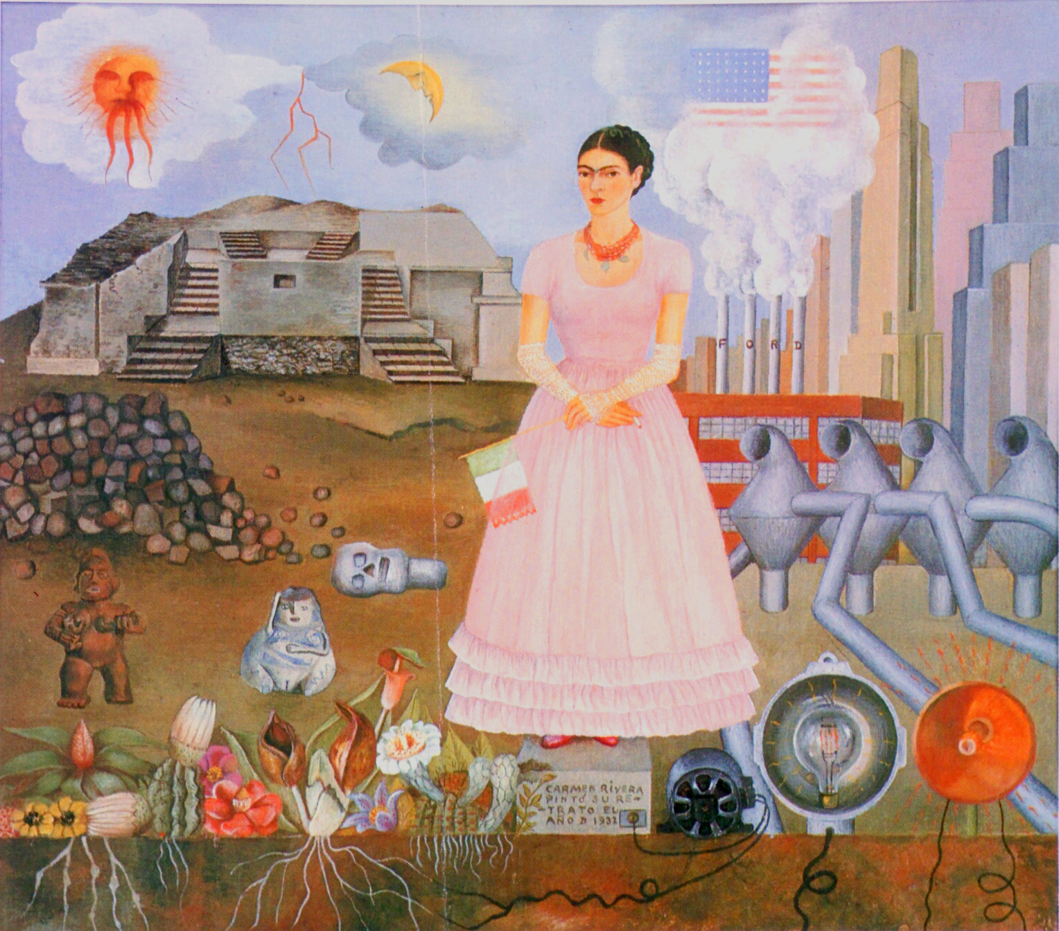

Professor: Luis Duno-Gottberg
Class: Tuesday and Thursday, 11:00 – 12:20 A.M.
Office: GS 103 Office Hours: Monday, Tuesday 2:00 – 3:00 P.M
Or by appointment
Telephone: 297-0612 Email: lduno@fau.edu

I. Course Description

This course immerses students into Caribbean and Latin American history, society, politics, economics, and culture through a multi-disciplinary and multi-national approach. A cultural studies methodology will integrate such diverse disciplines to examine salient themes, preparing students for the Caribbean and Latin American Studies Certificate.

Several units have been designed to examine different regions of Latin America. These units explore key topics such as class, race, gender, colonialism, dependency and intervention, arts, music and literature, to name a few.

It is our intention to awaken the interest of students on this vast, complex, and rich region, so they can continue with further academic and/or professional work. We also invite them to think critically about preconceptions and stereotypes, while challenging the silences of history. These objectives should lead to a productive, respectful and exciting relationship with Latin America and its people.

This writing intensive course serves as one of two "Gordon Rule" classes at the 2000-4000 level that must be taken after completing 1101 and 1102 or their equivalents. You must achieve a grade of "C" (not C-minus) or better to receive credit. A student with a grade below C will not get credit for the course. Furthermore, this class meets the University-wide Writing Across the Curriculum (WAC) Criteria that govern the writing objectives that students are expected to achieve at FAU. You will be expected to improve your writing over the course of the term.

Overall, this class allows students to develop their critical thinking skills. To this end we include writing activities that facilitate working with content, developing writing skills, as well as engaging in more personal explorations of the issues raised by the class.

II. Dynamics of the class
Classes will be based on discussions generated by assigned readings and movies. Most discussions will be preceded by a brief writing exercise that will elicit ideas, problems, etc. Only some of these exercises will be graded and they should be seen as an organizational device, or as a part of a brainstorming strategy.

Films will be assigned to explore the representation of certain topics. Students are expected to engage in these materials critically. In order to do this, students will have to take notes and distance themselves from a passive spectator stand.

Group work will be encouraged to review reading materials, as well as to establish a peer review process of writing activities.

III. Course Materials

(1) Skidmore, Thomas E.; Peter H. Smith. Modern Latin America. 5th ed., New York : Oxford University Press, 2001.
(2) García Márquez, Gabriel. 100 Years of Solitude.
(3) Course Reader. These required readings are on electronic reserve at the Wimberly Library. They are also accessible electronically via MYFAU. It is highly recommended that students download the readings and print them for use in class and for exam preparation on the first week of class.
(4) Films will be placed on reserve at the media center in the Wimberly Library. The viewing of the films is mandatory, unless indicated in the syllabus as “suggested”. When viewing the films, please take notes that will help in our class discussion.

IV. Evaluation

In class writing assignments 20%
Final essay Problem and outline 10%
First draft 10%
Final draft 10%
Participation 20%
Portfolio 20%
Extracurricular activity 10%

In-class and at-home writing assignments will be graded based on “Rubric A”. Final essay will be graded in three phases, using “Rubrics B, C, and D”. Pleases refer to enclosed rubrics at the end of the syllabus.

In class writing assignments
Over the course of the semester you will be assigned a variety of writing exercises to be completed in class. Some will require the discussion of specific questions; others will be reaction or “think” pieces. A complete description of each assignment is available in section VI of this syllabus. Sometimes I will collect this writing assignment and grade it; sometimes I will not. However, all of these assignments must be included in your final portfolio at the end of semester (see below).

Some assignments will be shared with your peers. This will be part of a collective discussion and revision of writing exercises, and is to be considered an integral part of your formative experience. You are expected to engage actively in this process of peer review, exchanging ideas and suggestions with your classmates.

Final essay
Students will write one final long essay (8-10 pages) on a topic addressed in class. A list of possible topics is included at the end of this syllabus. Essays must typed and follow MLA format. For information on this format, please see http://owl.english.purdue.edu/owl/resource/557/01/. Essays will be submitted through “Turn In” on “Blackboard”.

This assignment should be completed as a series of steps that will lead to the final paper: A) Students must select and turn in a research problem by the beginning of the fourth week of class. B) On the sixth week, students must submit an outline of their paper, containing title, problem to be discussed, preliminary argumentation, and bibliography. C) Students will submit a first draft on week eight, and a final paper at the end of the semester. Your final paper should be turned in your portfolio.
Plagiarism is a serious offense that will not be tolerated in any form. See FAU Student Handbook (Rule 6C5-4.001) for FAU’s official position on plagiarism.

Class participation
Participation is a fundamental part of this class. Therefore, regular attendance is required and implies ACTIVE INVOLVEMENT in class discussions and activities. Students are required to prepare the day’s reading assignment prior to class, since they will serve as the basis for class discussion. So
- be ready to share and explain your opinions. Feel free to disagree with others, but be specific in your assertions and back them with evidence.
- be willing to build on classmates’ contributions to our discussions, praising them for their insights, and further developing the thoughts and ideas of others.
- listen carefully and respond to other members of the group. Be willing to change your mind when someone demonstrates an error in your own logic or use of facts.
- do not hesitate to ask for clarification of any point or any term you do not understand.
- make your point succinctly, avoid repetition, and stick to the subject.

All readings and film viewing are mandatory. Frequent quizzes based on the readings will be calculated into the participation grade. If missed, reading quizzes cannot be made up except in cases of excused absences.

Portfolio
Students are required to submit two copies of a portfolio at the end of the semester. One will be graded; the other will be kept in our files.

The portfolio is a collection of your work throughout the semester and must be started early on. Using a three-ring binder, your portfolio should include the items listed below, in order, separated by tabs:

1. Outside cover, indicating your name, course number, section and date; my name and department.
2. Cover letter: Write a cover letter addressed to me. This letter is a self- assessment; a short narrative explaining how your writing has improved over the semester and how your perception of Latin America and the Caribbean has been affected by your experience in this class.
3. Final paper, followed by outline, first draft, and any brainstorming materials that you developed in producing your final paper.
4. In class writing activities. This includes individual as well as group work.
5. Writing assigned as homework.

Your portfolio will be graded on the following factors: completeness, neatness, organization, and self-assessment.

Extracurricular activity

In consultation with the professor, students must participate in an activity related to the Caribbean or Latin America. Conferences and film screenings are suitable venues. The main idea is that students interact with the culture and report their experience.

Absences due to illness or other acceptable reasons will be excused upon immediate presentation of proper verification. NO LATE WORK will be accepted unless verifiable medical excuse is provided in a timely manner. More than two un-excused absences will lower the course grade by one-half letter grade per additional absence.

VI. Program

Date | Topic of Class & Discussion | Required Readings  and Assignments
Week 1 | Introduction to the class:  1) Presentation of syllabus  2) Definition of Latin American Cultural Studies | In class non-graded writing activity:  Look at Frida Kahlo’s painting (pg.1 of the syllabus). Write a reaction essay indicating: What do you see? How do you think this relates to the Caribbean and Latin America? What is Frida Kahlo trying to convey with this image? After discussing your piece with classmates, please keep it for your portfolio and for an additional activity at the end of the semester.  Suggested video: "The Buried mirror reflections on Spain and the New World. Program 1, The virgin and the bull" and "The Buried mirror reflections on Spain and the New World. Program 2, The conflict of the gods".
Week 1 | 1) The concept of “Latin America”  2) Keys to Latin America | Read Skidmore and Smith:  “Prologue: Why Latin America?”  In class writing activity:  Pick one stereotypic view on Latin America and challenge such view drawing from Skidmore’s keys to Latin America.
Week 2 | Conquest & Colonization | Read Skidmore and Smith,  Chap. 1: “The European Context Spanish America: From Conquest to Colony, 1492-1600”, “Spanish America: The Transformation of Colonial Society, 1600-1750”, “Portuguese America: A Different World?”.
Week 2 | Colonial Desires: Imagining America | Read Christopher Columbus, "Letter to the Sovereigns of 4 March 1493"  In class writing activity:  Identify the passages where Columbus refers to the indigenous people, the natural resources and the geography. In groups of three, discuss his interest in these issues. Characterize his language and speculate on his purpose. Write a brief report on the group’s findings.  Suggested movies: “Christopher Columbus” (1985), Dir. Alberto Lattuada, 128 min. “1492 – Conquest of Paradise” (1992), Dir. Ridley Scott. “Christopher Columbus: The Discovery” (1992), Dir. John Glen, 121 min.
Week 3 | Conquest & Colonization | Video: “Aguirre the Wrath of God” (1977), Dir. Werner Herzog, 94 min. View outside of class.  Work at home with sections 1,2, 3 from the following link: http://lilt.ilstu.edu/smexpos/cinergia/Aguirre.htm  In class writing activity:  In groups of three students, prepare to answer two questions randomly chosen by the professor from section 3 of the previous link.
Week 3 | Caribbean plantation societies, slavery | “The Last Supper [La última cena]” (Cuba, 1976), Dir. Tomás Gutiérrez Alea, 100 min. View outside of class.  Select one scene that you consider important to understand the dynamics of slavery and the plantation economy.  At home writing activity:  Write a one page commentary about the significance of the selected scene, and bring it to class for discussion and peer review.  Homework:  Drawing from the input received in class, re-write and turn in the previous piece.  Read Rogoziński, Chap. 9 & 10
Week 4 | Independence and Nation Building | Read “The Search for Cultural Identity: Concepts”, and selected fragments: Bolívar, “Speech before the Congress of Angostura”; José Martí, “Our America”; D. F. Sarmiento, “Civilization and Barbarism”; Rodó, Ariel; Vasconcelos, “The Cosmic Race”.  In class writing activity:  In groups of three, be ready to present the rest of the class with a summary of the key ideas of one of the authors discussed in this essay.
Week 4 | Transformation of Modern Latin America | Read Skidmore and Smith,  Chap. 2  By this date, all students must have selected and turned in their topic for the final paper in consultation with me.
Week 5 | United States and Latin America | Read “The Monroe Doctrine”, “In Opposition to Monroe”, and “The Roosevelt Corollary”.  Read Rubén Darío, “Ode to Roosevelt”  In class writing activity:  Imagine that Roosevelt answers to Rubén Darío’s poem, what would he say? Write a one page response to the Nicaraguan poet, from the perspective of this U.S. president.
Week 5 | United States and Latin America | Read Skidmore and Smith,  Chap. 11  Video: “Hidden in Plain Sight. The School of the Americas”
Week 6 | A taste of Latin America Art | Slide presentation of Twentieth Century Latin American and Caribbean Art.  No assignments for this class. Use this time to advance on the reading of the novel.  Turn in the outline of your final paper.
Week 6 | García Márquez, 100 Years of Solitude | Read sections 1-4.  In this class we will have a very informal conversation about the novel, without attempting an in- depth analysis. At this stage of the reading, we will focus on the experience of students with the narrative.
Week 7 | García Márquez, 100 Years of Solitude | Documentary on Gabriel García Márquez. View in class.
Week 7 | García Márquez, 100 Years of Solitude | Read sections 5 -9  No assignments for this class. Use this time to advance on the reading of the novel.
Week 8 | The Caribbean, Colonies and Mini-States | Read Skidmore and Smith, Chap. 9: “The Caribbean, Colonies and Mini-States”  Turn in first draft.
Week 8 | The Cuban Revolution | Read Skidmore and Smith,  Chap. 8  Suggested movies: “Portrait of Teresa [Retrato de Teresa]” (Cuba, 1980), Dir. Pastor Vega, 103 min. “Amor Vertical” (Cuba - Francia, 1998), Dir. Arturo Sotto Díaz. 100 min. “Bitter Sugar” (Cuba, 1996), Dir. León Ichaso, 102 Min.  Suggested essay: Julianne Burton-Carvajal. "Portrait(s) of Teresa: Gender Politics and the Reluctant Revival of Melodrama in Cuban Film." Ed. Diane Carson, et al. Multiple Voices in Feminist Film Criticism. Minneapolis: U of Minnesota P, 1994. pgs. 305-17  Suggested book: Marifeli Perez-Stable, The Cuban Revolution: Origins, Course, & Legacy, Oxford Press, 1998.
Week 9 | Central America: Neo-Colonialism and Dictatorship | "Salvador" (USA, 1986). Dir. Oliver Stone.  Work with sections 1,2, 3 from the following link: http://lilt.ilstu.edu/smexpos/cinergia/salvador.htm  In class writing activity:  In groups of three students, prepare to answer two questions randomly chosen by the professor from section 3 of the previous link.
Week 9 | García Márquez, 100 Years of Solitude | Read sections 10-15.  At this stage of the reading, I invite students to think about the relationship between the narrative and some of the different issues of Latin American history we have studied.
Week 10 | Central America: Neo-Colonialism and Dictatorship | Read Skidmore and Smith,  Chap. 10  Study “The Dictators Flash Cards”  Suggested video: “Cold War: detente, 1969-1975; Good guys, bad guys, 1967-1978 ; Backyard, 1954-1990”, Jeremy Isaacs production for Turner Original Productions, Inc. 1998. (47 min.)
Week 10 | The Disappeared in Chile | Read Skidmore and Smith,  Chap. 4  Pablo Neruda. "La United Fruit Co.", “Oda a la sal”, “Los dictadores”. Neruda and Vallejo. Selected Poems. Ed. Robert Bly. Beacon Press, Boston, 1971.
Week 11 | The Disappeared in Argentina | “The Official Story” (Argentina, 1985), Dir. Luis Puenzo, 110 min. View outside of class.  Work with sections 1,2,3 from the following link: http://lilt.ilstu.edu/smexpos/cinergia/historia%20oficial.htm  Suggested: Read Skidmore and Smith, Chap. 3  In class writing activity:  In groups of three students, prepare to answer two questions randomly chosen by the professor from section 3 of the previous link. Your group will shine if you are able to incorporate some elements from  Skidmore’s Chapter 3
Week 11 | Hispanics in the United States | Samuel Huntington: “The Hispanic Challenge”. At: http://media-cyber.law.harvard.edu/blogs/gems/culturalagency1/SamuelHuntingtonTheHispanicC.pdf
Week 12 | Border Discourse: Latino Culture | Guillermo Gómez Peña, “Border Brujo” (Video Performance). View in class.
Week 12 | Debt and development | Video: "Life and debt" (2001) Dir. Stephanie Black. 86 min. View outside class.  Be prepared for a conversation about this film. Focus on the dynamics of globalization and their effect in small economies like Jamaica’s.
Week 13 | García Márquez, 100 Years of Solitude | Read sections 16-20
Week 13 | 1) Urban Latin America  2) Current Issues | Read Skidmore and Smith, Epilogue.
 | THANKSGIVING RECESS
Week 14 | Closing session:  A conversation  about Latin America | Students should be ready to engage in an ample conversation about their experience in the class and on their views on Latin America.  In class writing activity:  Go back to the first piece you wrote in class, the commentary on Frida Kahlo’s painting, and answer the same questions using what you have learned during the semester.
READING DAY
Exams week ( )
 | FINAL ESSAY AND PORTFOLIO DUE IN MY OFFICE

Introduction to Latin American Studies
Fall 2007
Luis Duno-Gottberg

This is a list of large topics that can be narrowed down. Feel free to pick one and formulate a problem or a question that can be addressed in your final paper. These are only suggestions and in no way should limit your options to choose some other topic.

People
Simón Bolívar
José Martí
Eva Perón
Monseñor Arnaldo Romero
Jacobo Arbenz Guzmán
Jorge Luis Borges
Gabriela Mistral
Delmira Agustini
Beny Moré
Rigoberta Menchú
Famous Latin American Scientists (three or more)

Culture
Brasilia, a tribute to modernism
Conceptual Art in Latin America
Sculpture in Latin America
Rock and Politics in Latin America
Rap and the urban experience in Latin America
Latin American Food as a reflection of its culture

US – Latin America Relations
Latin America within the U.S. (immigration, culture, labor)
The CIA in Latin America
Kissinger and Nixon and Latin America
The Ronald Regan years in Latin America
The United Fruit Company in Latin America
Coca-Cola and Labor Unions in Colombia
ITT -- International Telephone and Telegraphs -- and Chile’s coup

Economy
Latin America’s debt
Dependency Theory and the Import Substitution Period
Industrialization
Latin America and the globalization process
NAFTA

Religions
The cult of Maria Lionza
Theology of Liberation
Santería and Politics in Cuba
Voodoo and the Haitian Revolution

Politics
Social Movements in Latin America
Urban Poor in Latin America and the Caribbean
Women and Politics in Latin America

RUBRIC A

FOR ALL IN-CLASS AND A- HOME WRITING ASSIGNMENTS

Date:________ Writer: __________________
_____ 1. The piece specifically addresses the suggested topic or problem (3 pts.)
_____ 2. The piece reflects a “critical reading” of the assigned materials (3)
_____ 3. The piece is clearly written and easy to follow. (2)
_____ 5. Wording and ideas are fresh and interesting (1)
_____ 4. Details are interesting and appropriate (1)

______ (Total Possible = 10)

Notes
_________________________________________________________________________________________________________________________________________________________________________________________________________________________________________________________________________________________________________________________________________________________________________________________________

A “critical reading” of the assigned materials must not only show an understanding of the content of a particular text, but it must also assume a position in relation to such content. You can agree or disagree with a text, always explaining your reasons for such position. You can also explain how a particular text is relevant to your world views or life experience.
RUBRIC B
FOR OUTLINE OF YOUR FINAL PAPER.

Date:________ Writer: __________________

Summary 1 2 3
Title
Objective

Structure

List specific points you would like to explore 1 2

Relevance 1 2
Why research idea is a good one?

References 1 2 3
List preliminary bibliography

Total points (10)

Notes
_________________________________________________________________________________________________________________________________________________________________________________________________________________________________________________________________________________________________________________________________________________________________________________________________

RUBRIC C
FOR FIRST DRAFT.

Date:________ Writer: __________________

STRUCTURE | 4 pts.
Clear thesis statement
Well developed argument
Concluding paragraph

CONTENT | 2 pts.
Not repetitive; fresh; interesting
Paper convincingly proves thesis

FORMAT | 4 pts.
Titling, page headers, page numbers
Spacing and margins
Sections in correct order
Properly cited works

Total points (10)

Notes
________________________________________________________________________________________________________________________________________________________________________________________________________________________________________________________________________________________________________________________________________________________________________

RUBRIC D
FOR FINAL ESSAY

Date:________ Writer: __________________

STRUCTURE | 4 pts.
Strong thesis statement with an opinion in introduction
Well developed argument with examples drawn from scholarly sources
Concluding paragraph sums up information and reiterates opinion of thesis
Incorporates suggestions from previous draft

CONTENT | 4 pts.
Not repetitive; fresh; interesting
Paper convincingly proves thesis
Incorporates suggestions from previous draft

FORMAT | 2 pts.
Titling, page headers, page numbers
Spacing and margins
Sections in correct order
Properly cited works
Incorporates suggestions from previous draft

Total points (10)

Notes
___________________________________________________________________________________________________________________________________________________________________________________________________________________________________________________________________________________________________________________________________________________________________________

