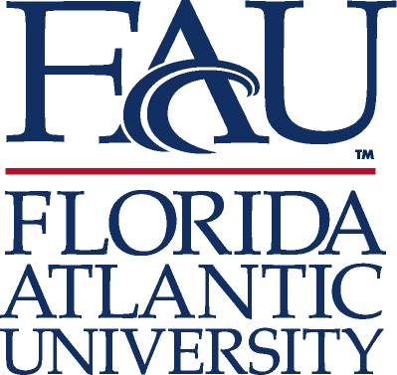
COLLEGE OF BUSINESS
Business Communications Program
777 Glades Road
Boca Raton, FL 33431
tel: 561.297.3940
fax: 561.297.0801
www.fau.edu
M E M O R A N D U M

TO: College Curriculum Chair
College of Business Dean
UUPC Chair
Undergraduate Studies Dean
UFS President
Provost

FROM: Mary Kay Boyd, Director, Business Communications Program ^{mkb}

DATE: September 25, 2017

SUBJECT: New Course Proposal, Undergraduate Programs
GEB 3213 (RI)

We are submitting the New Course Proposal and its Syllabus for your approval.

The course has been approved by OURI, and I have approved it for our undergraduate Business Communications Curriculum, hoping to begin offering it in spring 2018.

GEB 3213 (RI) aligns with the current curriculum of GEB 3213: Communicating Business Information, which is a Gordon Rule and WAC course; although the current course includes a research component, this course adopts a more intensive focus on scaffolded assignments to enhance, significantly, the skills of research and inquiry.

We strongly support the OURI initiative and believe our program is a suitable fit for building and refining these research skills.

Please contact me at 297-3633 if you have questions.

Thank you!

Boca Raton • Dania Beach • Fort Lauderdale • Davie • Jupiter • Treasure Coast
An Equal Opportunity/Access/Affirmative Action Institution

