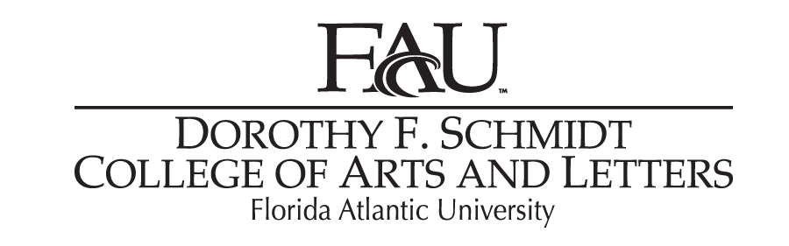

Audio Post-Production For Picture

MUM 4642
3 credits
Class location: TBA
Syllabus for Fall 2018
Dates:_____________

Instructor:

Matt Baltrucki
Office: AL - 233
Classroom/Lecture location: TBD
Class Time: TBA
Office hours: TBD

E-mail: mbaltruc@fau.edu

Phone (561)297-0600

Pre-Requisites:

MUM4664-Sound Recording II
Permission of Instructor

Course Description:
An In-depth look at audio-post production for picture. Students will learn about the various processes involved in recording, processing and mixing audio for use in TV and Film production as it applies to the sound recordist and mixer. Students will focus on learning about the areas of Production Audio, Foley, Sound Design, and Mixing to spec for professional broadcast. They will then apply these principles and methodologies to their work in the form of hands-on, professional grade projects throughout the semester.

Course Objectives:
1) Familiarization with the various processes involved in post-production audio for the TV and film industry.
2) Experience using professional level tools and methodologies for professional level post-production work.
3) Creation of a demo reel for future opportunities outside of the class.

Required Texts:
Holman, Tomlinson. Sound for Film and Television 3rd edition. Focal Press, 2010
Cross, Mark. Audio Post-Production: For Film and Television. Berklee Press, 2013

Course Evaluation:
This course is designed as a project driven class. Students will be introduced weekly to new concepts or methods and be assessed on satisfactory completion of 12 weekly projects (each graded on a 10-point scale), as well as a final portfolio containing descriptive summaries of all twelve assigned projects (20 points possible. Some of the projects will be team-efforts and as such attendance is mandatory. Failure to attend class more than three times will result in an automatic F for the semester. Late work will be accepted only at the discretion of the instructor. Refer to list below for assignment specifics. All assignments are due a week from the assigned date.

Grading Scale (based on the percentages listed below):
95-100=A
90-94=A-
87-89=B+
84-86=B
80-83=B-
77-79=C+
74-76=C
70-73=C-
67-69=D+
64-66=D
60-63=D-
below 60 =F

Attendance Policy Statement:
Students are expected to attend all of their scheduled University classes and to satisfy all academic objectives as outlined by the instructor. The effect of absences upon grades is determined by the instructor, and the University reserves the right to deal at any time with individual cases of non-attendance. Students are responsible for arranging to make up work missed because of legitimate class absence, such as illness, family emergencies, military obligation, court-imposed legal obligations or participation in University-approved activities. Examples of University-approved reasons for absences include participating on an athletic or scholastic team, musical and theatrical performances and debate activities. It is the student’s responsibility to give the instructor notice prior to any anticipated absences and within a reasonable amount of time after an unanticipated absence, ordinarily by the next scheduled class meeting. Instructors must allow each student who is absent for a University-approved reason the opportunity to make up work missed without any reduction in the student’s final course grade as a direct result of such absence.

Incomplete Policy:
Incompletes will be given at the discretion of the instructor and only in the case of extreme emergency or illness situations. Such emergencies include illness or death in the immediate family and must be documented. Outside employment or a heavy class schedule are not acceptable reasons for incompletes. It is the student’s responsibility to consult with the instructor if an incomplete is necessary. Incompletes can be made up by arrangement with the instructor and must be completed within one year.

Make up/ Late Work:
Please see instructor concerning makeup exams and late work.
No homework assignments or late work will be accepted after the due date without permission of the instructor. Makeup exams are only available upon instructor’s approval.

Students with Disabilities:
In compliance with the Americans with Disabilities Act (ADA), students who require reasonable accommodations due to a disability to properly execute coursework must register with Student Accessibility Services (SAS) and follow all SAS procedures. SAS has offices across three of FAU’s campuses – Boca Raton, Davie, and Jupiter, however, disability services are available for students on all campuses.

Code of Academic Integrity Policy Statement
Students at Florida Atlantic University are expected to maintain the highest ethical standards. Academic dishonesty is considered a serious breach of these ethical standards, because it interferes with the university mission to provide a high quality education in which no student enjoys an unfair advantage over any other. Academic dishonesty is also destructive of the university community, which is grounded in a system of mutual trust and places high value on personal integrity and individual responsibility. Harsh penalties are associated with academic dishonesty. For more information, see University Regulation 4.001, http://www.fau.edu/ctl/4.001_Code_of_Academic_Integrity.pdf

Religious Holiday Accommodations:
- In accordance with rules of the Florida Board of Education and Florida law, students have the right to reasonable accommodations from the University in order to observe religious practices and beliefs with regard to admissions, registration, class attendance, and the scheduling of examinations and work assignments.
- Students who wish to be excused from course work, class activities, or examinations must notify the instructor in advance of their intention to participate in religious observation and request an excused absence. The instructor will provide a reasonable opportunity to make up such excused absences.
- Any student who feels aggrieved regarding religious accommodations may present a grievance to the director of Equal Opportunity Programs. Any such grievances will follow Florida Atlantic University’s established grievance procedure regarding alleged discrimination.

Credit and Time Requirements
Federal regulations, FAU and our accrediting body the National Association of Schools of Music have determined the following formula to represent the amount of work represented per credit hour: for each credit hour in a class, the combined contact hours in class and out-of-class student work should equal three hours. In the cases of applied music lessons, each individual area will provide specific out-of-class expectations that will lead to student success in the applied lesson. Large ensembles may meet additional hours beyond this formula to accommodate the rigors of the repertoire scheduled for performances.

Course Schedule

Topics Covered and Assignments By Week

Week 1: Introduction to tools and methods

Week 2: ProTools for Audio Post (OMF/AAF import and session organization)

AP_01: Successfully import and organize a provided OMF sample session (10 points)

Week 3: Production Sound Recording

AP_02: Record Production Sound sample and present to class (10 points)

Week 4: Dialogue: production dialogue editing

AP_03: Edit the dialog for the provided scene (10 points)

Week 5: ADR and Voice Over

AP_04: Record and Lay in ADR for provided scene. Replace all Production Dialogue (10 points)

Week 6: Sound Design: SFX

AP_05: Spot and Lay in SFX for a provided Scene (10 points)

Week 7: Sound Design: Ambience

AP_06: Spot and Lay in Ambience/Sound Design for a provided scene (10 points)

Week 8: Foley (Process: recording and mixing)

AP_07: Spot and Record Foley to a silent picture. Mix in with ambience and SFX (10 points)

Week 9: Music Editorial (spotting, placing temp music, editing to picture)

AP_08: Spot, place and edit musical selections for a provided scene (10 points)

Week 10: Mixing: Temp Mixes

AP_09: Mix a provided OMF/AAF for a temp deliverable (10 points)

Week 11: Mixing: Signal processing Audio Post (tutorial)

Week 12: Final Dub Mix

AP_10: Mix Provided Full Show OMF to spec provided (10 points)

Week 13: Mixing in Surround

AP_11: Lay in Surround FX and Ambiences. Stem tracks for integration into final Mix (10 points)

Week 14: Deliverables (stems and mixes)

AP_12: Deliver final mix and properly labeled submix stems from AP_10 (10 points)

Final Exam: Presentation of DVD containing all twelve semester projects (30 points)

All projects are due one week after they are assigned.

