Department of Exceptional Student Education
College of Education
Florida Atlantic University

Instructor: Office:
Phone: E-mail:
Office Hours: Class Day/Time:

Course Number: Sls2920

Course Title: Career Seminar

2 Credits

Catalog Description: In this course, students will learn all necessary details and specific of their chosen career field in order to enhance their skills and obtain employment.

INSTRUCTOR INTRODUCTION TO THE COURSE: This course is designed for the Florida Atlantic University Academy for Community Inclusion. In this course, students will participate in a specific career seminar to work towards the ultimate goal of competitive employment in their specific career field. The course will include multiple outings to jobs in the field for students to be able to observe and trial their skills in the field.

PREREQUISITE or COREQUISITE:
None

REQUIRED TEXTS or MATERIALS:

All materials will be provided by instructor in class or on Blackboard. Materials will be provided in multiple formats as appropriate.
Owl Card to access the library (Student Services)
Tablet

TECHNOLOGY:

E-mail: Your FAU email will be used for this class.

Computer: This course will be web assisted through FAU Blackboard site. Some handouts, forms, handbook and resources may be available on the website. Go to the website: http://blackboard.fau.edu (Do not type www).

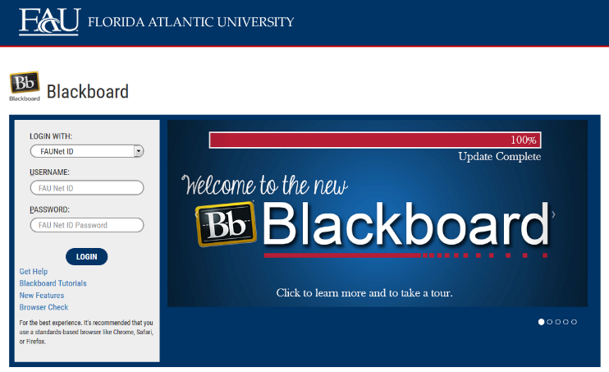

Tablet: The tablet will be used to record others during group observations.

COURSE OBJECTIVES:
Upon completion of this course, the successful student will be able to demonstrate the following:

- Students will show punctuality, attendance, and proper attire in that is suitable in the work place.
- Students will work in groups on job sites to observe skills that are required for their specific career field.
- Students will demonstrate appropriate social interactions with peers and staff during group observations.
- Students will acquire a skill set in a specific career field or area that will assist students in successfully maintaining a job.

Content Outline:

- Focusing on specific job skills and qualifications for desired career path
- Building knowledge of desired career path
- Utilizing strategies on the job to create success

COURSE REQUIREMENTS: (See Appendix for more details on assignments)

- Observations (10 points per observation)- Each week, students will meet with their assigned group and go to a job site with an instructor, a job coach, or a supervisor that is on the job site. The job sites the students will be observing will be jobs in their career field of interest. Students will be required to take notes, via tablet while they are on the job site. These notes will be used in a discussion about what the student saw in the next class time. The notes will be submitted to the instructor at the end of every week. The notes can be in a video, visual, or verbal form.

- Discussions (10 points per discussion)- After the observation, students will participate in a group discussion and individually complete a discussion worksheet that will be given to students at the beginning of the class period. The worksheet will require students to recall some of the specific job tasks they saw at the observation that week, what tasks they may have participated in at the observation, how many people were required to complete the task, the job environment, and what skills they would need to develop if they wanted to have a job at that specific job site.

- Plan for Internship- In this assignment; students will pick an internship site by applying, going in for an interview, and discussing job responsibilities with the site supervisor. The student will then speak with their job coach to talk about what the next steps for their internship. The student will write a plan for the next semester. If the student does not get accepted to this internship site, the student will need to go to their advisor to assist in applying for another internship. The student will submit their plan for approval to their advisor (Mrs. Downey) at the end of this semester. The plan will include, their job site, how they will get to work, how many days a week they will work, their job responsibilities, strategies they will use to successfully complete their internship, and who the key players are during their internship (supervisor, job coach, etc.).

In order to receive credit for this course, you will sit with your job coach to apply for your career internship for the next semester. Be timely! Don’t wait until the last minute.
- You get to choose the jobs you would like to apply to so you will need to have finished your job search before you can apply.
- You will also need to go through the interview process and be hired with a start date for the first week of the next semester that you will take internship in.
- After you are hired, you will sit with your job coach to complete a hire form (supplied by your job coach) and go over an action plan for the first day at your career internship.

ASSESSMENT PROCEDURES:

Assignment | Points Earned | Possible
1: Observations |  | S/U
2: Discussions |  | S/U
3: Plan for Internship |  | S/U
TOTAL

GRADING (FAU GRADING SCALE):
Activity scores are cumulative and the grade scale represents percentage of total points earned.
S= 73% and higher U = 72% and lower

POLICIES AND PROCEDURES:

ATTENDANCE:
According to University policy, “Students are expected to attend all of their scheduled University Classes and to satisfy all academic objectives as outlined by the instructor.” Attendance includes meaningful, active involvement in all class sessions, class discussions, and class activities as well as professional, ethical, conduct in class. Reasonable accommodations are made for religious observances.

STUDENTS WITH DISABILITIES:
In compliance with the Americans with Disabilities Act (ADA) and FAU policy, students with disabilities who require special accommodations to properly execute course work must register with FAU Student Accessibility Services (SAS) and provide the instructor of this course with a letter from SAS indicates the reasonable accommodations that would be appropriate for this course. SAS offices are located on Boca, Davie and Jupiter campuses. Information regarding SAS services and locations can be found at: http://www.fau.edu/sas/

CODE OF INTEGRITY:
Students at Florida Atlantic University are expected to maintain the highest ethical standards. Academic dishonesty, including cheating and plagiarism, is considered a serious breach of these ethical standards, because it interferes with the University mission to provide a high quality education in which no student enjoys an unfair advantage over any other. Academic dishonesty is also destructive of the University community, which is grounded in a system of mutual trust and places high value on personal integrity and individual responsibility. Harsh penalties are associated with academic dishonesty. For more information, see https://www.fau.edu/ctl/4.001_Code_of_Academic_Integrity.pdf

BIBLIOGRAPHY

Grigal, M., & Hart, D. (2010). Think college: Postsecondary education options for students with intellectual disabilities. Baltimore, MD: Paul H. Brookes Publishing Co.
Revell, G., & Targett, P. (2012). Adult services. In P. Wehman & J. Kregel (Eds.), Functional curriculum for elementary and secondary students with special needs (pp. 507-526). Austin, TX: PRO-ED.

Strieker, T., Sloan, J., Stern, H., & Wade, K. (2010). Designing inclusive educational programs in higher education: Standards, assessment & evaluation. Lexington, KY: Kennesaw State University.

Synatschk, K., Clark, G., Patton, J., & Copeland, L. (2007). Informal assessments for transition: Employment and career planning (pp. 17-47). Autsin, TX: PRO-ED.

Wolffe, K. (2012). Career exploration and vocational selection. In Career counseling for people with disabilities (Second ed., pp. 47-63). Austin, TX: PRO-ED.

COURSE SCHEDULE FOR SEMESTER

Week | DATE | TOPICS | ASSIGNMENTS
1 |  | Overview of Syllabus  Introduction to Course | Hmwk: collect required materials for class
2 |  | Career Interests | Hmwk: Create a list of jobs in your career field of interest
3 |  | Observation and Discussion Procedures | Hmwk: Device a way of taking notes on tablet
4 |  | Observation and Discussion 1 | Hmwk: Submit observation notes and discussion 1 to instructor
5 |  | Observation and Discussion 2 | Hmwk: Submit observation notes and discussion 2 to instructor
6 |  | Observation and Discussion 3 | Hmwk: Submit observation notes and discussion 3 to instructor. Practice skills required for job sites
7 |  | Observation and Discussion 4 | Hmwk: Submit observation notes and discussion 4 to instructor. Practice skills required for job sites.
8 |  | Observation and Discussion 5 | Hmwk: Submit observation notes and discussion 5 to instructor. Practice skills required for job sites.
9 |  | Observation and Discussion 6 | Hmwk: Submit observation notes and discussion 6 to instructor. Practice skills required for job sites.
10 |  | Work week: No observation or Discussion this week | Hmwk: Start working on Plan for Internship
11 |  | Observation and Discussion 7 | Hmwk: Submit observation notes and discussion 7 to instructor. Practice skills required for job sites.
12 |  | Observation and Discussion 8 | Hmwk: Submit observation notes and discussion 8 to instructor. Practice skills required for job sites.
13 |  | Observation and Discussion 9 | Hmwk: Submit observation notes and discussion 9 to instructor. Practice skills required for job sites.
14 |  | Observation and Discussion 10 | Hmwk: Submit observation notes and discussion 10 to instructor. Practice skills required for job sites.
15 |  | Plan for Internship Tips for Next Semester | Plan for Internship Approved by Advisor

