Department of Exceptional Student Education
College of Education
Florida Atlantic University

Instructor: Office:
Phone: E-mail:
Office Hours: Class Day/Time:

Insert instructor picture here:

Course Number: SLS 2252

2 credits

Course Title: Personal Well-being

Catalog Description:
This course will increase a student’s understanding of health information. Students will learn how to connect with the health care system and to help them become better consumers of health services.

INSTRUCTOR INTRODUCTION TO THE COURSE:
This course will help students learn about the health care system in the U.S. They will learn how to find a doctor, talk to the doctor, follow doctor’s directions, and become a more knowledgeable person about their own health. This class will also help students become organized where there health care is concerned. They will learn about yearly physicals and specialist visits (like those you have for glasses, dentists, and other specialists). The health care system in the US is very complicated and ever changing. So it is important for young adults to learn how to get what they need in the system of health care.

PREREQUISITE or COREQUISITE:
None

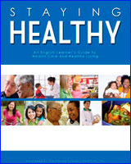
REQUIRED TEXTS or MATERIALS:

Kurtz-Rossi, S., Lane M.A., McKinney, J., Frost, J., & Smith , G. (2008). Staying healthy: An English learner’s guide to health care and healthy living. Orlando, FL: Florida Literacy Coalition.
http://floridaliteracy.org/health_literacy_curriculum.html

Students will download this text from the internet at the first class. The materials will also be provided in multiple formats as appropriate.

TECHNOLOGY:
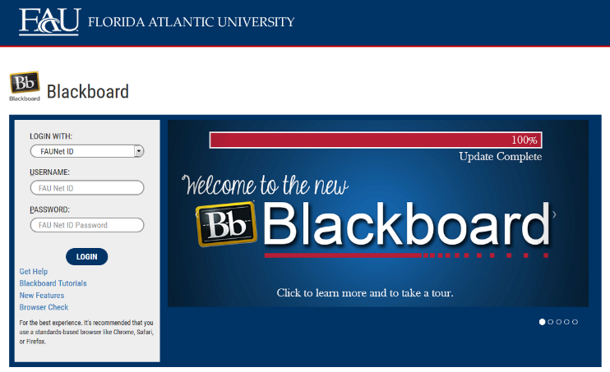
E-mail: Your FAU email address will be used.

Computer: This course will be web assisted through FAU Blackboard site. Some handouts, forms, handbook and resources may be available on the website. Go to the website: http://blackboard.fau.edu (Do not type www).

Videos:

Health Care Facts
https://www.youtube.com/watch?v=0WKVyozJSbA

What is nutrition?
https://www.youtube.com/watch?v=l0cZfaadP3k

How can I stay healthy?
https://www.youtube.com/watch?v=yvxX0XfqJtw

COURSE OBJECTIVES:

At the end of this course, the successful student will be able to:

1) Explain how, when, and why to go to vist a doctor.
2) Demonstrate how to make an appointment for a doctor and what tyes of health history they should be prepared to take with them.
3) Identify good meal and food choices.
4) Explain how to take medicines, and which medicines they take regularly.
5) Describe what is a chronic Illness.
6) Describe three ways to prevent illnesses.
7) Describe their personal healthy living plan.

Content Outline:

COURSE REQUIREMENTS:

1) Pre- & Post- Health Literacy Assessment: During the first & last weeks in class, students will complete the Pre- & PostTest to assess their health literacy. All students need to complete this assessment and the total points will be added to their grade for the course.

2) Health Care Info Card: Students will gather helath care information for the Health Care Info Card. This assignment will need to be completed early in the semester and with the help of the student’s parents/guardians as it requires personal information.

3) Practice Assignments: Students will abe assigned weekly homework activites that are part of the coursework for the class. These assignments can be found in the textbook and ont eh course website in BlackBoard. It is the student’s responsibility to complete the assignments on time and completely to receive full credit.

ASSESSMENT PROCEDURES:

Assignment | Points I Earned | Possible
Health Literacy Assessments (2 @ 20 points each) |  | 40
Health Care Info Card (1 @ 20 points) |  | 20
Practice Assignements (10 @ 10 points each) |  | 100
TOTAL |  | 160

GRADING (FAU GRADING SCALE):
Activity scores are cumulative and the grade scale represents percentage of total points earned.
A = 93-100 A- = 90-92 B+= 87-89 B = 83-86
B- = 80-82 C+= 77-79 C = 73-76 C-= 70-72
D+= 67-69 D = 63-66 D-= 60-62 F = Below 60

POLICIES AND PROCEDURES:

ATTENDANCE:
According to University policy, “Students are expected to attend all of their scheduled University Classes and to satisfy all academic objectives as outlined by the instructor.” Attendance includes meaningful, active involvement in all class sessions, class discussions, and class activities as well as professional, ethical, conduct in class. Reasonable accommodations are made for religious observances.

STUDENTS WITH DISABILITIES:
In compliance with the Americans with Disabilities Act (ADA) and FAU policy, students with disabilities who require special accommodations to properly execute course work must register with FAU Student Accessibility Services (SAS) and provide the instructor of this course with a letter from SAS indicates the reasonable accommodations that would be appropriate for this course. SAS offices are located on Boca, Davie and Jupiter campuses. Information regarding SAS services and locations can be found at: http://www.fau.edu/sas/

CODE OF INTEGRITY:
Students at Florida Atlantic University are expected to maintain the highest ethical standards. Academic dishonesty, including cheating and plagiarism, is considered a serious breach of these ethical standards, because it interferes with the University mission to provide a high quality education in which no student enjoys an unfair advantage over any other. Academic dishonesty is also destructive of the University community, which is grounded in a system of mutual trust and places high value on personal integrity and individual responsibility. Harsh penalties are associated with academic dishonesty. For more information, see https://www.fau.edu/ctl/4.001_Code_of_Academic_Integrity.pdf

BIBLIOGRAPHY

Agran, M. (2012). Health and safety skills. In In Paul Wehman and John Kregel (Eds.) Functional curriculum for elementary and secondary students with special needs (3rd Ed). Austin, TX: Pro-Ed, An International Publisher.

Camargo, E. P., Carvalho, L. B. C., Prado, L. B. F., & Prado, G. F. (2013). Comic strips for health education–Comparative study of the effective between children with learning disabilities and regular school performance. Sleep Medicine, 14, e85-e86.

Grigal, M., & Hart, D. (2010). Think College! Postsecondary Education Options for Students with Intellectual Disabilities. Brookes Publishing Company. PO Box 10624, Baltimore, MD 21285.

Kurtz-Rossi, S., Lane M.A., McKinney, J., Frost, J., & Smith , G. (2008). Staying healthy: An English learner’s guide to health care and healthy living. Orlando, FL: Florida Literacy Coalition.
http://floridaliteracy.org/health_literacy_curriculum.html

Marks, B., Sisirak, J., & Hellar T. (2010). Health matters: The exercise and nutrition health education curriculum for people with developmental disabilities (1st ed.). Baltimore, MD: Paul H. Brookes Pubishing.

Wood, W. M. & Spooner, F. (2012). Personal care and hygiene skills. In Paul Wehman and John Kregel (Eds.) Functional curriculum for elementary and secondary students with special needs (3rd Ed). Austin, TX: Pro-Ed, An International Publisher.
COURSE SCHEDULE FOR SEMESTER

WEEK | DATE | TOPICS | ASSIGNMENTS
1 |  | Intro to Class  What do you know about health care? | -Take pre-test in class  -take home health care card and work on it with parents  Read chapter 1
2 |  | Health Care Facts  https://www.youtube.com/watch?v=0WKVyozJSbA  Role plays
3 |  | When do you go to the Emeregency Room?  -why go to the emergency room? | -bring back health care care  Read chapter 2
4 |  | When do you go to the doctor?  -what kind of doctors are there?
5 |  | Making appointments and getting ready for appointments  What do you take with you? | -practice health info sheet completed
6 |  | What will the doctor ask you?  What will you ask the doctor? | Read Chapter 4
7 |  | What is nutrition?  https://www.youtube.com/watch?v=l0cZfaadP3k  Role Plays | -complete measurement activites
8 |  | What does a well planned meal look like?  What does the nutrition label mean?
9 |  | How do you make good food choices? | Read Chapter 3
10 |  | Why do people take medicines?  What do you need to know about your medicines?
11 |  | -more on taking medicines | Read chapter 5
12 |  | What are Chronic Illnesses?
13 |  | How can exercise help prevent illness? | Read chapter 6
14 |  | What is my prevention plan?
15 |  | How can I stay healthy?  https://www.youtube.com/watch?v=yvxX0XfqJtw  Role plays
16 |  | Take post- test

