Department of Exceptional Student Education
College of Education
Florida Atlantic University

Instructor: Office:
Phone: E-mail:
Office Hours: Class Day/Time:

Course Number: Sls 1251

Course Title: Residential Experience

Catalog Description: This course provides a discussion of interpersonal relationships and utilizing of life skills such as pro-active communication skills; active listening and response skills; and conflict resolution techniques.

INSTRUCTOR INTRODUCTION TO THE COURSE: This course is designed for the Florida Atlantic University Academy for Community Inclusion. In this course, students will learn how to effectively communicate with others while living in a residential setting. This requires for students to learn how to listen and appropriately respond, deal with conflicts, and overcome specific obstacles in communication. This course also explores how to manage feelings and overcome barriers to communication.

PREREQUISITE or COREQUISITE:

Admission to or good standing in Academy for Community Inclusion program.

REQUIRED TEXTS or MATERIALS:

All materials will be provided by instructor in class or on Blackboard. Materials will be provided in multiple formats as appropriate.
Journal (Either video recording, verbal recording, or written/typed)
Tablet

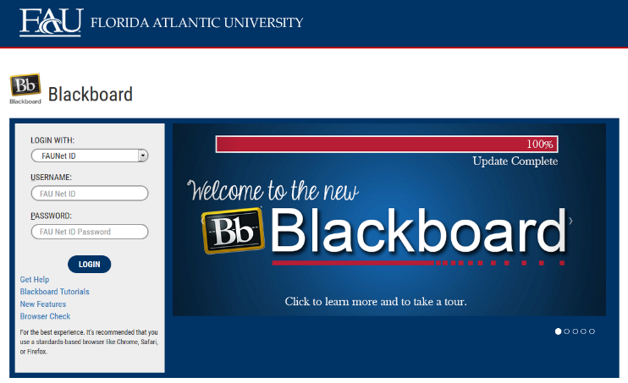
TECHNOLOGY:

E-mail: Your FAU email will be used for this course.

Computer: This course will be web assisted through FAU Blackboard site. Some handouts, forms, handbook and resources may be available on the website. Go to the website: http://blackboard.fau.edu (Do not type www).

Videos:
- Happy Roommates-
https://www.youtube.com/watch?v=JNI1fWTlGwY

COURSE OBJECTIVES:
Upon completion of this course, the successful student will be able to demonstrate the following:

- Students will appropriately introduce themselves to their roommates prior to move-in and discuss moving-in procedures and items to bring to dorm life.
- Students will create a roommate contract with expected living conditions, quiet times, supplies/spaces shared, and cleaning schedules.
- Students will learn how to listen actively to their roommates.
- Students will learn how to appropriately respond to their roommates comments.
- Students will learn how to deal with communication barriers.
- Students will learn how to resolve conflicts with roommates and other personal relationships.
- Students will learn how to talk about their feelings or concerns with roommates and in other personal relationships.
- Students will learn strategies for compromising and managing their feelings.

Content Outline:

COURSE REQUIREMENTS: (See Appendix for assignment rubrics)

- Roommate Contract- (20 points) Students will create a roommate contract for their common living area with rules that they have agreed upon with their roommate. The contract will include a list of expectations that each roommate has agreed to follow and the contract should be signed by all parties. The issues that are required to be included in the contract are agreements on: sharing food items, kitchen supplies, and common area items such as couches, TV, and entertainment devices; cleaning schedules, dish washing, and emptying the garbage; music and TV loudness along with quiet hours; guests visiting hours and appropriateness around them. Students will type their contract and submit the contract with both signatures via email to the instructor.

- Peer Conversation Video-(30 points) Students will get together with a partner to record themselves having a conversation that follows the conversation rules for sharing information, giving compliments, listening, and appropriate responses. The students will start the conversation by asking the other person about himself or herself and continue by finding common interests. The students are then free to have a conversation and are encouraged to talk about their own creative topics. The conversation is required to be 10 minutes in length. Students will use their tablets to record themselves and submit their video to the instructor via Blackboard.

- Dorm Room Journal- (50 points) Students will be required to keep a journal that they will write in two times per week. The journal will be used to document communication between roommates. Students will write down, or video record themselves for the journal entries. In the entries, students will share their experiences in the dorm room, their interactions with their roommates, their feelings, etc. Students will submit their final product at the last class of the semester to the instructor.

- In Class Assignments and Homework- (20 points) Students are expected to attend and fully participate in class. Each class session will have either an in- class or homework assignment that will allow students to practice the skills presented in class. Students are responsible for completing the assignments within the given time frame stated by the instructor.

ASSESSMENT PROCEDURES:

Assignment | Points Earned | Possible
1: Roommate Contract |  | 20
2: Peer Conversation Video |  | 30
3: Dorm Room Journal |  | 50
4: In Class Assignments and Homework |  | 20
TOTAL |  | 120

GRADING (FAU GRADING SCALE):
Activity scores are cumulative and the grade scale represents percentage of total points earned.
A = 93-100 A- = 90-92 B+= 87-89 B = 83-86
B- = 80-82 C+= 77-79 C = 73-76 C-= 70-72
D+= 67-69 D = 63-66 D-= 60-62 F = Below 60

POLICIES AND PROCEDURES:

ATTENDANCE:
According to University policy, “Students are expected to attend all of their scheduled University Classes and to satisfy all academic objectives as outlined by the instructor.” Attendance includes meaningful, active involvement in all class sessions, class discussions, and class activities as well as professional, ethical, conduct in class. Reasonable accommodations are made for religious observances.

STUDENTS WITH DISABILITIES:
In compliance with the Americans with Disabilities Act (ADA) and FAU policy, students with disabilities who require special accommodations to properly execute course work must register with FAU Student Accessibility Services (SAS) and provide the instructor of this course with a letter from SAS indicates the reasonable accommodations that would be appropriate for this course. SAS offices are located on Boca, Davie and Jupiter campuses. Information regarding SAS services and locations can be found at: http://www.fau.edu/sas/

CODE OF INTEGRITY:
Students at Florida Atlantic University are expected to maintain the highest ethical standards. Academic dishonesty, including cheating and plagiarism, is considered a serious breach of these ethical standards, because it interferes with the University mission to provide a high quality education in which no student enjoys an unfair advantage over any other. Academic dishonesty is also destructive of the University community, which is grounded in a system of mutual trust and places high value on personal integrity and individual responsibility. Harsh penalties are associated with academic dishonesty. For more information, see https://www.fau.edu/ctl/4.001_Code_of_Academic_Integrity.pdf

BIBLIOGRAPHY

Becoming a comprehensive transition program. (n.d.). Retrieved October 28, 2015, from http://www.thinkcollege.net/topics/becoming-a-comprehensive-transition-program

Boyd, L., McReynolds, C., & Chanin, K. (2013). The social compass curriculum. Baltimore, MD: Paul H. Brooks Publishing.

Gaumer Erickson, A., Clark, G., & Patton, J. (2013). Informal assessments for transition planning (pp. 54-162). Austin, TX: PRO-ED.

Pankaskie, S.,& Chandler, S. (2012). Social skills. In P. Wehman & J. Kregel (Eds.), Functional curriculum for elementary and secondary students with special needs (pp. 258-317). Austin, TX: PRO-ED.

Synatschk, K., Clark, G., Patton, J., & Copeland, L. (2007). Informal assessments for transition: Employment and career planning (pp. 17-47). Austin, TX: PRO-ED.

COURSE SCHEDULE FOR SEMESTER

Week | DATE | TOPICS | ASSIGNMENTS
1 |  | Overview of Syllabus  Introduction to Course | Hmwk: collect required materials for class
2 |  | What rules would I want to create for my roommate and myself? | Hmwk: Brainstorm a list of rules for the dorm suite.
3 |  | What items should be listed on my Roommate Contract? | Hmwk: Watch https://www.youtube.com/watch?v=JNI1fWTlGwY
4 |  | What do I do if a roommate violates the contract? | Hmwk: Brainstorm a step by step process of how you would confront your roommate.
5 |  | Why is it important to listen to others when they speak? | Hmwk: Read “Pat Likes to Pretend” and answer comprehension questions posted on Blackboard.
6 |  | What are inappropriate responses to a peer’s comment? | Roommate Contract Due
7 |  | How do I stay on topic? | Hmwk: Read “Blurting Bob” posted on Blackboard and answer comprehension questions.
8 |  | BREAK- No Classes | Continue to log in the Dorm Room Journal
9 |  | What information is okay to share with others? | Hmwk: Read “Sharon Shares Her Thoughts” and answer comprehension questions posted on Blackboard.
10 |  | How can I give a compliment? | Hmwk: Read “Connie Compliments” and answer comprehension questions posted on Blackboard.
11 |  | How do I talk about my feelings with others? | Hmwk: Read “Ida’s Story of Intense Feelings” and answer comprehension questions posted on Blackboard.
12 |  | What are some issues that I have when talking with my peers? | Peer Conversation Video Due
13 |  | What are some strategies to handle arguments and my frustration? | Hmwk: Develop a strategy to use when you are angry or frustrated in order to calm down.
14 |  | What should I do if someone is teasing or bullying me? | Hmwk: Read “Freddy’s Friendly Teasing” and answer comprehension questions posted on Blackboard.
15 |  | How can I avoid being left out of activities with my peers? | Dorm Room Journal Due

Appendix A- Assignment Rubrics

Roommate Contract | Exceeds Expectations | Meets Expectations | Does Not Meet Expectations
Detailed

_____/5

Signature

_____/5

Rules

____/10

Peer Conversation Video | Exceeds Expectations | Meets Expectations | Does Not Meet Expectations
Creativeness

_____/10

Presentation

_____/10

Scenario Interactions/ Communication Skills

____/10

Dorm Room Journal | Exceeds Expectations | Meets Expectations | Does Not Meet Expectations
Timely Entries

_____/20

Descriptions/ Issues

_____/20

Organization

____/10

