Department of Exceptional Student Education
College of Education
Florida Atlantic University

Instructor: Office:
Phone: E-mail:
Office Hours: Class Day/Time:

Insert Instructor Picture Here

Course Number: SLS 1211

2 Credits

Course Title: Social Skills

Catalog Description:
Designed to assist students with developing conversation skills, resolving interpersonal conflict and enhancing interpersonal effectiveness in a variety of settings.

INSTRUCTOR INTRODUCTION TO THE COURSE: Sometimes the things that you say without even saying leave the biggest impression in other people’s minds. The way you look at them, the frowns, smiles, facial expressions, that’s what people remember. They also remember your tone of voice, and the language you use. In this course, students will learn to pay attention to the WAY they talk to others to make the best impression possible at work, home, and in the community. These skills are essential to making a lasting positive impact on others as well as handling personal matters.

PREREQUISITE: No Prerequisites or Co-Requisites

Note: This class may be repeated to ensure mastery of the skills presented in the course objectives.

REQUIRED TEXTS or MATERIALS:

All materials will be provided by instructor in class or on Blackboard. Materials will be provided in multiple formats as appropriate.

TECHNOLOGY: E-mail: Your FAU email address will be used.

Computer: This course will be web assisted through FAU Blackboard site. Some handouts, forms, handbook and resources may be available on the website. Go to the website: http://blackboard.fau.edu (Do not type www).

COURSE OBJECTIVES:

Upon completion of this course, the successful student will be able to demonstrate:

- An understanding of verbal communication skills.
- An understanding of nonverbal communication skills.
- An understanding of various types of social interactions.
- An understanding of friendship development.
- An understanding of the appropriate use of humor.
- An understanding of dealing with rejection.
- An understanding of dealing with disagreements.

Content Outline:

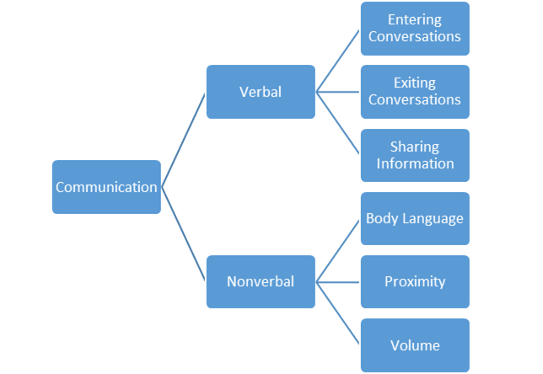

COURSE REQUIREMENTS:

- Social Scenario Presentation
Students will be assigned to groups. Each group will be given a common social scenario. Students must work together to develop a 3-5 minute presentation utilizing appropriate social and communication skills.

2. In-class and Homework Assignments
Students are expected to attend and fully participate in class. Each class session will have either an in- class or homework assignment that will allow you to practice the skills presented in class. Students are responsible for completing the assignments within the given time frame stated by the faculty instructor.

3. Conversation Video
Students will enter a conversation, share information and exit a conversation appropriately while being video recorded. Students will submit their video clip along with a completed reflection sheet.

ASSESSMENT PROCEDURES:

Assignment | Possible Points | Points I Earned
Conversation Video | 30
Social Scenario | 40
In-class and Homework Assignments | 30
Total | 100

GRADING (FAU GRADING SCALE):
Activity scores are cumulative and the grade scale represents percentage of total points earned.
A = 93-100 A- = 90-92 B+= 87-89 B = 83-86
B- = 80-82 C+= 77-79 C = 73-76 C-= 70-72
D+= 67-69 D = 63-66 D-= 60-62 F = Below 60

POLICIES AND PROCEDURES:

ATTENDANCE:
According to University policy, “Students are expected to attend all of their scheduled University Classes and to satisfy all academic objectives as outlined by the instructor.” Attendance includes meaningful, active involvement in all class sessions, class discussions, and class activities as well as professional, ethical, conduct in class. Reasonable accommodations are made for religious observances.

STUDENTS WITH DISABILITIES:
In compliance with the Americans with Disabilities Act (ADA) and FAU policy, students with disabilities who require special accommodations to properly execute course work must register with FAU Student Accessibility Services (SAS) and provide the instructor of this course with a letter from SAS indicates the reasonable accommodations that would be appropriate for this course. SAS offices are located on Boca, Davie and Jupiter campuses. Information regarding SAS services and locations can be found at: http://www.fau.edu/sas/

CODE OF INTEGRITY:
Students at Florida Atlantic University are expected to maintain the highest ethical standards. Academic dishonesty, including cheating and plagiarism, is considered a serious breach of these ethical standards, because it interferes with the University mission to provide a high quality education in which no student enjoys an unfair advantage over any other. Academic dishonesty is also destructive of the University community, which is grounded in a system of mutual trust and places high value on personal integrity and individual responsibility. Harsh penalties are associated with academic dishonesty. For more information, see https://www.fau.edu/ctl/4.001_Code_of_Academic_Integrity.pdf

BIBLIOGRAPHY

Boyd, L., McReynolds, C., & Chanin, K. (2013). The social compass curriculum. Baltimore, MD: Paul H. Brooks Publishing.

Grigal M., & Hart D. (2010). Think college: Postsecondary education options for students with intellectual disabilities. Baltimore, MD: Paul H. Brookes Publishing.

Laugeson, E.A., & Frankel, F. (2010). The PEERS treatment manual: Social skills for teenagers with developmental and autism spectrum disorders. New York, NY: Routledge, Taylor & Francis Group.

Van Reusen, A.K., Bos C.S., Schumaker, J, & Deshler, D. (2007). The self-advocacy strategy for enhancing student motivation and self-determination. Lawrence, KS: Edge Enterprises.

Wehmeyer, M. (2007). Promoting self-determination in students with developmental disabilities. New York, NY: The Guilford Press.

SLS 1211 Sem 20XX
COURSE SCHEDULE

SESSION | Week of | TOPICS | ASSIGNMENTS
1 |  | What are social skills? Why are they important? | Review Syllabus
2 |  | What is nonverbal communication? | HW: Read Brad’s Better Body Language  Spencer’s Space
3 |  | How can I improve my conversation skills? | HW: Victor’s Volume
4 |  | How can I improve my conversation skills? | HW: Read Sharon Shares Her Thoughts
5 |  | How can I improve my conversation skills? | HW: Group Call
6 |  | How do I choose appropriate friends? | HW: Worksheet - What do you want in a friend?
7 |  | What is an appropriate use of humor? | HW: Use humor in social situation
8 |  | How do I enter a conversation? | HW: Read Ned Gets Nervous
9 |  | How do I exit a conversation? | HW: Willie Wraps It Up
10 |  | What is good sportsmanship? | Conversation Video Due
11 |  | How should I deal with bullying and teasing? | HW: Read Freddy’s Friendly Teasing
12 |  | How should I deal with rumors and gossip? | HW: Develop presentation w/ group
13 |  | How can I handle disagreements? | HW: Develop presentation w/ group
14 |  | What is dating etiquette? | HW: What do you want in a boyfriend/girlfriend?
15 |  | Presentations | Social Scenario Presentations Due

SLS 1211

SCORING RUBRIC FOR
Social Scenario Presentation

Social Skills

Name: Date:

Project Component | Exceeds Expectations | Meets Expectations | Does Not Meet Expectations
Included All Components

___ /10
Clearly Communicates Ideas

___ /10
Collaborated with Team

___ /20

Overall Rating / Points Earned: / 30
SLS 1211

SCORING RUBRIC FOR
Conversation Video

Social Skills

Name: Date:

Project Component | Exceeds Expectations | Meets Expectations | Does Not Meet Expectations
Included All Components

___ /10
Clearly Communicates Ideas

___ /10
Insightful Reflection

___ /10

Overall Rating / Points Earned: / 30

