Department of Exceptional Student Education
College of Education
Florida Atlantic University

Instructor: Office:
Phone: E-mail:
Office Hours: Class Day/Time:

Insert Picture of Instructor Here

Course Number: FFP 1820

2 Credits

Course Title: Emergency preparation
Catalog Description:
Course provides a fundamental understanding of strategies for preparing and planning for emergency situations. Increasing awareness and developing a personal plan for emergency response is central to the course.
INSTRUCTOR INTRODUCTION TO THE COURSE: In this course, students will learn how to safely live independently. Some of the topics will include first aid, food safety, emergency preparedness, and natural disasters. This course will provide students with skills they need to live safely within their community.

PREREQUISITE or COREQUISITE:
HSC 2400 or permission of the instructor

REQUIRED TEXTS or MATERIALS:

All materials will be provided by instructor in class or on Blackboard. Materials will be provided in multiple formats as appropriate.

TECHNOLOGY:

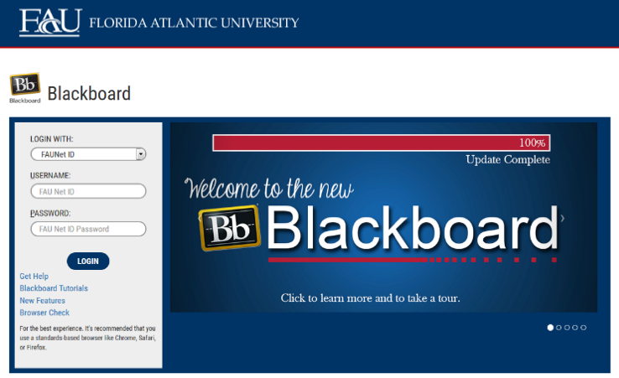
E-mail: Your FAU email address will be used.

Computer: This course will be web assisted through FAU Blackboard site. Some handouts, forms, handbook and resources may be available on the website. Go to the website: http://blackboard.fau.edu (Do not type www).

COURSE OBJECTIVES:

Upon completion of this course, the successful student will demonstrate:

- The ability to apply simple first aid to common injuries.
- An understanding of food safety.
- The abilitity to create and utilize an emergency preparedness kit.
- The ability to prepare for or respond to a natural disaster.

Content Outline:

COURSE REQUIREMENTS:

- In-class and Homework Assignments
Students are expected to attend and fully participate in class. Each class session will have either an in-class or homework assignment that will allow students to practice the skills presented in class. Students are responsible for completing the assignments within the given time frame stated by the instructor.
- First Aid and Safety Presentations
Students will present to the class information on a first aid or safety topic. The topic will be chosen from a list provided by the teacher. Students may present topic information in a PowerPoint presentation, poster, song, or other medium approved by the instructor.
- Emergency Preparedness Presentations
Students will present to the class information on an emergency preparedness topic. The topic will be chosen from a list provided by the teacher. Students may present topic information in a PowerPoint presentation, poster, song, or other medium approved by the instructor.
- Natural Disaster Group Presentation
Students will be divded into groups. Each group will be assigned a disaster scenario that they may encounter in their life. The group will have to research and present to the class appropriate ways to prepare for an impending disaster. Students will individually complete a reflection paper about the experience. Time will be provided in class to work on the assignment.

ASSESSMENT PROCEDURES:

Assignment | Points Possible
In-class and Homework Assignments | 30
First Aid and Safety Presentations | 20
Emergency Preparedness Presentations | 20
Natural Disaster Group Presentation | 30
TOTAL | 100

GRADING (FAU GRADING SCALE):
Activity scores are cumulative and the grade scale represents percentage of total points earned.
A = 93-100 A- = 90-92 B+= 87-89 B = 83-86
B- = 80-82 C+= 77-79 C = 73-76 C-= 70-72
D+= 67-69 D = 63-66 D-= 60-62 F = Below 60

POLICIES AND PROCEDURES:

ATTENDANCE:
According to University policy, “Students are expected to attend all of their scheduled University Classes and to satisfy all academic objectives as outlined by the instructor.” Attendance includes meaningful, active involvement in all class sessions, class discussions, and class activities as well as professional, ethical, conduct in class. Reasonable accommodations are made for religious observances.

STUDENTS WITH DISABILITIES:
In compliance with the Americans with Disabilities Act (ADA) and FAU policy, students with disabilities who require special accommodations to properly execute course work must register with FAU Student Accessibility Services (SAS) and provide the instructor of this course with a letter from SAS indicates the reasonable accommodations that would be appropriate for this course. SAS offices are located on Boca, Davie and Jupiter campuses. Information regarding SAS services and locations can be found at: http://www.fau.edu/sas/

CODE OF INTEGRITY:
Students at Florida Atlantic University are expected to maintain the highest ethical standards. Academic dishonesty, including cheating and plagiarism, is considered a serious breach of these ethical standards, because it interferes with the University mission to provide a high quality education in which no student enjoys an unfair advantage over any other. Academic dishonesty is also destructive of the University community, which is grounded in a system of mutual trust and places high value on personal integrity and individual responsibility. Harsh penalties are associated with academic dishonesty. For more information, see https://www.fau.edu/ctl/4.001_Code_of_Academic_Integrity.pdf

BIBLIOGRAPHY

American Red Cross. (n.d.) Be Red Cross ready. Retrieved October 12, 2015 from http://arcbrcr.org

American Red Cross. (n.d.) Types of emergency. Retrieved October 12, 2015 from http://www.redcross.org/prepare/disaster

Mayo Clinic. (n.d.) Burns:First aid. Retrieved October 15, 2015 from http://www.mayoclinic.org/first-aid/first-aid-burns/basics/art-20056649

Mayo Clinic. (n.d.). Cuts and Scrapes: First Aid. Retrieved October 15, 2015 from http://www.mayoclinic.org/first-aid/first-aid-cuts/basics/art-20056711

Florida Center for Inclusive Communities. (n.d.) Emergency preparedness and planning. Retrieved October 13, 2015 from http://flfcic.fmhi.usf.edu/program-areas/emergency.html

Florida Division of Emergency Management (n.d.). Florida’s severe weather awareness guide: Get a plan. Retrieved October 14, 2015 from http://flgetaplan.com

Florida Center for Inclusive Communities (n.d.) Preparing for disaster for people with disabilities and other special needs. Retrieved October 13, 2015 from http://flfcic.fmhi.usf.edu/docs/prepare_special_needs.pdf

Vecova Center for Disability Services and Research (2012). Easy reading brochure: How to prepare for an emergency. Calgary, Alberta, CA: Vecova Centre for Disability Services and Research.

COURSE SCHEDULE FOR SEMESTER

WEEK | DATE | TOPICS | ASSIGNMENTS
1 |  | Class overview
2 |  | What do you remember about First Aid and Safety?  Review of skills from HSC 2400 | First aid training  HW: Create emergency contact card
3 |  | How can we keep our food safe? | Food safety
4 |  | -continued First Aid and Safety | Food safety
5 |  | First Aid and Safety Presentations | PRESENTATIONS
6 |  | What goes in an emergency kit? | Create a class emergency preparedness kit
7 |  | What is YOUR fire safety plan? | Fire safety
8 |  | What do you do to stay safe in a car? | Car accident
9 |  | SPRING BREAK – NO CLASS
10 |  | Emergency Preparedness Presentations | PRESENTATIONS
11 |  | What the difference between watches and warnings | Warnings and Watches
12 |  | How do you prepare for natural disasters? | Flooding
13 |  | -continued Natural Disasters | Hurricane
14 |  | -continued Natural Disaster | Heat Wave
15 |  | Natural Disaster group presentation | PRESENTATIONS
16 |  | What is my plan for living on my own?

FFP1820
SCORING RUBRIC FOR
First Aid and Safety Presentation

Name: Date: Instructor:

Overall Rating/Points Earned: ____________/20

Project Component | Exceeds Expectation  5 points | Meets Expectations  3-4 points | Does Not Meet Expectations  1-2 points
What do people need to do to prepare for scenario?  _____/5 | Fully answers the question. | Answers part of the question. | Does not answer the question.
Create a task analysis for handling this scenario  _____/5 | Task analysis fully addresses steps for scenario. | Task analysis partially addresses steps for scenario. | Task analysis does not address steps for scenario.
Displays interest and enthusiasm  _____/5 | Is enthusiastic and interested. | Is enthusiastic and interested at times. | Is not interested or enthusiastic.
Visual Presentation  _____/5 | Is appealing to look at AND appropriate to the topic. | Is appealing to look at OR appropriate to the topic. | Is not appealing to look at and it not appropriate to the topic.

FFP1820
SCORING RUBRIC FOR
Emergency Preparedness Presentation

Name: Date: Instructor:

Overall Rating/Points Earned: ____________/20

Project Component | Exceeds Expectation  5 points | Meets Expectations  3-4 points | Does Not Meet Expectations  1-2 points
What do people need to do to prepare for this emergency?  _____/5 | Fully answers the question. | Answers part of the question. | Does not answer the question.
Create a task analysis for preparation for this emergency.  _____/5 | Task analysis fully addresses steps for preparation. | Task analysis partially addresses steps for preparation. | Task analysis does not address steps for preparation.
Displays interest and enthusiasm  _____/5 | Is enthusiastic and interested. | Is enthusiastic and interested at times. | Is not interested or enthusiastic.
Visual Presentation  _____/5 | Is appealing to look at AND appropriate to the topic. | Is appealing to look at OR appropriate to the topic. | Is not appealing to look at and it not appropriate to the topic.

FFP1820
SCORING RUBRIC FOR
Natural Disaster Group Project

Name: Date: Instructor:

Overall Rating/Points Earned: ____________/30

Project Component | Exceeds Expectation  5 points | Meets Expectations  3-4 points | Does Not Meet Expectations  1-2 points
Group discussions  _____/5 | Fully participated in group discussions. | Participated at times in group discussions. | Did not participate at all.
Group presentation  _____/5 | Fully participated in group presentation. | Participate at times in group presentation. | Did not participate at all.
Displays interest and enthusiasm  _____/5 | Is enthusiastic and interested. | Is enthusiastic and interested at times. | Is not interested or enthusiastic.
Visual Presentation  _____/5 | Is appealing to look at AND appropriate to the topic. | Is appealing to look at OR appropriate to the topic. | Is not appealing to look at and it not appropriate to the topic.
Individual reflection  _____/5 | Completely answers questions in reflection. | Answers part of the questions in the reflection. | Did not answer questions at all.
Overall group presentation  _____/5 | Overall score for presentation as a group. | Overall score for presentation as a group. | Overall score for presentation as a group.

