Honors Programs Coordinator
Office of the Dean of Undergraduate Studies
777 Glades Road, GS 211F
Boca Raton, FL 33431-0991
tel: 561.297.0337
fax: 561.297.2657
kdawsons@fau.edu

MEMORANDUM:
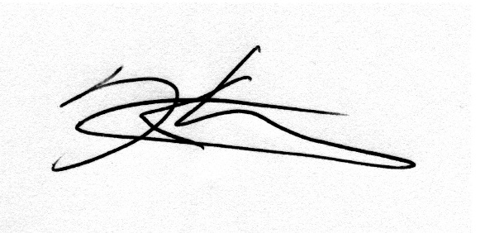
TO: Dr. Jerome Haky
Chair, University Undergraduate Programs Committee (UUPC)
FROM: Dr. Ken Dawson-Scully
Chair, University Honors Council (UHC) University Honors Coordinator
DATE: Dec 2nd, 2016
RE: URP 4978 Honors Planning Project

As per FAU's Honors Curriculum Manual, this course proposal was submitted to the OURI Programs Committee. The proposal was then discussed and approved by the University Honors Council on Dec 2 2016.
We are now asking the UUPC to consider this course change and approve it for inclusion in the catalog. Thank you.

