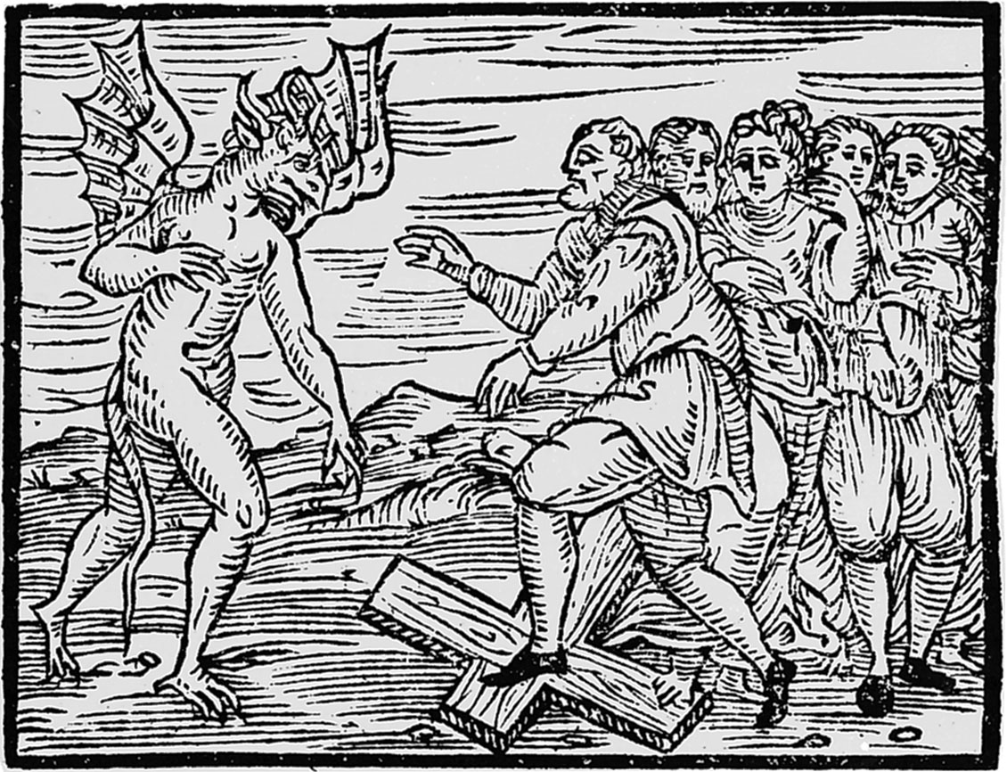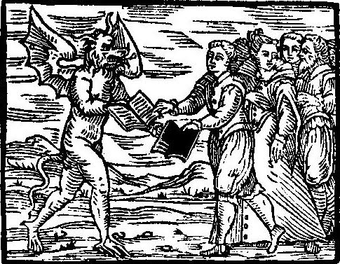

This course traces the changing roles and understandings of magic in European culture, religion, politics, and science from the late Middle Ages to the modern day. Exploring the experiences of individuals and communities in Europe, North America, and the Caribbean, students will gain a deep understanding of the diversity and development of beliefs about magic and witchcraft over several centuries. In addition to understanding scholars’ explanations of the development of these phenomena, students will build skills in historical interpretation through reading a variety of primary sources, from the *Malleus Maleficarum* to Harry Houdini’s *A Magician Among the Spirits.*

HIS 4262

Magic and Superstition in the Atlantic World

Spring 2018

Office Hours: Wednesdays and Fridays, 10-11:30am

AL 160

561-297-3951

[afinucane@fau.edu](mailto:afinucane@fau.edu)

3 Credit Hours

Wednesdays and Fridays

12:30-1:50pm

AL 242

#### Office Hours

#### Contact Information

#### Class Meetings

### Department of History, Florida Atlantic University

# Dr. Adrian Finucane

Students are required to purchase four books for this course:

John Demos, *The Enemy Within: A Short History of Witch-Hunting*. New York: Penguin Books, 2009. ISBN: 978-0143116332

Richard Godbeer, *The Salem Witch Hunt: A Brief History with Documents*. New York: Bedford/St. Martin’s, 2011. ISBN: 978-0312484550

Richard Kieckhefer, *Magic in the Middle Ages*. New York: Cambridge University Press, 2000. ISBN: 978-1107431829

Peter Alan Morton, ed. *The Trial of Temple Anneke: Records of a Trial in Brunswick, Germany, 1663*. New York: University of Toronto Press, 2006. ISBN: 978-1551117065

Additional readings on the Canvas website are marked on the course calendar with an asterisk.*

## Course Policies

Readings

Academic misconduct, including plagiarism, will be penalized. Class discussion and debate is highly encouraged, but interactions with others must remain respectful.

**Academic Integrity:** Students at Florida Atlantic University are expected to maintain the highest ethical standards. Academic dishonesty is considered a serious breach of these ethical standards, because it interferes with the University mission to provide a high quality education in which no student enjoys an unfair advantage over any other. Academic dishonesty is also destructive of the University community, which is grounded in a system of mutual trust and places high value on personal integrity and individual responsibility. Harsh penalties are associated with academic dishonesty. For more information, see the Code of Academic Integrity in the University Regulations: <http://www.fau.edu/regulations/chapter4/4.001_Code_of_Academic_Integrity.pdf>

Students are expected to produce original and individual work on all assignments. Students are expected to understand that the definition of plagiarism includes:

1. Copying large or smalls sections of a written text without appropriate quotations and citation
2. Paraphrasing written material without citing the source
3. Citing a source other than that from which you obtained your evidence
4. Altering or contriving evidence

Plagiarizing, intentionally or unintentionally, may result in the failure of individual assignments and/or the course as a whole.

Students must complete exams on their own, without referring to any notes or other students during the exam.

Students are required to turn off cell phones and other devices that vibrate or make noise during class meetings. The use of laptops during meetings is permitted but restricted to class-related activity.

At the discretion of the instructor, there may be changes to this syllabus over the course of the semester. Students must check their FAU email regularly for notice of changes.

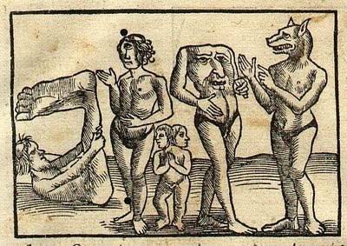

Course Policies, continued

The **FAU Center for Excellence in Writing** has a number of resources designed to help you with your writing. Students are encouraged to take advantage of the writing center, which can be accessed at [www.fau.edu/ucew](http://www.fau.edu/ucew).

Students are encouraged to **take advantage of office hours** in order to ask questions about assignments, seek clarifications, and discuss further any class material they do not fully understand. Email will be answered on weekdays. Papers turned in **late** without prior extension will result in the loss of 10% of the paper grade per day late, including weekend days.

**Accommodations for Students with Disabilities:** In compliance with the Americans with Disabilities Act Amendments Act (ADAAA), students who require reasonable accommodations due to a disability to properly execute coursework must register with Student Accessibility Services (SAS) – in Boca Raton, SU 133 (561-297-3880); in Davie, LA 203 (954-236-1222); or in Jupiter, SR 110 (561-799-8585) – and follow all SAS procedures. **Counseling and Psychological Services (CAPS) Center:** Life as a university student can be challenging physically, mentally and emotionally. Students who find stress negatively affecting their ability to achieve academic or personal goals may wish to consider utilizing FAU’s Counseling and Psychological Services (CAPS) Center. CAPS provides FAU students a range of services – individual counseling, support meetings, and psychiatric services, to name a few – offered to help improve and maintain emotional well-being. For more information, go to http://www.fau.edu/counseling/

**Attendance Policy**: Students are expected to attend all of their scheduled University classes and to satisfy all academic objectives as outlined by the instructor. The effect of absences upon grades is determined by the instructor, and the University reserves the right to deal at any time with individual cases of non-attendance. Students are responsible for arranging to make up work missed because of legitimate class absence, such as illness, family emergencies, military obligation, court-imposed legal obligations or participation in University-approved activities. Examples of University-approved reasons for absences include participating on an athletic or scholastic team, musical and theatrical performances and debate activities. It is the student’s responsibility to give the instructor notice prior to any anticipated absences and within a reasonable amount of time after an unanticipated absence, ordinarily by the next scheduled class meeting. Instructors must allow each student who is absent for a University-approved reason the opportunity to make up work missed without any reduction in the student’s final course grade as a direct result of such absence. Should the examination schedule for this course conflict with your **mandated religious observance,** please contact Dr. Finucane *at the beginning of the semester* so we can schedule a make-up exam at a mutually acceptable time.

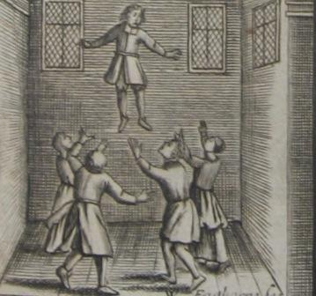

**Participation will be graded as follows:**

A-level Participation: Attends class consistently and always contributes actively and insightfully to the discussion. Comments are judicious and succinct. Student demonstrates engagement with the reading and the class discussion, and asks questions that advance the conversation.

B-level Participation: Attends consistently, and often contributes substantively to the discussion. Demonstrates a considerable effort to understand the material and advances the class discussion. Student asks good questions.

C-level Participation: Student participates infrequently, in ways that suggest a lack of preparation.

D-level Participation: Student is present but unengaged in the discussion. Contributions are very infrequent or unproductive. Does not advance the class discussion.

F-level Participation: Student is absent.

Complete your course readings well ahead of time, and keep notes on what you read. These will be important as you study for exams.

Students are required to bring the week’s readings to each class meeting. Some information from the exams will come from the readings and will not be repeated in lecture; keep this in mind as you study. More detailed instructions on the final paper will be given in class. Ask questions early and often! Start writing assignments early, and seek help from Professor Finucane or the Writing Center if you have any difficulties with the assignments. Let Dr. Finucane know in advance if you plan to come to office hours or if you are in need of an alternative meeting time.

Students are required to attend all class meetings, participate in discussion, and do all of the assigned readings for the week before the Wednesday class meeting. Students may miss up to 2 class meetings during the semester without penalty. Further absences will negatively affect the student’s participation grade.

Short papers are due at the beginning of class on the day listed on the syllabus. Along with the longer written assignments for this course, these will be submitted through Turnitin on the course Canvas site and filtered through anti-plagiarism software. For more on plagiarism and academic misconduct, see above.

Assignments and Grading

Assignments

The components of your grade, their relative weight, and a short description are listed below.

**Paper** (200 points possible): Students will each choose ONE of the following papers to complete:

***Trial of Temple Anneke* Paper**): Students will write a paper of a minimum of 1,200 words about the trial of Temple Anneke, based on primary source readings. *Due February 9th*

**Salem Witch Trials Paper*:*** Students will write a paper of a minimum of 1,200 words about the Salem witch trials, based on primary source readings. *Due March 16th*

**Midterm Exam** (250 points possible): This will be an identification-based exam, on which students will be asked to identify terms and explain their significance. *February 23rd*

**Final Exam** (250 points possible): This exam will include an identification-based section and an essay section. *April 27th*

**Short Papers** (200 points possible): Students will write a one-page (minimum 250 words) response to the assigned readings five times during the semester (40 points each). *Due weeks 2, 3, 11, 13, 15*

**Class Participation** (100 points possible): The participation grade includes both enthusiastic and prepared engagement in class discussion and a variety of in-class writing activities. More than three unexcused absences will negatively impact your participation grade.

Grading

This course will use the following grading system:

A (1000-940 points) A- (939-900 points)

B+ (899-870) B (869-830) B- (829-800)

C+ (799-770) C (769-730) C- (729-700)

D+ (699-670) D (669-630) D- (629-600)

F (599 and below)

#### Image Credits

Page 1: Francesco Maria Guazzo, *Compendium Maleficarum,* 1608

Page 2: Francesco Maria Guazzo, *Compendium Maleficarum,* 1626

Page 3: Sebastian Münster, *Cosmographia*, 1552

Page 5: Joseph Glanvill, *Saducismus Trimphatus*, 1681

**Course Schedule**

WEEK 1

Read: John Demos, *The Enemy Within*, 5-13

Richard Kieckhefer, *Magic in the Middle Ages,* 1-18

W January 10 Intro: What is Magic? What is Superstition?

F January 12 The Supernatural and the Ancient World

WEEK 2

Read: John Locke, *A Strange and Lamentable Accident . . .*\*

Richard Kieckhefer, *Magic in the Middle Ages,* 56-94

Write: **One-page response: “What is magic?” due 1/17**

W January 17 Magic and Superstition in the Middle Ages

F January 19 Monsters and Demons in the European Imagination

WEEK 3

Read: John Demos, *The Enemy Within*, 14-61

Begin reading *The Trial of Tempel Anneke*

Do: Witch Hunt Simulation*

Write: **One-page response on witch hunt simulation, due 1/26**

W January 24 Magic and Religion: The Reformation and the Inquisition

F January 26 Witch Hunting in Early Modern Europe

WEEK 4

Read: Finish reading *The Trial of Tempel Anneke*

W January 31 Case Studies: Germany and England

F February 2 Learned Magic: Alchemy and Astrology

WEEK 5

Read: *The Mowing Devil* *

The *Malleus Maleficarum,* excerpts*

Richard Kieckhefer, *Magic in the Middle Ages,* 151-175

Write: **Paper on the Trial of Tempel Anneke, due 2/9**

W February 7 Ghosts, Apparitions, and the Devil

F February 9 Magic, Superstition, and Print Culture

WEEK 6

Read: John Demos, *The Enemy Within*, 62-140

W February 14 Investigating Magic and Witchcraft

F February 16 The Supernatural and Popular Magic Across the Atlantic

WEEK 7

Read: Start reading Richard Godbeer, *The Salem Witch Trials*

Do: Study for Midterm Exam

W February 21 Miracles and Healing AND Exam Review

F February 23 **MIDTERM EXAM**

WEEK 8

Read: Finish Reading Richard Godbeer, *The Salem Witch Trials*

W February 28 North American Witch Trials

F March 2 Salem: Legal and Social Contexts and the End of the Witch Trials

**Week 9: SPRING BREAK**

WEEK 10

Read: Allison Coudert, *Religion, Magic, and Science*, 133-152*

Michael Hunter, “The Royal Society and the Decline of Magic,” *Notes and Records of the Royal Society* (2011): 1-17.*

Write: **Paper on the Salem Witch Trials, due 3/16**

W March 14 Investigating the Supernatural

F March 16 The Scientific Revolution

WEEK 11

Read: The Brothers Grimm, “Frau Trude”*

The Brothers Grimm, “Briar-Rose”*

Heidi Breuer, “Hags on Film: Contemporary Echoes of the Early Modern Wicked Witch”*

Watch: One movie or television show about magic or witchcraft.

Write: **One-page response on the show or movie you have watched** **due 3/23**

W March 21 Witchcraft and Magic in Literature I

F March 23 Witchcraft and Magic in Literature II

WEEK 12

Read: Médéric-Louis-Élie Moreau de Saint-Méry, Description of a Ritual Dance*

Carolyn Morrow Long, “Marie Laveau: A Nineteenth-Century Voudou Priestess” *Louisiana History: The Journal of the Louisiana Historical Association* 46:3 (Summer 2005): 262-292.*

Ruth Behar, “Sex and Sin, Witchcraft and the Devil in Late-Colonial Mexico” *American Ethnologist* 14:1 (February 1987): 34-54.*

W March 28 Magic in the Spanish Atlantic

F March 30 Magic in the French Atlantic

WEEK 13

Read: “What an Anglo-American has Recently Seen of Spiritualism in America,” *The Spiritual Magazine* (April 1871): 166-175.*

Roy Porter, “The Disenchantment of the World in the Nineteenth Century” in *Witchcraft and Magic in Europe: The Eighteenth and Nineteenth Centuries,* 255-273.*

Write: **One-page response on the description of a séance, due 4/6**

W April 4 Magic and Superstition in the Nineteenth Century

F April 6 Communicating with the Dead: Séances and Spiritualism

WEEK 14

Read: Helen A. Berger, “Witchcraft and Neopaganism” in *Witchcraft and Magic: Contemporary North America*, 28-54.*

Harry Houdini, *A Magician among the Spirits* (1924), 117-137.*

April 11 Skepticism and the Rejection of Magic

April 13 Magic and Superstition in the 20th Century

WEEK 15

Read: John Demos, *The Enemy Within,* 229-295

Write: **One-page response: “Why does belief in magic and the supernatural continue?” due 4/18**

April 18 Modern Witch Hunts

April 20 Exam Review

**FINAL EXAM FRIDAY, APRIL 27, 10:30am-1pm**