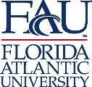

MEMORANDUM:
Office of Undergraduate Research and Inquiry Center for Teaching and Learning 777 Glades Road, GS 209 H
Boca Raton, FL 33431 Tel: 561.297.1019
www.fau.edu/qep

TO: Dr. Jerome Haky
Chair, University Undergraduate Programs Committee (UUPC) FROM: Dr. Donna Chamely-Wiik 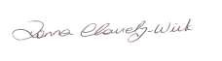
Chair, Undergraduate Research Curriculum Committee (URCC) DATE: October 23, 2018
RE: RI Designation for FIL 4672

As per the Undergraduate Research Curriculum Committee Manual, the proposal for Research Intensive designation of FIL 4672 RI: Hollywood, Censorship, and Regulation was discussed and approved on Tuesday, October 23, 2018, by the Undergraduate Research Curriculum Committee.

The committee asks the UUPC to consider this course and give its approval.

