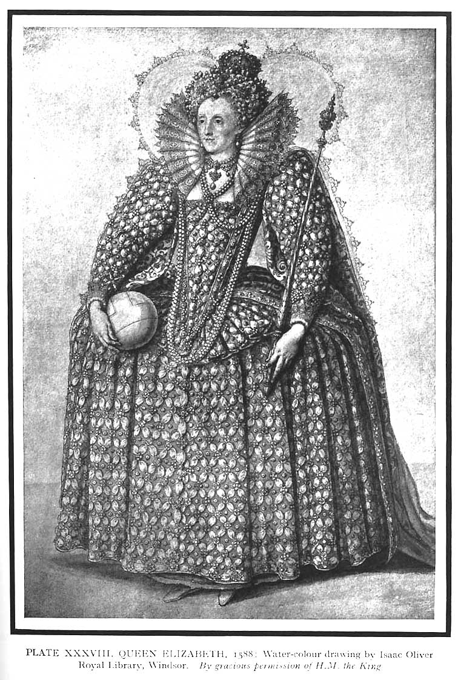

FLORIDA ATLANTIC UNIVERSITY
DEPARTMENT OF HISTORY
EUH 3619-15835: Women in European History- 3 credits
Boca Raton campus: WF 2-3:20 PM in AL 338
Fall 2018

Dr. Patricia Kollander
AL 153 Boca Raton Campus- 561-297-4156
E-mail: kollande@fau.edu (preferred contact)
Office Hours: TR 2-5PM; Fridays, 4-5pm and by appointment

Course Content:
This course will examine the social, political and economic roles played by women in Europe from the beginning of known civilization to the present. Course highlights include the development of patriarchal societies, the role of ideologies in shaping popular notions about women and the sexual division of labor, women's work, women's role in the family and community, forms of women's collective action and varieties of feminism, and the impact of war and the welfare state on women's lives.

This course counts not only towards completion of the major in history, but also towards completion of a Women’s Studies Undergraduate Certificate. The certificate requires five courses and once you have successfully finished this class with a grade of “C” or better, you will need only four additional classes. If you would like additional information about the certificate., you may contact the interim director of Women’s Studies, Dr. Barclay Barrios, at bbarrios@fau.edu

All of the following books must be purchased:
- Di Caprio, L., and Wiesner, M., Lives and Voices: Sources in European Women’s History. Houghton Mifflin, 2001. ISBN 0-395-97052
- French, K. and Polska, A., Women and Gender in the Western Past Vol. I: to 1815. Houghton Mifflin, ISBN-13: (978-0-618-24624-3)307 Pages Paper 2007
- French, K. and Polska, A., Women and Gender in the Western Past Vol. II: since 1500. Houghton Mifflin, ISBN-13: (978-0-618-24625-0) 413 Pages Paper 2007

Required website reading
http://www.womenintheancientworld.com

Blackboard: Syllabi, handouts and assignments will appear on Canvas. To access these materials, please log on to Canvas.fau.edu .
Please note: Class PowerPoint presentations will not appear on Canvas. Students are responsible for coming to each class and taking notes and doing all of the in-class document analyses. Students who miss class should get notes from another student.

Grading

Students’ grades in the course will be based on the following:
I. In-class written work 30 percent of the course grade
II. Document based essay 20 percent
III. Midterm exam 20 percent (identifications—review sheet will be provided)
V. Final examination 30 percent (identifications & essay—review sheet will
be provided)

Document-based paper—student will write essay based on 5-7 documents in the Lives and Voices reader. Topics will be handed out in due course.

In-class worksheets—students will fill out document analyses or film worksheets- this work cannot be made up in the event of an unexcused absence from class, hence regular attendance in class is crucial

Please note: Late work will NOT be accepted. Early or makeup exams will NOT be given

Plagiarism
There should be no need to remind students that plagiarism is "to take and pass off as one's own the ideas, writings, etc., etc., of another." [Source: Webster's New World Dictionary of the American Language, (Cleveland, 1964), p. 1164]

Students found guilty of plagiarism will receive a grade of 0 (zero percent) on the paper and will be subject to penalties outlined in the undergraduate catalog under the section of academic irregularity.

Grading scale
A 94-100 D 63-66
A- 90-93 D- 60-62
B+ 87-89 F 59 and below
B 83-86
B- 80-83
C+ 77-79
C 73-76
C- 70-72

Approaching the Professor: Please feel free to come and talk with me about any aspects of your experience in this course. I will be available after most lectures to talk and will always be found in my office during the hours listed above. If neither of these times are appropriate for you, please make an appointment with me. I will do my best to respond to all of your e-mail questions and will schedule extra office hours around exam times and paper deadlines

Classroom Etiquette:

- Students must use class time to engage course material and learn. This involves paying attention and taking thorough notes during lectures . It has been the experience of the instructor that laptops serve as a distraction to this crucial educational mission; overall student performance suffers if even a handful of students are surfing the net or checking cell phones instead of taking notes during class time.

For this reason, laptop computers are not permitted in the classroom, and use of cell phones is not permitted during lectures. If you intend to use class time for doing anything besides paying attention in class and taking notes, please refrain from attending lectures; your absence will not be held against you.

Please remember that exams count for 45% of the course grade, and are largely based on material presented during lectures. Students therefore need to attend lectures regularly, and take thorough notes (this involves more than writing down what appears on each PowerPoint slide; students are also responsible for information that supports each bullet point). Thorough note-taking will not only help you do well in the course, it will also help class time pass more quickly!

Exception to the no laptop rule, will be made only if I am provided with valid documentation.
2. Please do your very best to arrive to class on time.
3. If you are late for class, use the rear door of the classroom.
4. Do not leave early.
5. All students must adhere to appropriate classroom behavior at all times, which includes respect for the instructor and peers. Disruptive classroom behavior (this includes eating, talking, “texting” or any other kind of cell phone use) is distracting and unfair to other students who are in class to learn, as well as to the instructor, and will not be tolerated.

- Students wishing to talk, play electronic games or correspond with friends via computer or cell phone, must do this outside of the classroom.

Assistance for Students:
The Writing Center supports and promotes writing for all members of the FAU community -- undergraduate and graduate students, staff, faculty and visiting scholars. The center's consultants are informed and sensitive readers who help writers become more reflective readers and more self-sufficient crafters of their written work. Consultants help students at any point in the writing process (i.e., brainstorming, drafting, revision) and with papers for courses, senior or master theses, dissertations, job applications, applications for graduate school, articles for publication, grant proposals and other documents. We provide writing aid rather than an editing service. Consequently, consultants may not get to all of a paper's issues, but writers will come away with a fresh perspective on their work as well as documents in which one or more aspects are improved. For information and hours, and to schedule an appointment, go to http://www.fau.edu/ucew/

Students with disabilities: In compliance with the Americans with Disabilities Act (ADA), students who require special accommodation due to a disability to properly execute coursework must register with Student Accessibility Services (SAS) and follow all SAS procedures. SAS has offices across three of FAU’s campuses – Boca Raton, Davie and Jupiter – however disability services are available for students on all campuses. For further information, go to https://www.fau.edu/sas/
Counseling Services: Life as a university student can be challenging physically, mentally and emotionally. Students who find stress negatively affecting their ability to achieve academic or personal goals may wish to consider utilizing FAU’s Counseling and Psychological Services (CAPS) Center. CAPS provides FAU students a range of services -- individual counseling, support meetings, and psychiatric services, to name a few -- offered to help improve and maintain emotional well-being. CAPS is located on the second floor above the Breezeway food court of the Boca Raton campus. For more information, go to http://www.fau.edu/counseling or call 561-297-3540
Other policies
Attendance Policy: Students are expected to attend all of their scheduled University classes and to satisfy all academic objectives as outlined by the instructor. The effect of absences upon grades is determined by the instructor, and the University reserves the right to deal at any time with individual cases of non-attendance.
Students are responsible for arranging to make up work missed because of legitimate class absence, such as illness, family emergencies, military obligation, court-imposed legal obligations or participation in University-approved activities. Examples of University-approved reasons for absences include participating on an athletic or scholastic team, musical and theatrical performances and debate activities. It is the student’s responsibility to give the instructor notice prior to any anticipated absences and within a reasonable amount of time after an unanticipated absence, ordinarily by the next scheduled class meeting. Instructors must allow each student who is absent for a University-approved reason the opportunity to make up work missed without any reduction in the student’s final course grade as a direct result of such absence.

Late work and absences: Papers turned in late will be penalized. Students may not be penalized for absences due to participation in University-approved activities, including athletic or scholastics teams, musical and theatrical performances, and debate activities; students may make up missed work without any reduction in the student’s final course grade. Reasonable accommodation will be made for students participating in a religious observance.

Grades of Incomplete (“I”) are reserved for students who are passing a course but have not completed all the required work because of exceptional circumstances (documented illness, death or severe illness in the family, unexpected hospitalization, or severe family crisis).

Code of Academic Integrity policy Students at Florida Atlantic University are expected to maintain the highest ethical standards. Academic dishonesty is considered a serious breach of these ethical standards, because it interferes with the university mission to provide a high quality education in which no student enjoys an unfair advantage over any other. Academic dishonesty is also destructive of the university community, which is grounded in a system of mutual trust and places high value on personal integrity and individual responsibility. Harsh penalties are associated with academic dishonesty. For more information, see University Regulation 4.001.

Schedule of Classes and Assignments

August 22 & 24 Introduction; In the Beginning

Reading: French, K. and Polska, A., Women and Gender in the Western Past Vol. I: to 1815. Preface, Introduction and pages 1-6; Di Caprio, L., and Wiesner, M., Lives and Voices: Sources in European Women’s History, Introduction, and Gerda Lerner interview https://www.youtube.com/watch?v=R_PJwMpAgtQ

August 29 & 31 The First Civilizations

Ancient Greece
Reading: French and Polska, Women and Gender, chapters 1 and 2; Di Caprio, Lives and Voices, chapters 1 & 2

September 5 & 7 Ancient Rome, Christianity and the Early Middle Ages
Reading: French and Polska, Women and Gender, chapters 3-4; Di Caprio, Lives and Voices, ch 3

September 12 & 14 Learned Women of the Middle Ages
Reading: French and Polska, Women and Gender, chapter 5; Di Caprio, Lives and Voices, chapter 4

September 19 & 21 Women and the Church
Reading: French and Polska, Women and Gender, chapter 5

September 26 & 28 Great Women in the Middle Ages
Reading: Di Caprio, chapter 6

October 3 & 5 Women during the Renaissance and the Reformation
Reading: French and Polska, chapter 7, Di Caprio, chapters 6-7

Friday, October 5--Midterm exam

October 10 & 12 The Enlightenment and the French Revolution
Reading: French and Polska, Women and Gender, chapter 8; Di Caprio, Lives and Voices, chapter 8

October 17 & 19 Women during the Victorian Era
Reading: French and Polska, Women and Gender, chapters 9-10; Di Caprio, Lives and Voices, chapter 9

October 24 & 26 The First Feminist Wave/Women and World War I
Reading: French and Polska, Women and Gender, chapter 11; Di Caprio, Lives and Voices, chapter 10

October 31 & Nov 2 Women in the Russian Revolution
Reading: French and Polska, Women and Gender, chapter 12; Di Caprio, Lives and Voices, chapters 11-12

November 7 & 9 The Interwar Period and Virginia Woolf
Reading: French and Polska, Women and Gender, chapter 13 and Virginia Woolf, “A Room of One’s Own”: https://victorianpersistence.files.wordpress.com/2013/03/a-room-of-ones-own-virginia-woolf-1929.pdf

November 14 & 16 Women in the World War II era
Reading: French and Polska, Women and Gender, chapter 14; Di Caprio, Lives and Voices, chapter 13.

November 16--Document based essay due

November 21 The Second Feminist Wave
Reading: French and Polska, chapter 15, Di Caprio, Lives and Voices, chapter 14
Friday, November 23- Thanksgiving holiday—no class

November 28 & 30 Contemporary Issues and Concerns
Reading: Reading: French and Polska, Women and Gender, chapter 16

Final Exam –Wednesday, Dec 12 from 1:15 - 3:45pm

Attention, Students: Put Your Laptops Away
NPR STAFF
JAMES DOUBEK

Laptops are common in lecture halls worldwide. Students hear a lecture at the Johann Wolfang Goethe-University on Oct. 13, 2014, in Frankfurt am Main, Germany.
Thomas Lohnes/Getty Images
As laptops become smaller and more ubiquitous, and with the advent of tablets, the idea of taking notes by hand just seems old-fashioned to many students today. Typing your notes is faster — which comes in handy when there's a lot of information to take down. But it turns out there are still advantages to doing things the old-fashioned way.
For one thing, research shows that laptops and tablets have a tendency to be distracting — it's so easy to click over to Facebook in that dull lecture. And a study has shown that the fact that you have to be slower when you take notes by hand is what makes it more useful in the long run.
In the study published in Psychological Science, Pam A. Mueller of Princeton University and Daniel M. Oppenheimer of the University of California, Los Angeles sought to test how note-taking by hand or by computer affects learning.

"When people type their notes, they have this tendency to try to take verbatim notes and write down as much of the lecture as they can," Mueller tells NPR's Rachel Martin. "The students who were taking longhand notes in our studies were forced to be more selective — because you can't write as fast as you can type. And that extra processing of the material that they were doing benefited them."
Mueller and Oppenheimer cited that note-taking can be categorized two ways: generative and non-generative. Generative note-taking pertains to "summarizing, paraphrasing, concept mapping," while non-generative note-taking involves copying something verbatim.
And there are two hypotheses to why note-taking is beneficial in the first place. The first idea is called the encoding hypothesis, which says that when a person is taking notes, "the processing that occurs" will improve "learning and retention." The second, called the external-storage hypothesis, is that you learn by being able to look back at your notes, or even the notes of other people.
Because people can type faster than they write, using a laptop will make people more likely to try to transcribe everything they're hearing. So on the one hand, Mueller and Oppenheimer were faced with the question of whether the benefits of being able to look at your more complete, transcribed notes on a laptop outweigh the drawbacks of not processing that information. On the other hand, when writing longhand, you process the information better but have less to look back at.

For their first study, they took university students (the standard guinea pig of psychology) and showed them TED talks about various topics. Afterward, they found that the students who used laptops typed significantly more words than those who took notes by hand. When testing how well the students remembered information, the researchers found a key point of divergence in the type of question. For questions that asked students to simply remember facts, like dates, both groups did equally well. But for "conceptual-application" questions, such as, "How do Japan and Sweden differ in their approaches to equality within their societies?" the laptop users did "significantly worse."
The same thing happened in the second study, even when they specifically told students using laptops to try to avoid writing things down verbatim. "Even when we told people they shouldn't be taking these verbatim notes, they were not able to overcome that instinct," Mueller says. The more words the students copied verbatim, the worse they performed on recall tests.
And to test the external-storage hypothesis, for the third study they gave students the opportunity to review their notes in between the lecture and test. The thinking is, if students have time to study their notes from their laptops, the fact that they typed more extensive notes than their longhand-writing peers could possibly help them perform better.
But the students taking notes by hand still performed better. "This is suggestive evidence that longhand notes may have superior external storage as well as superior encoding functions," Mueller and Oppenheimer write.
Do studies like these mean wise college students will start migrating back to notebooks?
"I think it is a hard sell to get people to go back to pen and paper," Mueller says. "But they are developing lots of technologies now like Livescribe and various stylus and tablet technologies that are getting better and better. And I think that will be sort of an easier sell to college students and people of that generation."

Checking phones in lectures can cost students half a grade in exams
Source: EurekAlert.com
Students perform less well in end-of-term exams if they are allowed access to an electronic device, such as a phone or tablet, for non-academic purposes in lectures, a new study in Educational Psychology finds.
Students who don't use such devices themselves but attend lectures where their use is permitted also do worse, suggesting that phone/tablet use damages the group learning environment.
Researchers from Rutgers University in the US performed an in-class experiment to test whether dividing attention between electronic devices and the lecturer during the class affected students' performance in within-lecture tests and an end-of-term exam.
118 cognitive psychology students at Rutgers University participated in the experiment during one term of their course. Laptops, phones and tablets were banned in half of the lectures and permitted in the other half. When devices were allowed, students were asked to record whether they had used them for non-academic purposes during the lecture.
The study found that having a device didn't lower students' scores in comprehension tests within lectures, but it did lower scores in the end-of-term exam by at least 5%, or half a grade. This finding shows for the first time that the main effect of divided attention in the classroom is on long-term retention, with fewer targets of a study task later remembered.
In addition, when the use of electronic devices was allowed in class, performance was also poorer for students who did not use devices as well as for those who did.
The study's lead author, Professor Arnold Glass, added: "These findings should alert the many dedicated students and instructors that dividing attention is having an insidious effect that is impairing their exam performance and final grade.
"To help manage the use of devices in the classroom, teachers should explain to students the damaging effect of distractions on retention - not only for themselves, but for the whole class."
This is the first-ever study in an actual classroom showing a causal relationship between distraction from an electronic device and subsequent exam performance.
###
Disclaimer: AAAS and EurekAlert! are not responsible for the accuracy of news releases posted to EurekAlert! by contributing institutions or for the use of any information through the EurekAlert system.

Mystic and scholar Hildegarde of Bingen, British Celtic Queen Boadicea, Elizabeth I, Queen Christina, Emmeline Pankhurst, Alexandra Kollontai, Simone de Beauvoir, Angela Merkel, Kalinda Grabar -Kitarovic, president of Croatia
Please refer to the articles “Attention, Students: Put Your Laptops Away” and “Checking Cell Phones in Lectures Can Cost Students Half a Grade On Exams” at the end of the syllabus.

