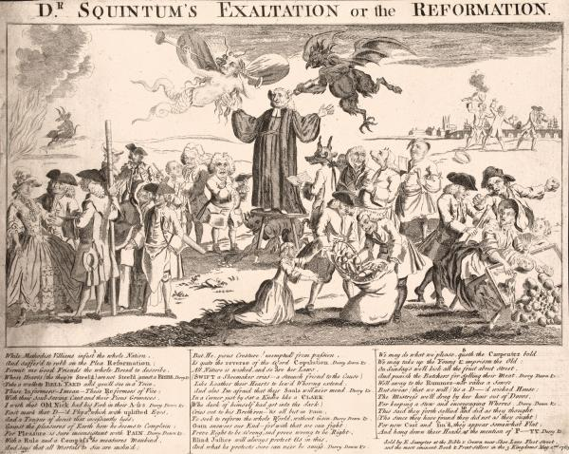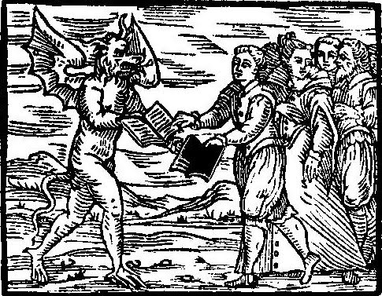

### Department of History, Florida Atlantic University

### Course Description and Learning Objectives

This course is a history of American religious thought from the colonial period to the present. We will focus on the issues of religious diversity and religious liberty as they have been understood from earliest European settlement to today.

In this course, students will read both scholarly works and original sources. We will consider the place of religion in American life and address the following questions: As America grows and changes, how has it allowed for religious liberty or limited it? How has religion shaped decisions about what American society will look like? How does religion influence ideas of American morality? Who is counted as an American? How have people used religion to identify themselves with or against society?

# Dr. Adrian Finucane

**Contact Information**

Office Hours: Tuesdays, 2-5pm

AL 160

[afinucane@fau.edu](mailto:afinucane@fau.edu)

561-297-3951

**Class Meetings**

Tuesdays and Thursdays

9:30-10:50am

GS 102

3 Credit Hours

AMH 4620-15663

Religion in America

Fall 2018

Students are required to purchase one book for this course. It is available at the FAU bookstore and can be acquired through online vendors:

Jon Butler, *New World Faiths: Religion in Colonial America* (Oxford University Press, 2008) ISBN: 978-0-19-533310-7

Additional readings will be available through the course Canvas website.

Students are required to do all of the assigned readings for the week before our Tuesday meeting, and to complete the listed assignments. Students are required to bring the readings listed for the week to class meetings, whether in print or electronically. Students are discouraged from using their phones for class readings.

## Course Policies

Readings

Academic misconduct, including plagiarism, will be penalized. Class discussion and debate is highly encouraged, but interactions with others must remain respectful.

**Academic Integrity:** Students at Florida Atlantic University are expected to maintain the highest ethical standards. Academic dishonesty is considered a serious breach of these ethical standards, because it interferes with the University mission to provide a high quality education in which no student enjoys an unfair advantage over any other. Academic dishonesty is also destructive of the University community, which is grounded in a system of mutual trust and places high value on personal integrity and individual responsibility. Harsh penalties are associated with academic dishonesty. For more information, see University Regulation 4.001.

Students are expected to produce original and individual work on all assignments. Students are expected to understand that the definition of plagiarism includes:

1. Copying large or smalls sections of a written text without appropriate quotations and citation
2. Paraphrasing written material without citing the source
3. Citing a source other than that from which you obtained your evidence
4. Altering or contriving evidence

Plagiarizing, intentionally or unintentionally, may result in the failure of individual assignments and/or the course as a whole.

Students must complete exams on their own, without referring to any notes or other students during the exam.

Students are required to turn off cell phones and other devices that vibrate or make noise during class meetings. The use of laptops during meetings is permitted but restricted to class-related activity.

At the discretion of the instructor, there may be changes to this syllabus over the course of the semester. Students must check their FAU email regularly for notice of changes.

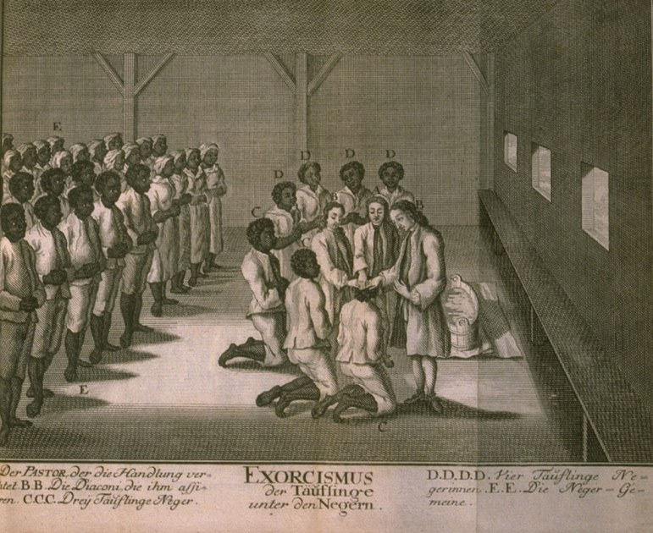

The **FAU Center for Excellence in Writing** has a number of resources designed to help you with your writing, including appointments to address individual assignments both in person and online. Students are encouraged to take advantage of the writing center, which can be accessed at [www.fau.edu/ucew](http://www.fau.edu/ucew).

**Attendance Policy Statement:** Students are expected to attend all of their scheduled University classes and to satisfy all academic objectives as outlined by the instructor. The effect of absences upon grades is determined by the instructor, and the University reserves the right to deal at any time with individual cases of non-attendance.  Students are responsible for arranging to make up work missed because of legitimate class absence, such as illness, family emergencies, military obligation, court-imposed legal obligations or participation in University- approved activities. Examples of University-approved reasons for absences include participating on an athletic or scholastic team, musical and theatrical performances and debate activities. It is the student’s responsibility to give the instructor notice prior to any anticipated absences and within a reasonable amount of time after an unanticipated absence, ordinarily by the next scheduled class meeting. Instructors must allow each student who is absent for a University-approved reason the opportunity to make up work missed without any reduction in the student’s final course grade as a direct result of such absence.

Students are encouraged to **take advantage of office hours** in order to ask questions about assignments, seek clarifications, and discuss further any class material they do not fully understand. Email will be answered on weekdays.

Papers turned in **late** without prior extension will result in the loss of 10% of the paper grade per day late, including weekend days.

**Accommodations for Students with Disabilities:** In compliance with the Americans with Disabilities Act Amendments Act (ADAAA), students who require reasonable accommodations due to a disability to properly execute coursework must register with Student Accessibility Services (SAS) and follow all SAS procedures. SAS has offices across three of FAU’s campuses – Boca Raton, Davie and Jupiter – however disability services are available for students on all campuses. For more information, please visit the SAS website at www.fau.edu/sas/.

**Counseling and Psychological Services (CAPS) Center**: Life as a university student can be challenging physically, mentally and emotionally. Students who find stress negatively affecting their ability to achieve academic or personal goals may wish to consider utilizing FAU’s Counseling and Psychological Services (CAPS) Center. CAPS provides FAU students a range of services – individual counseling, support meetings, and psychiatric services, to name a few – offered to help improve and maintain emotional well-being. For more information, go to http://www.fau.edu/counseling/

## Course Policies, continued

Complete your course readings well ahead of time, and keep notes on what you read. These will be important as you study for exams.

Students are required to bring the week’s readings to each class meeting. Some information from the exams will come from the readings and will not be repeated in lecture; keep this in mind as you study. More detailed instructions on the final paper will be given in class.

Ask questions early and often! Start writing assignments early, and seek help from Professor Finucane or the Writing Center if you have any difficulties with the assignments. Let Dr. Finucane know in advance if you plan to come to office hours or if you are in need of an alternative meeting time.

Students are required to attend all class meetings, participate in discussion, and do all of the assigned readings for the week before the Tuesday class meeting. Students may miss up to 2 class meetings during the semester without penalty. Further absences will negatively affect the student’s participation grade.

Short papers are due at the beginning of class on the Tuesday of the relevant week through Canvas. The longer written assignments for this course will be submitted through Turnitin on the course Canvas site and filtered through anti-plagiarism software. For more on plagiarism and academic misconduct, see above.

Assignments and Grading

**Statement Regarding Out-of-Class Work Expectations:** Florida Atlantic University defines a credit hour as requiring one hour of classroom instruction each week, and a minimum of two hours of work outside of class. As this is a three-credit course, students are expected to dedicate a minimum of six hours outside of class to class work each week, in accordance with university policies. This includes completing the reading required for each week, reviewing your notes from previous lectures, working on writing assignments, and studying for exams. If you have any questions about these requirements, contact Dr. Finucane at [afinucane@fau.edu](mailto:afinucane@fau.edu).

**Participation will be graded as follows:**

A-level Participation: Attends class consistently and always contributes actively and insightfully to the discussion. Comments are judicious and succinct. Student demonstrates engagement with the reading and the class discussion, and asks questions that advance the conversation.

B-level Participation: Attends consistently, and often contributes substantively to the discussion. Demonstrates a considerable effort to understand the material and advances the class discussion. Student asks good questions.

C-level Participation: Student participates infrequently, in ways that suggest a lack of preparation.

D-level Participation: Student is present but unengaged in the discussion. Contributions are very infrequent or unproductive. Does not advance the class discussion.

F-level Participation: Student is absent.

Assignments

The components of your grade, their relative weight, and a short description are listed below. All papers are due at 9:30am on their due date through Canvas.

**Reading Response** (20 points each, 160 total points possible): Students will write a short paper of 250 words responding to the prompt on the syllabus, due at 9:30 am on the relevant Tuesday.  *Due weeks 2, 3, 4, 5, 7, 8, 9, 13*

**Midterm Exam** (200 points possible): This will be an identification-based exam, on which students will be asked to identify terms and explain their significance. *September 27th*

**Paper Proposal** (20 points possible): Students will submit a one-page paper proposal, including a short paragraph describing the proposed topic, identifying a scholarly book on the topic, and identifying two primary sources to be used in the paper. *Due October 23rd*

**Final Paper Draft and Peer Review** (100 points possible): Students will complete a full draft of their final paper, and engage in peer review and revision with their classmates.  *Due November 8th*

**Final Paper** (150 points possible): Students will write a 7-8 page final paper that addresses an aspect of the course topic that most interests them. The research for this will include reading at least one academic book on the chosen topic from outside the syllabus, identified in consultation with and with the approval of the professor. Students will also identify and incorporate at least two primary sources into their paper. More information will be provided in class. *Due November 27th*

**Final Paper Presentation** (20 points possible): Students will give a brief presentation on their research for the final paper to the class. *November 27th*

**Final Exam** (250 points possible): This exam will include an identification-based section and an essay section. *December 6th, 7:45-10:30am*

**Class Participation** (100 points possible): The participation grade includes both enthusiastic and prepared engagement in class discussion and a variety of in-class writing activities.

Grading

This course will use the following grading system:

A (1000-940 points) A- (939-900 points)

B+ (899-870) B (869-830) B- (829-800)

C+ (799-770) C (769-730) C- (729-700)

D+ (699-670) D (669-630) D- (629-600) F (<599)

**Course Schedule**

WEEK 1

Read: 3D box Jon Butler, *New World Faiths*, 47-70

T August 21 Introduction and Anglicanism

Th August 23 Puritanism and Religious Toleration

WEEK 2

Read: 3D box Jon Butler, *New World Faiths*, 71-109

3D box Jane Landers, *Black Society in Spanish Florida*, 107-135*

Write: 3D box **Reading response:** Choose two groups described in the reading, and explain how their religious beliefs and practices were different. How did each group end up in America? Why did their religions develop in these ways?

T August 28 Religious Diversity in British North America

Th August 30 Religion Among Enslaved Populations

WEEK 3

Read: 3D box Mary Rowlandson, *The Sovereignty and Goodness of God*, excerpts*

3D box “A Brief Account of a Strange and Unusual Providence of God Befallen to Elizabeth Knapp of Groton, 1672”*

Write: 3D box **Reading response:** In the Rowlandson and Knapp readings, who is claiming or exercising religious authority? What form does that authority take? In what ways is it challenged?

T September 4 Religion and Native American Policy

Th September 6 Magic and Alternate Claims to Authority

WEEK 4

Read: 3D box Jonathan Edwards, “Sinners in the Hands of an Angry God,” 1741*

3D box Letter from Benjamin Franklin to Joseph Huey, 6 June 1753*

3D box James Madison, “A Memorial and Remonstrance against Religious Assessments,” 1785*

3D box Thomas Jefferson, “An Act for Establishing Religious Freedom, passed in the Assembly of Virginia, 1786” in *Notes on the State of Virginia* (Philadelphia: R. T. Rawle, 1801)*

Write: 3D box **Reading response:** What were the major issues at question in debates over religion in the mid-18th century? Which of these authors were at conflict over how the government and religion should relate to each other, and why?

T September 11 The Great Awakening

Th September 13 Religion and the Road to Revolution

WEEK 5

Read: 3D box Butler, *New World Faiths*, 21-46 and 132-151

3D box Alexis de Tocqueville, *Democracy in America*, excerpts*

3D box Letter from George Washington to the Hebrew Congregation in Newport, RI 18 August 1790*

Write: **Reading response:** How did religion change after the American Revolution? What were the hopes of religious minority groups, and how were they realized or not realized?

T September 18 Religious Freedom and Conflict in the New Nation

Th September 20 American Religions Outside the 13 Colonies

WEEK 6

Do: 3D box Study for Midterm Exam

T September 25 Midterm Exam Review

Th September 27 **MIDTERM EXAM**

WEEK 7

Read: 3D box *An Appeal to the Wives, Mothers, and Daughters of Our Land*, 1836*

3D box Ralph Waldo Emerson, “The Over-Soul,” in *Essays: First Series* (Philadelphia; David McKay, 1989), excerpts*

Write: 3D box **Reading response:** In the pamphlet, what are women being encouraged to do? What is the relationship between morality and religion for the author?

T October 2 Visit to the Weiner Collection, FAU Library

Th October 4 The Second Great Awakening: Strategies for Reform

WEEK 8

Read: 3D box Stephen Eliot Smith, “Barbarians within the Gates: Congressional Debates on Mormon Polygamy, 1850-1879” *Journal of Church and State* 51:4 (Autumn 2009): 587-616.*

3D box Josiah Priest, *Bible Defence of Slavery* (1853), excerpts*

3D box Angelina Grimke, *Appeal to the Christian Women of the South* (1840), excerpts*

Write: 3D box **Reading response:** How did slavery influence both political and religious debates in the mid-nineteenth century?

T October 9 New Religions in America and Limits to Religious Liberty

Th October 11 Religion, North and South: Rejecting and Defending Slavery

WEEK 9

Read: 3D box Mark S. Massa, *Catholics and American Culture: Fulton Sheen, Dorothy Day, and the Notre Dame Football Team*, excerpt*

3D box C. Stanley Lowell, *Embattled Wall*, excerpt*

Write: 3D box **Reading response:** Given the similarities they shared with Protestants, what were the objections to Catholics holding political power in the mid-20th century?

T October 16 Spiritualism and Technology

Th October 18 Anti-Catholicism in America

WEEK 10

Read: 3D box Malcolm X, *The Autobiography of Malcolm X*, Ch. 13 and 14*

3D box Rani-Henrik Andersson, *The Lakota Ghost Dance of 1890*, p. 1-29*

Watch: 3D box Sioux Ghost Dance, Library of Congress*

Write: 3D box **Paper Proposal due Tuesday, October 23rd**

T October 23 The Limits of Toleration: The Ghost Dance

Th October 25 Malcolm X and Black Muslims

WEEK 11

Read: 3D box Work on reading the outside book you have selected for your final paper

3D box Langdon Gilkey, *Creationism on Trial: Evolution and God at Little Rock*, 1985*

T October 30 Religion and Science

Th November 1 The Scopes Trial

WEEK 12

Read: 3D box Wallace vs. Jaffree, 1985*

3D box Lawrence J. McAndrews, “‘Moral’ Victories: Ronald Reagan and the Debate over School Prayer” *Religion and Education* 30:1 (Spring 2003): 92-107.*

Write: 3D box **Full paper draft due Thursday, November 8th**

T November 6 The Supreme Court and Prayer in Schools

Th November 8 Workshop Papers in Small Groups

WEEK 13

Read: 3D box Starhawk, *The Spiral Dance*, excerpts*

3D box J. Stillson Judah, *Hare Krishna and the Counter Culture*, excerpts*

3D box Jerry Falwell, *Listen America*, excerpts*

3D box Nancy Ammerman, “Fundamentalism and Politics”*

Write: 3D box **Reading response:** Why did Americans have an increased interest in both new religious movements and conservative religious movements in the second half of the 20th century? What were the appeals of counter-culture and fundamentalism?

T November 13 The Rise of the Christian Right

Th November 15 Religion as Resistance

WEEK 14

Read: 3D box Pew Research Center, “America’s Changing Religious Landscape,” 2015*

T November 20 The Present and Future of Religion in America

Th November 22 **THANKSGIVING BREAK**

WEEK 15

Write: 3D box **Final papers due Tuesday, November 27th**

Do: 3D box Prepare Your Presentation

3D box Study for Final Exam

T November 27 **Presentations on Papers**

Th November 29 Final Exam Review

**FINAL EXAM Thursday, December 6th, 7:45-10:15am**