AML 3266: Florida Writers
Spring 2019
M 7:10-10:00
CU321
3 credits
Dr. Ulin
Office: CU 349
Office Phone: 561-297-3830
Office Hours: M 6-7, T 7-10
Email: julin@fau.edu

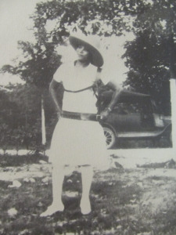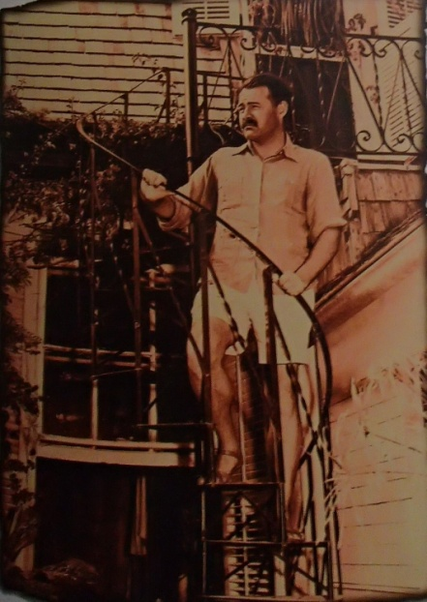

Course Description/Objectives:

This course will offer an in-depth examination of two of the writers most closely associated with Florida: Zora Neale Hurston and Ernest Hemingway. We will read a number of works by each author alongside criticism focused on their relationship with Florida. In addition, a series of assignments will introduce students to the resources of FAU’s Special Collections, specifically the Bessie DuBois Floridiana Collection.

Catalog Description:

Florida Writers (AML 3266) An exploration of authors associated with and/or writing about Florida, such as John Audubon, William Bartram, Harry Crews, Marjorie Douglas, Ernest Hemingway, Zora Neale Hurston, James Weldon Johnson, Marjorie Rawlings, and Wallace Stevens. Topics and approaches will vary and the course may draw upon FAU’s Bessie DuBois Floridiana Collection.

Course Texts:

Hemingway, A Farewell to Arms (1929)
Hemingway, To Have and Have Not (1937)
Hemingway, The Short Stories (1938)
Hemingway, The Old Man and the Sea (1951)
Hurston, Mules and Men (1935)
Hurston, Their Eyes Were Watching God (1937)
Hurston, Dust Tracks on a Road (1942)
Hurston, Seraph on the Suwanee (1948)

Critical Texts:

Curnutt and Sinclair, Key West Hemingway: A Reassessment (e-book available via FAU library)
Glassman and Seidel, Zora in Florida (e-book available via FAU library)

Figure 1 Hemingway House, Whitehead Street Key West
Course Grade:

Attendance and Participation: 10%
Students are expected to attend all of their scheduled University classes and to satisfy all academic objectives as outlined by the instructor. The effect of absences upon grades is determined by the instructor, and the University reserves the right to deal at any time with individual cases of non-attendance. Students are responsible for arranging to make up work missed because of legitimate class absence, such as illness, family emergencies, military obligation, court-imposed legal obligations or participation in University approved activities. Examples of University-approved reasons for absences include participating on an athletic or scholastic team, musical and theatrical performances and debate activities. It is the student’s responsibility to give the instructor notice prior to any anticipated absences and within a reasonable amount of time after an unanticipated absence, ordinarily by the next scheduled class meeting. Instructors must allow each student who is absent for a University-approved reason the opportunity to make up work missed 3 without any reduction in the student’s final course grade as a direct result of such absence. Please note that 4 missed classes will result in automatic failure of the course regardless of other grades. Arriving late will result in ½ credit for the class.
Hemingway Exam: 20%
Hemingway Paper 20%
Hurston Exam 20%
Hurston Paper 20% (Hurston Proposal, Hurston Annotated Bibliography and Paper)
Final Exam or Project based on FAU Special Collections: 10% (Abstract, bio and presentation)

Grade Scale

Florida Atlantic University follows a plus/minus (+/-) grading system. Numeric values for this course are as follow:

A | A- | B+ | B | B- | C+ | C | C- | D | F
93-100 | 90-92 | 87-89 | 83-86 | 80-82 | 77-79 | 73-76 | 70-72 | 60-69 | 0-59

Schedule of Readings:

Jan 5 – Introduction. Hemingway’s “After the Storm.”
Jan 12 – From Key West Hemingway: A Reassessment. Hemingway in the Keys. Farewell to Arms through Chapter 27.
Jan 19 – No class, MLK Day.
Jan 26 - Farewell to Arms (Chapter 27-end), Selections from The Short Stories (“The Snows of Kilimanjaro,” “The Short Happy Life of Francis Maycomber,” “The Undefeated” through “After the Storm”)
Feb 2 – To Have and Have Not.
Feb 9 – From Key West Hemingway: A Reassessment. (Revisionary Readings of To Have and Have Not). From The Short Stories (“A Clean, Well-Lighted Place” and “The Light of the World.”)
Feb 16 – The Old Man and the Sea. From Key West Hemingway: A Reassessment. (Destination Hemingway)
Feb 23 – Hemingway Exam. Paper proposal due in class.
Feb 27 – Last day to W
March 1: Hemingway paper due
March 2-8 = Spring Break, March 2 no class
March 9 – Dust Tracks on a Road. Introduction and Chapter 14 in Zora in Florida).
March 16 – Mules and Men (Chapters 5 and 6 in Zora in Florida)
March 23 – Mules and Men, Their Eyes Were Watching God (Chapter 2 in Zora in Florida)
March 30 – Their Eyes Were Watching God
April 6 – Seraph on the Suwanee (Chapter 1 of Zora in Florida). Upload Annotated Bibliography by 11:59 pm via Canvas.
April 13 – Seraph on the Suwanee. Abstract for Conference Presentation due via Canvas by 11:59 pm.
April 20 – Hurston Exam. Paper proposal due in class.
April 21-22: Reading Days
April 25: Hurston Paper Due by 11:59 pm via Canvas.
April 23-29 = Finals
April 27: Final Exam (Conference-style presentation of 5-7 minutes based on FAU Special Collections)

Disability policy statement In compliance with the Americans with Disabilities Act Amendments Act (ADAAA), students who require reasonable accommodations due to a disability to properly execute coursework must register with Student Accessibility Services (SAS) and follow all SAS procedures. SAS has offices across three of FAU’s campuses – Boca Raton, Davie and Jupiter – however disability services are available for students on all campuses. For more information, please visit the SAS website at www.fau.edu/sas/
Counseling and Psychological Services (CAPS) Center Life as a university student can be challenging physically, mentally and emotionally. Students who find stress negatively affecting their ability to achieve academic or personal goals may wish to consider utilizing FAU’s Counseling and Psychological Services (CAPS) Center. CAPS provides FAU students a range of services – individual counseling, support meetings, and psychiatric services, to name a few – offered to help improve and maintain emotional well-being. For more information, go to http://www.fau,edu/counseling/
Code of Academic Integrity policy statement Students at Florida Atlantic University are expected to maintain the highest ethical standards. Academic dishonesty is considered a serious breach of these ethical standards, because it interferes with the university mission to provide a high quality education in which no student enjoys an unfair advantage over any other. Academic dishonesty is also destructive of the university community, which is grounded in a system of mutual trust and places high value on personal integrity and individual responsibility. Harsh penalties are associated with academic dishonesty. For more information, see University Regulation 4.001. http://www.fau.edu/regulations/chapter4/Reg_4.001_5-26-10_FINAL.pdf
Recording Policy: Video, audio or photographic recordings of class are prohibited.

Course Etiquette Policy: In order to enhance and maintain a productive atmosphere for education, personal communication devices, such as cell phones and wireless internet, are to be disabled in class sessions.
Note: I do not respond to email correspondence that does not conform to proper email etiquette (i.e. salutation, signature and proper tone). Only emails that originate from your FAU email address will be acknowledged.

Figure 2 Hemingway Writing Studio, Hemingway House Key West

