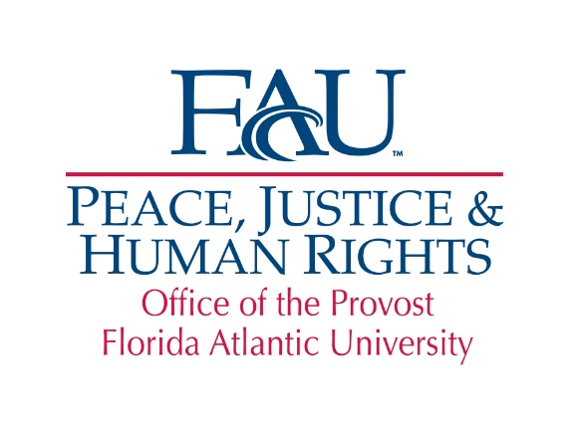

**The Peace, Justice and Human Rights (PJHR)**

**International Students Scholarship**

The Peace, Justice and Human Rights (PJHR) International StudentsScholarship is offered by the Peace, Justice and Human Rights Initiative to currently enrolled international students actively engaged in issues related to peace, social justice and human rights who plan to apply their academic knowledge to improving human rights, peace and social justice in their home country. The Scholarship provides a $1,000 stipend to be used by students to assist them in their academic studies. This Scholarship is generously funded by the Lynn, Wold, Schmidt PJHR Endowment.

**Eligibility**: Applicants must be either a full-time international undergraduate or graduate student holding either a F1 or J1 visa with a minimum 3.0 GPA undergraduate or 3.5 GPA graduate.

**Requirements**: Students are required to complete an application, including a 1,000-word essay detailing how they plan to apply their academic knowledge to improving human rights, peace and social justice in their home country; submit an unofficial copy of their transcript and their resume. Students awarded the Scholarship are expected to contribute to the programming of the Center for Global Engagement (*e.g.*, International Education Week, Festival of Nations or the International Friends Program). In addition, students awarded this Scholarship are required to write an acknowledgement letter thanking the donors.

**Application Process**: The completed application and supporting documentation must be submitted via email to pjhr@fau.edu by **March 30, 2018** in order to be considered. Applicants will be notified of the decision of the PJHR International Scholarship Committee by April 27, 2018.

**Name:** _____________________________________________________________ **Z#**:___________________________

Last First M.I.

**Address:** _____________________________________________________________________________________________

Street Address City State Zip

**Telephone:** ( ) _________________________ **Email:** _______________________________________________

**Country of citizenship:** _______________________________ **Grade Point Average:** __________________

**Major:** _____________________________________________________________________________________________

**Undergraduate:**  freshman  sophomore  junior  senior

**Graduate:**  Masters  Ph.D. **Anticipated Graduation Month/Year:**____________

# In 1,000 words or less, briefly explain how you plan to apply your academic degree to improve

# peace, social justice and human rights within your home country:

**I authorize the release of this application and any relevant supporting information to persons involved in the selection of scholarship recipients. I understand that if I am selected, I am required to write a thank you letter to the donor**. **If awarded a scholarship, I give permission to FAU to use my name, photo and general biographical information for publicity and marketing purposes.**

# Applicant’s Signature Date