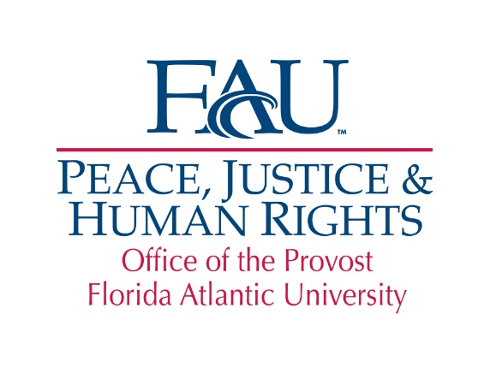

**The Peace, Justice and Human Rights (PJHR)**

**Education Abroad Scholarship**

The Peace, Justice and Human Rights (PJHR) Education Abroad Scholarship is offered by the Peace, Justice and Human Rights Initiative to currently enrolled FAU students that plan to use the education abroad experience to further their interests and work in peace, social justice and human rights. The Scholarship provides a $1,000 stipend to be used by students to assist in the costs of their education abroad program. This Scholarship is generously funded by the Lynn, Wold, Schmidt PJHR Endowment.

**Eligibility**: Applicants must be either a full-time undergraduate or graduate student with a minimum 3.0 GPA undergraduate or 3.5 GPA graduate and have registered for a [FAU faculty-led study abroad program](http://www.fau.edu/goabroad/Faculty-Led_Programs.php).

**Requirements**: Students are required to complete an application, including a 1,000-word essay detailing how they plan to use their education abroad experience to further their interests in peace, social justice and human rights; submit an unofficial copy of their transcript; provide proof of their registration for a [FAU faculty-led study abroad program](http://www.fau.edu/goabroad/Faculty-Led_Programs.php) and their resume. Students awarded this Scholarship are required to write an acknowledgement letter thanking the donors.

**Application Process**: The completed application and supporting documentation must be submitted via email to pjhr@fau.edu by **March 30, 2018** in order to be considered. Preference will be given to FAU-led education abroad programs administrated by a PJHR affiliate faculty member. Applicants will be notified of the decision of the PJHR International Scholarship Committee by April 27, 2018.

**Name:** _____________________________________________________________ **Z#**:___________________________

Last First M.I.

**Address:** _____________________________________________________________________________________________

Street Address City State Zip

**Telephone:** ( ) _________________________ **Email:** _______________________________________________

**Country of citizenship:** _______________________________ **Grade Point Average:** __________________

**Major:** _____________________________________________________________________________________________

**FAU-Led Education Abroad Program:**___________________________________________________________

**Undergraduate:**  freshman  sophomore  junior  senior

**Graduate:**  Masters  Ph.D. **Anticipated Graduation Month/Year**_____________

# In 1,000 words or less, briefly explain how your education abroad experience will further your interests and work in peace, social justice and human rights:

**I authorize the release of this application and any relevant supporting information to persons involved in the selection of scholarship recipients. I understand that if I am selected, I am required to write a thank you letter to the donor**. **If awarded a scholarship, I give permission to FAU to use my name, photo and general biographical information for publicity and marketing purposes.**

# Applicant’s Signature Date