Dear URCC Members,

The following RI, DIR, and RI Fast track courses were approved by the University committees and by the State:

1. **Courses Approved by the State on 9/25/2020**

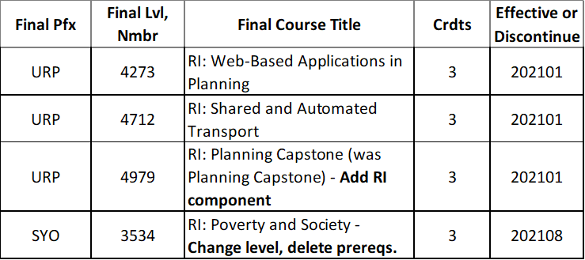

1. **Courses approved by UUPC on 10/12/2020**

* 3 ENG RI fast Track courses:

EML 4521C RI: Engineering Design

EOC 4804 RI: Ocean Engineering System Control Design

EOC 4804L RI: Ocean Engineering System Control Design Lab.

* 1 EDU DIR course: DIR 4916 DIR Ind Res Ed Leadership and Research Methodology

1. **Upcoming RI Fast Track Courses**
   1. SCI will submit to UUPC 11/9/2020 meeting - PCB 4832C RI: Neurophysiology for RI fast Track

**Note:** Since the above course go directly to UUPC for approval, this month’s URCC meeting is **cancelled.**