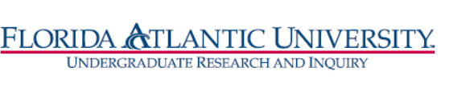

**Florida Atlantic University**

**Undergraduate Research Curriculum Committee**

Thursday, January 14, 2021

WebEx meeting from 12:15 to 1:30 pm

1. **RI Certificate**

Members: Dan Meeroff, Nancey France, Tricia Meredith, DCW

Chair: T. Meredith

1. RI certificate – [Research Certificate Catalog Language Draft](https://docs.google.com/document/d/1K29DTdICk6vTF95RArFX3U81zFu7Q2gIm40F4fOfZTg/edit?usp=sharing)
2. URCC guidelines for preliminary evaluation of Certificate
3. Skill building course - updates
4. **RI Fast Track**

a. Fast Track efforts to date: 15 courses submitted, 9 of them from ENG&CS



Three courses from ENG&CS are pending approval by the State.

b. Discussion for extending RI Fast Track

c. Courses submitted to UUPC for RI Fast Track:

