B.A. Learning at FAU Department of FAU
COLLEGE OF LEARNING AT FAU

Please use this as a TEMPLATE for creating SLOA PLEASE Keep the Fonts as it is in the same color & size Please just modified the content changing the B.A. Learning at FAU to the Degree name in the HEADING adding in your College.
Please print the final SLOA WORD.Doc to as PDF for which is ready to be loaded to the IEA web site as a PDF. IEA will only post the SLOA as a PDF.

ALL DEGREES of like names should be in ONE PDF with BA_BS_MA_MS_PHD and Please follow this naming convention so we keep the IEA web site clean. Thanks so much and all the final SLOA PDF can be e-mail to mgoodlin@fau.edu

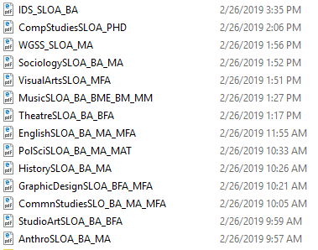

CONTENT KNOWLEDGE (Declarative Knowledge): Students will demonstrate knowledge of the major concepts
Assessment of students will be based on demonstration of satisfactory

COMMUNICATION (Written Communication): Students will demonstrate the ability to communicate
Assessment of students will be based on demonstration of satisfactory

CONTENT KNOWLEDGE (Declarative Knowledge): Students demonstrate knowledge of the major vocabulary, concepts, theories, and arguments associated with a research question or topic.
Assessment of students will be based on demonstration of satisfactory

CONTENT KNOWLEDGE (Research Skills): Students will demonstrate the ability to apply basic data collection strategies and methodologies to
Assessment of students will be based on demonstration of satisfactory

CRITICAL THINKING (Analytical Skills): Students will demonstrate the ability to conduct library or field‐based research on an anthropological topic that demonstrates critical, analytical (qualitative and/or quantitative), or technical skills.
Assessment of students will be based on demonstration of satisfactory

