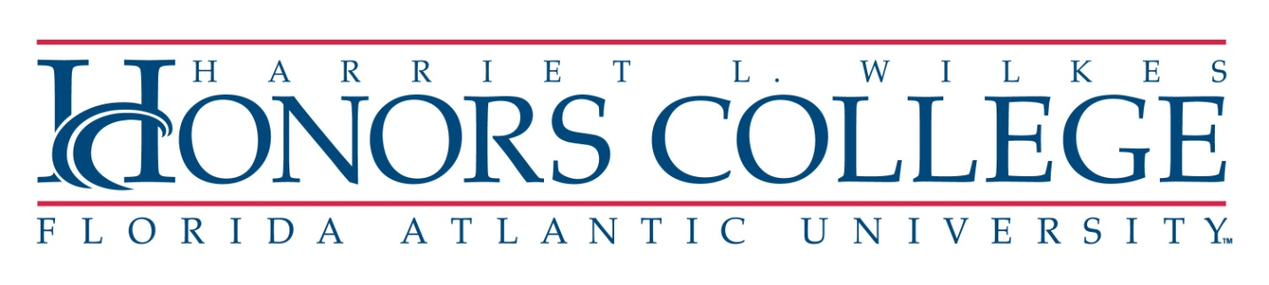Fred and Kit Bigony ‘Pay it Forward’ Scholarship Application Form

Name:
Z Number:
Email:
Phone:
Year (sophomore, junior, senior) [note that freshman are not eligible for this scholarship]:
Concentration:
Cumulative G.P.A. at FAU:
--------------------------------------------------------------------------------------------------------------------------------------
Were I to be offered a Bigony ‘Pay it Forward’ scholarship, I would agree to undertake a moral obligation to pay back this scholarship to the Wilkes Honors College when I have the means to do so:
Signature: ________________________________________
------------------------------------------------------------------------------------------------------------------------------------------
I have a current FAFSA form on file [note that only students with a current FAFSA form on file that indicates financial need are eligible for this scholarship]:
Circle one: Yes | No

Continued on next page
In no more than 150 words, answer the following question: What does “Paying it Forward” mean to you?

