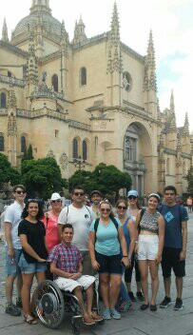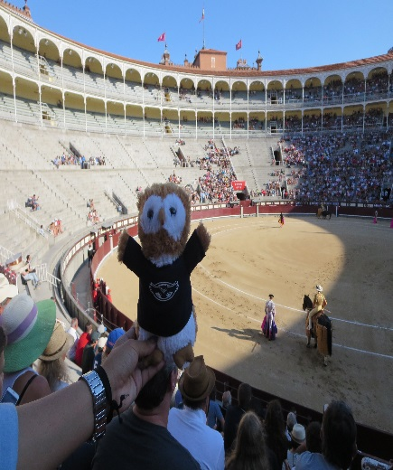

SUMMER ABROAD PROGRAM
UNIVERSIDAD COMPLUTENSE DE MADRID (SPAIN)
SUMMER 2019
Come learn about this exciting opportunity to study in Madrid with other FAU students this summer and earn academic credit!

INFO SESSION (Jupiter campus)
Tuesday, November 13 (2:30 p.m.– 4:00 p.m.) in SR 272
(Info session with Prof. Carmen Cañete Quesada, SAP faculty leader)

ADVISING MEETING (Jupiter campus)
Wednesday, November 14 (9:00 a.m.– 4:00 p.m.) in HC 112
(Meeting with Ms. Madison McShane, Education Abroad Advisor)
For an appointment with Ms. McShane, please log in to your Success Network powered by Starfish Solutions. Visit www.fau.edu/goabroad for more information.

More detailed program information can be found at, http://www.fau.edu/honors/current-students/study-abroad/study-abroad-program/
Contact Prof. Carmen Cañete Quesada (ccaneteq@fau.edu)
or Ms. Madison McShane (mmcshane@fau.edu) for any question

