Landscape vs. Landscaping: Evidence of Hand

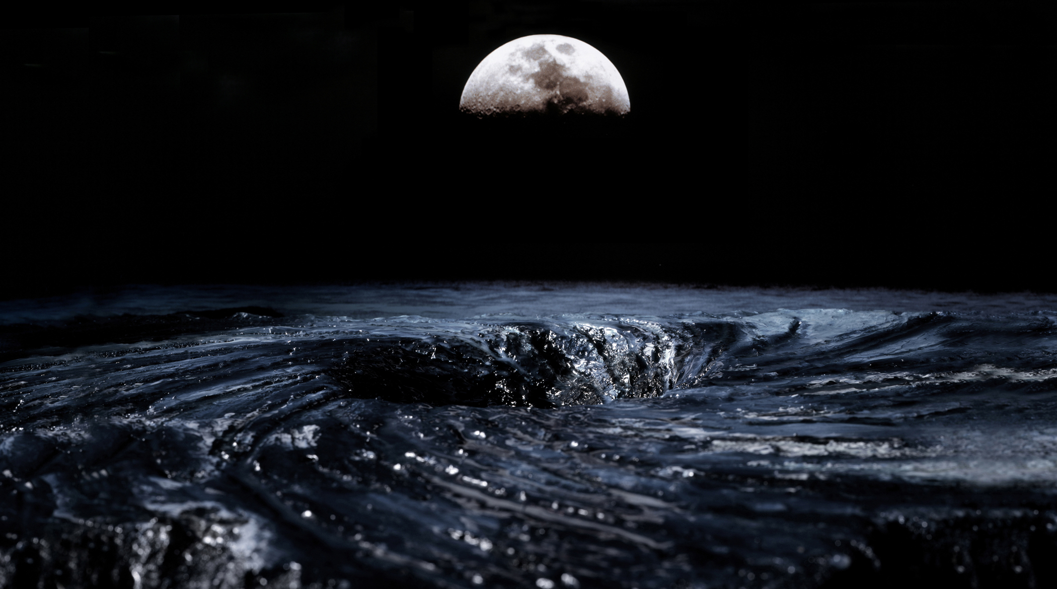
First attributed to Dutch artists in the 16th century, landscapes quickly joined portraiture, historical, and religious painting as the major genres of painting. Fast-forward to the 19th century invention and widespread use of photography, which changed the way we think about art, by essentially replacing a need for painters as documenters. The word "photography" comes from the Greek words for "light" and "paintbrush”, together meaning "drawing with light."
Samantha Salzinger. Bermuda Triangle, 2008. Ink Jet Print, 40x71 in

Broward resident and PBCC Art Department chair and photography professor Samantha Salzinger uses both art mediums of photography and painting, digitally through Photoshop and editing software, to create her large-scale photographic landscapes, based on the themes of catastrophes, utopia, or science fiction.

Samantha Salzinger’s photographs appear to be true-to-life (“real”) landscapes, but are in fact hybrids of her own hand-made dioramas, photographed and digitally altered. A diorama is a scene, often miniature, reproduced three dimensionally by placing objects and materials in front of a painted or printed background, like a theatre stage set. Salzinger painstakingly creates her dioramas, sometimes taking up to three months to create, out of everyday objects/art making materials, and before destroying them documents their existence using a traditional/old-fashioned 4”x5” view camera. The dioramas are then backed and blended by digital photo-shopping to create what appears to be a “real” image of nature.

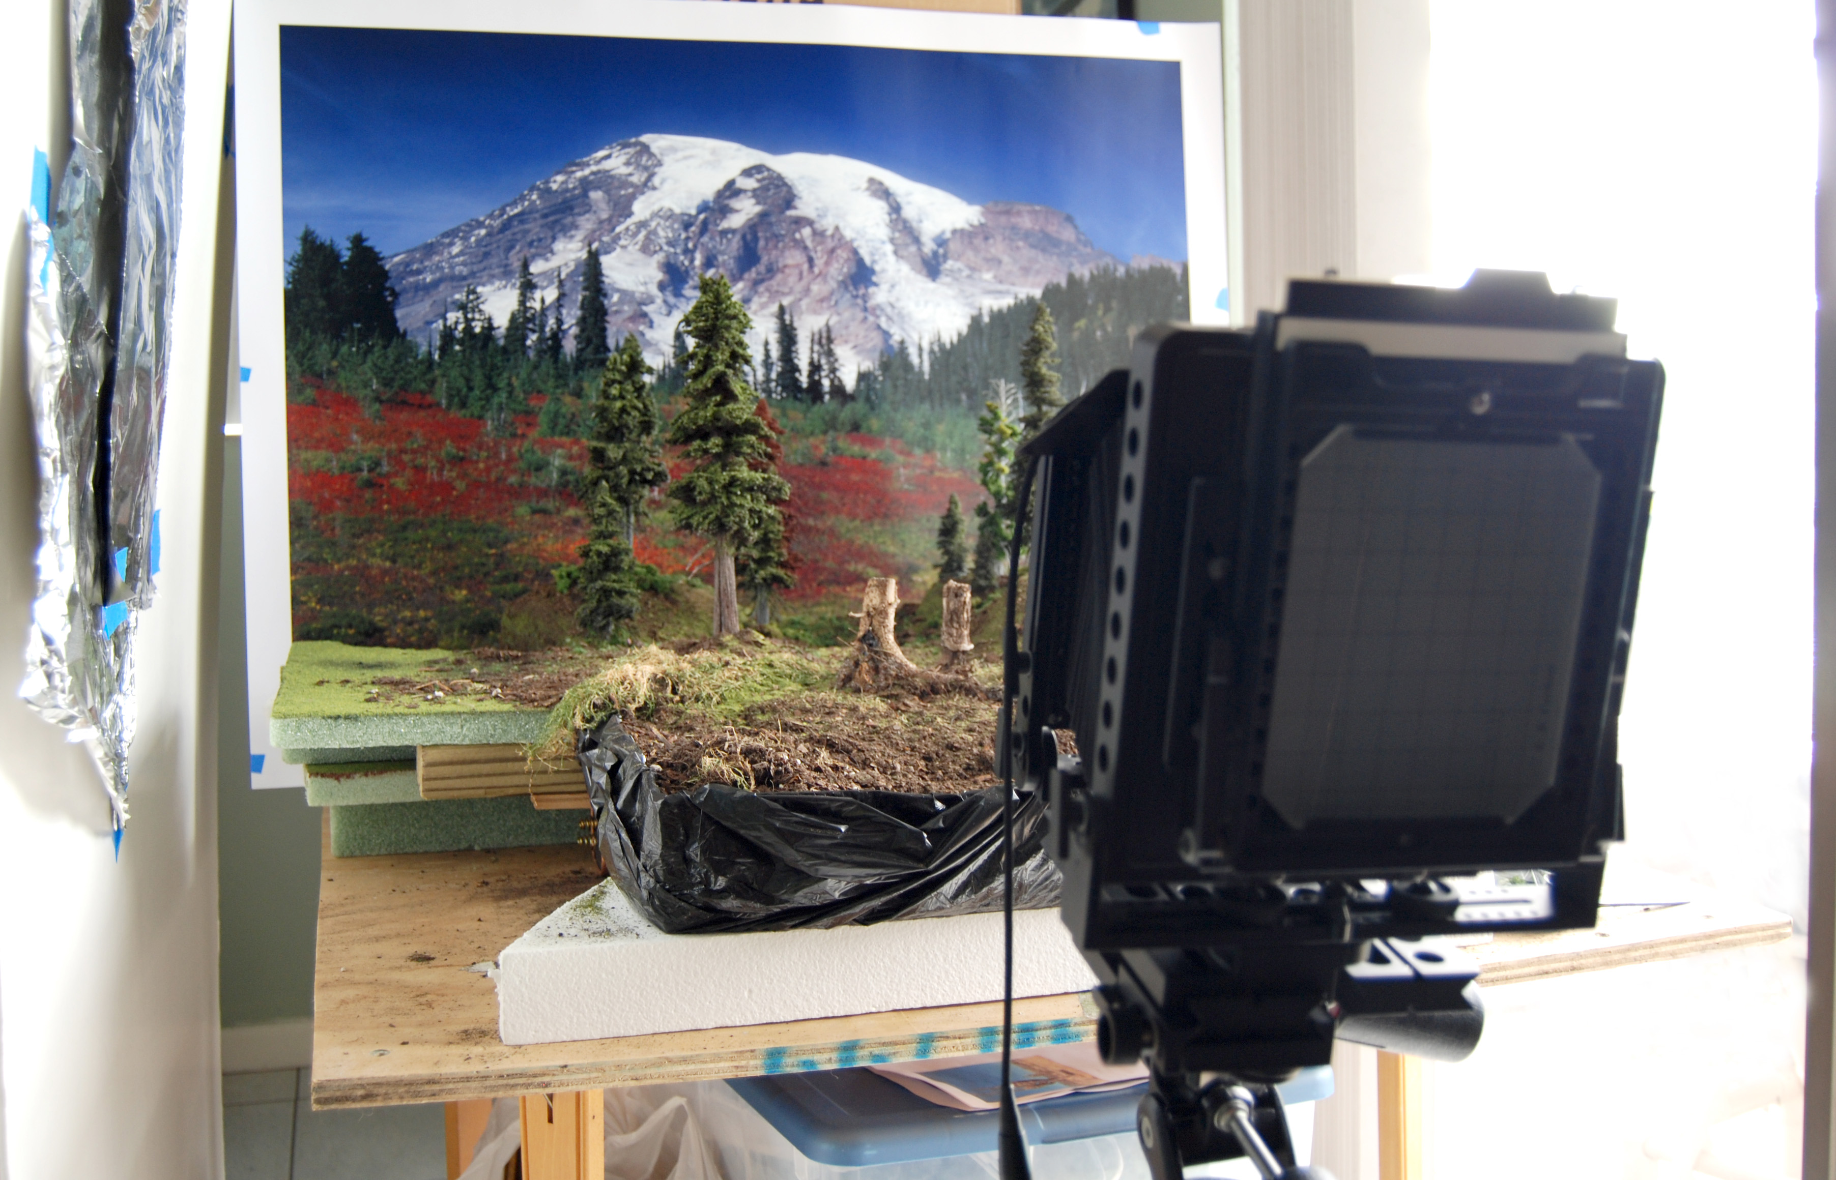
Critical Thinking

- The idea for Salzinger’s hybrid painting/diorama/photographs was inspired after visiting Disney World and related theme parks. Why do you think this is so? View the artist’s virtual gallery at samanthasalzinger.com and discuss how and why her work is dis/similar.
- Salzinger has referred to her photographs as being “painterly” or like paintings, with the addition of photo-manipulation software, and handmade diorama, many would agree. Do you agree? How is this photograph like a painting? How is it not?
- After she is satisfied with the outcome of her photographs, Salzinger destroys the original diorama sets she has painstakingly created (on her dining room table, see above image), leaving only the original photograph(s) and digital/manipulated scans. How does this affect collectors, dealers, and the notion of exclusivity/or limited edition of an art piece? Does it?
- Salzinger’s work is a combination of low-tech and hi-tech art. How do these qualifiers relate to the notion of fine art as seen today? How is digital media/manipulation affecting the nature of high art?

Landscape vs. landscaping Activity: Creating a Selfscape

Salzinger investigates the human desire to control and predict nature. The images romanticize nature as being untouched and uncontrollable. The irony behind her works is that what you see is entirely synthetic and created by human hands. Many things in the world that we as humans are unable to predict, control or explain, just as many of Salzinger’s images, are imagined renderings of unreal/fantastical occurrences. One example of an unsolved mystery is the Bermuda Triangle (pictured on opposite side), a triangular area in the Atlantic Ocean formed by three major points: Miami, Florida, San Juan, Puerto Rico, and the island of Bermuda. This area is infamous for the disappearance of over 2,000 ships and airplanes and has become a fabled legend, though its existence is debatable, as it cannot be backed by evidentiary support.

- Salzinger’s work is a combination of low-tech and hi-tech art. How does the combination of the two affect the viewer’s interpretation of the artwork. Discuss.
- What other unsolved mysteries can you think of? Have they been captured by artists? If yes, locate a copy of the artwork, research the phenomena: how would you ‘document’ this phenomenon differently or the same? Was the artist effective in the media and method used to translate this unseen occurrence? If the unsolved mystery has not been documented, follow the same steps and create your own ‘reflection’ or ‘false memory’ of this fantastic event.
Detail of Mout. Rainier, 2007, Ink jet print, 50x40 inches

Art Activity: Artificial Landscape: Self-scape, tablescape, seascape, cityscape

- Look at traditional landscape paintings, such as the Hudson River Valley painters, or the Highwaymen, and compare/contrast with the photographic work of Samantha Salzinger. (artchive.com may be a good resource) How are they similar, dissimilar? Could Salzinger be considered a painter? How has photography and more recently digital photography and manipulation changed the way in which traditional ‘fine arts’ (painting, sculpture) are viewed?
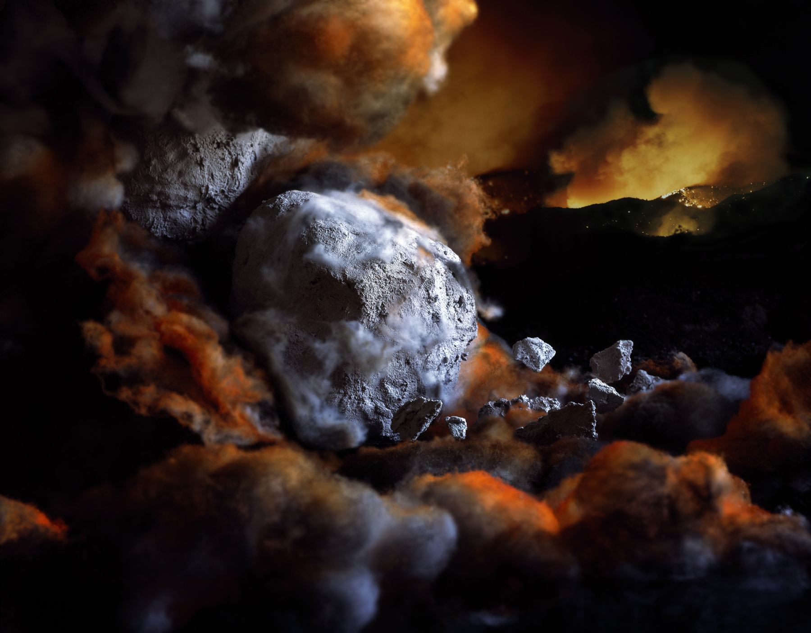
- Discuss the technical aspects of landscape painting such as perspective, space manipulation, lighting, movement, and color to create a mood, evoke an emotion, or capture a moment in time. Relate capturing a landscape to solving a problem, or capturing a moment in time, or illustrating the unlikely.
- Have students choose a theme or aesthetic problem to address in their illustration: an extreme climate; a scary place; fantasy; isolation; industrial; view from another world. Or, alternatively, try shifting the perspective of a traditional landscape: for instance, how does the classroom look differently from the level of a fly on the ceiling versus a lizard on the ground?
- Emphasize the artistic process as one of problem-solving, in steps. Begin with a sketch of the landscape and a statement of purpose. Continue with drafts and critiques.
- Have students create their landscape or selfscape.
Samantha Salzinger. Leonids Meteor, 2008. Ink jet print, 40x50 inches.
- Once finished, separate into groups by genre of subject, media utilized, or simply randomly.
- Compare and contrast the different ‘scapes’, utilizing vocabulary from the elements of art and relating them in context to the artist that created them.

Sunshine State Standards: VA.A.1.34, VA.B.1.34, VA.C.1.34, VA.D.1.34, VA.E.1.34

