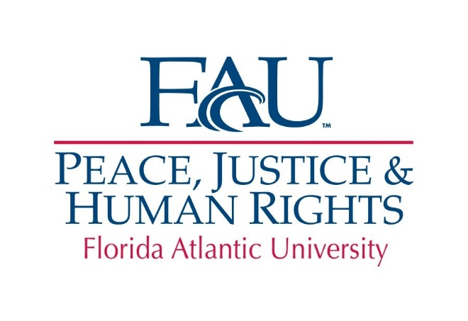
Conference Travel/Professional Development Grants

The Peace, Justice and Human Rights (PJHR) Initiative Conference Travel/Professional Development Grants are intended to promote the research and creative endeavors of faculty as well as professional development of staff within the themes of the Initiative. The purpose of these grants is to assist faculty in conference presentations which lead to publication/public exhibit of work and external funding as well as to assist staff in conference presentations and/or professional development which contributes to their ability to support the Initiative’s themes. Conference travel grants will be provided only to those presenting a paper/poster. Presentations must occur after the deadline for proposals. Applicants will be funded up to $1,000.

A complete grant application packet must be submitted as one document which includes the (1) application form, (2) narrative, (3) budget, (4) curriculum vita and a copy of a letter, email or page from the conference program indicating that the applicant’s participation. The narrative must not exceed one single-sided page (12-point type in Times New Roman with margins not smaller than one inch). This limitation does not include the application form, budget and vita.

Eligibility: Faculty must have status as a PJHR Affiliate in order to apply. Individuals who have received PJHR grants in the past should make sure a final report for that award is on file. Members of PJHR Research Committee may not apply, and those that received funding in the previous round in the same category may also not apply. Preference will be given to faculty at the pre-tenure stage.

Delivery of Proposals: An electronic copy of the proposal as a single document (Word or PDF) should be sent to pjhr@fau.edu and must be received by 15 January 2020. Please write “Conference Travel/Professional Development Grant” in the subject line. Proposals which are received after the deadline will not be reviewed.

Previous Grant Reports: Individuals who have received PJHR grants in the past should make sure a final report for that award is on file.

Review Criteria: Proposals will be reviewed by the PJHR Research Committee and submitted to the Executive Director for final approval.

Required Reporting: Awardees will be required to file a report detailing the results of the grant. Not completing this requirement will disqualify the individual for consideration for future funding.

Fund Disbursement: Funds will be available to awardees eight to ten weeks following notification of their award. Funds will be made as a reimbursement for conference travel.

1. APPLICATION FORM:

NAME:

PHONE AND EMAIL:

TITLE AND RANK:

PRE-TENURE (YES or NO):

DEPARTMENT/UNIT:

NAME OF THE CONFERENCE:

LOCATION OF THE CONFERENCE:

DATES OF THE CONFERENCE:

TITLE OF CONFERENCE PAPER (if applicable):

2. NARRATIVE (1 Page Maximum):

- Question 1: Describe how participation in this conference will develop or strengthen your professional goals. Examples include, but are not limited to: (1) The importance of this conference within your discipline and/or profession. (2) The importance of the panel or poster to your future research and/or professional development. (3) Following your conference participation, how will you disseminate the results of your paper or poster? List names of the journals or volumes to which you might submit the results.

3. BUDGET: Separately list costs for attendance. Please indicate whether there is any department/unit support and the amount.

This grant may be used for:

- Travel to the conference location.
- Lodging and per diem under Florida regulations.
- Registration

4. CURRIULUM VITA: Please attach a current vita which may not exceed five (5) single-sided pages.

