How to Do Things with William James | Proposal: MLA Roundtable | D.C. 2022
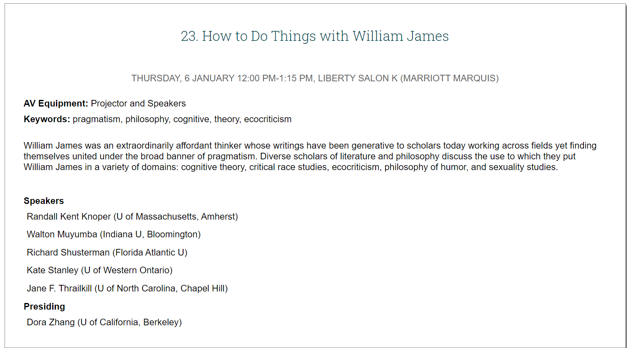

This roundtable pivots on the figure of William James, whose life began before the Civil War and who lived just long enough to welcome a young Sigmund Freud to his first and only lectures in the United States, in 1909. Across his career, James famously shifted among callings (artist, physician, scientist, philosopher, psychologist), resisting the disciplinary formations of the newly established research university even as he served as a longtime professor at Harvard. Roundtable discussants approach James as an extraordinarily affordant thinker, whose writings have been generative to scholars today working across fields yet finding themselves united under the broad banner of pragmatism.
The title of the roundtable invokes one of James’s most well known formulations—the core pragmatist precept, that truth happens to an idea—and also the work of J. L. Austin, whose account of language in How to Do Things with Words emphasized how illocutionary speech acts do not merely describe but in fact do things. The succinct coinage don't ask for the meaning, ask for the use (attributed to Ludvig Wittgenstein) will animate our roundtable discussion, in which diverse scholars of literature and philosophy talk about the use to which they put William James in a variety of domains: specifically, cognitive theory, critical race studies, ecocriticism, philosophy of humor, and sexuality studies.
*
Richard Shusterman, thinking under the banner of ars erotica, shifts away from the utilitarian register and instead takes up the question, “How to Make Love with William James”? In his remarks, Prof. Shusterman will explore the insights, tensions, and problematic complexities in James’s treatment of sexuality and physical affection by examining not only his published work on psychology but also his personal letters. He will attend to James on the topics of instinct and habit, discerning a “something more” nestled in James’s correspondence with beloved friends and family.
*
When we think in terms of affordances, things in the environment become invitations to do something—implicit, material calls to (inter)act. William James, this roundtable will demonstrate, serves as a reminder for both scholars and citizens that, embedded in the world of ideas and things, are potentialities which we can spin off into improvisations of our own.

