Activity: Expressive Storytelling
Grades K-12
Sunshine State Standards
see page 2 & 3 see bottom of page Sunshine State Standards see bottom of page

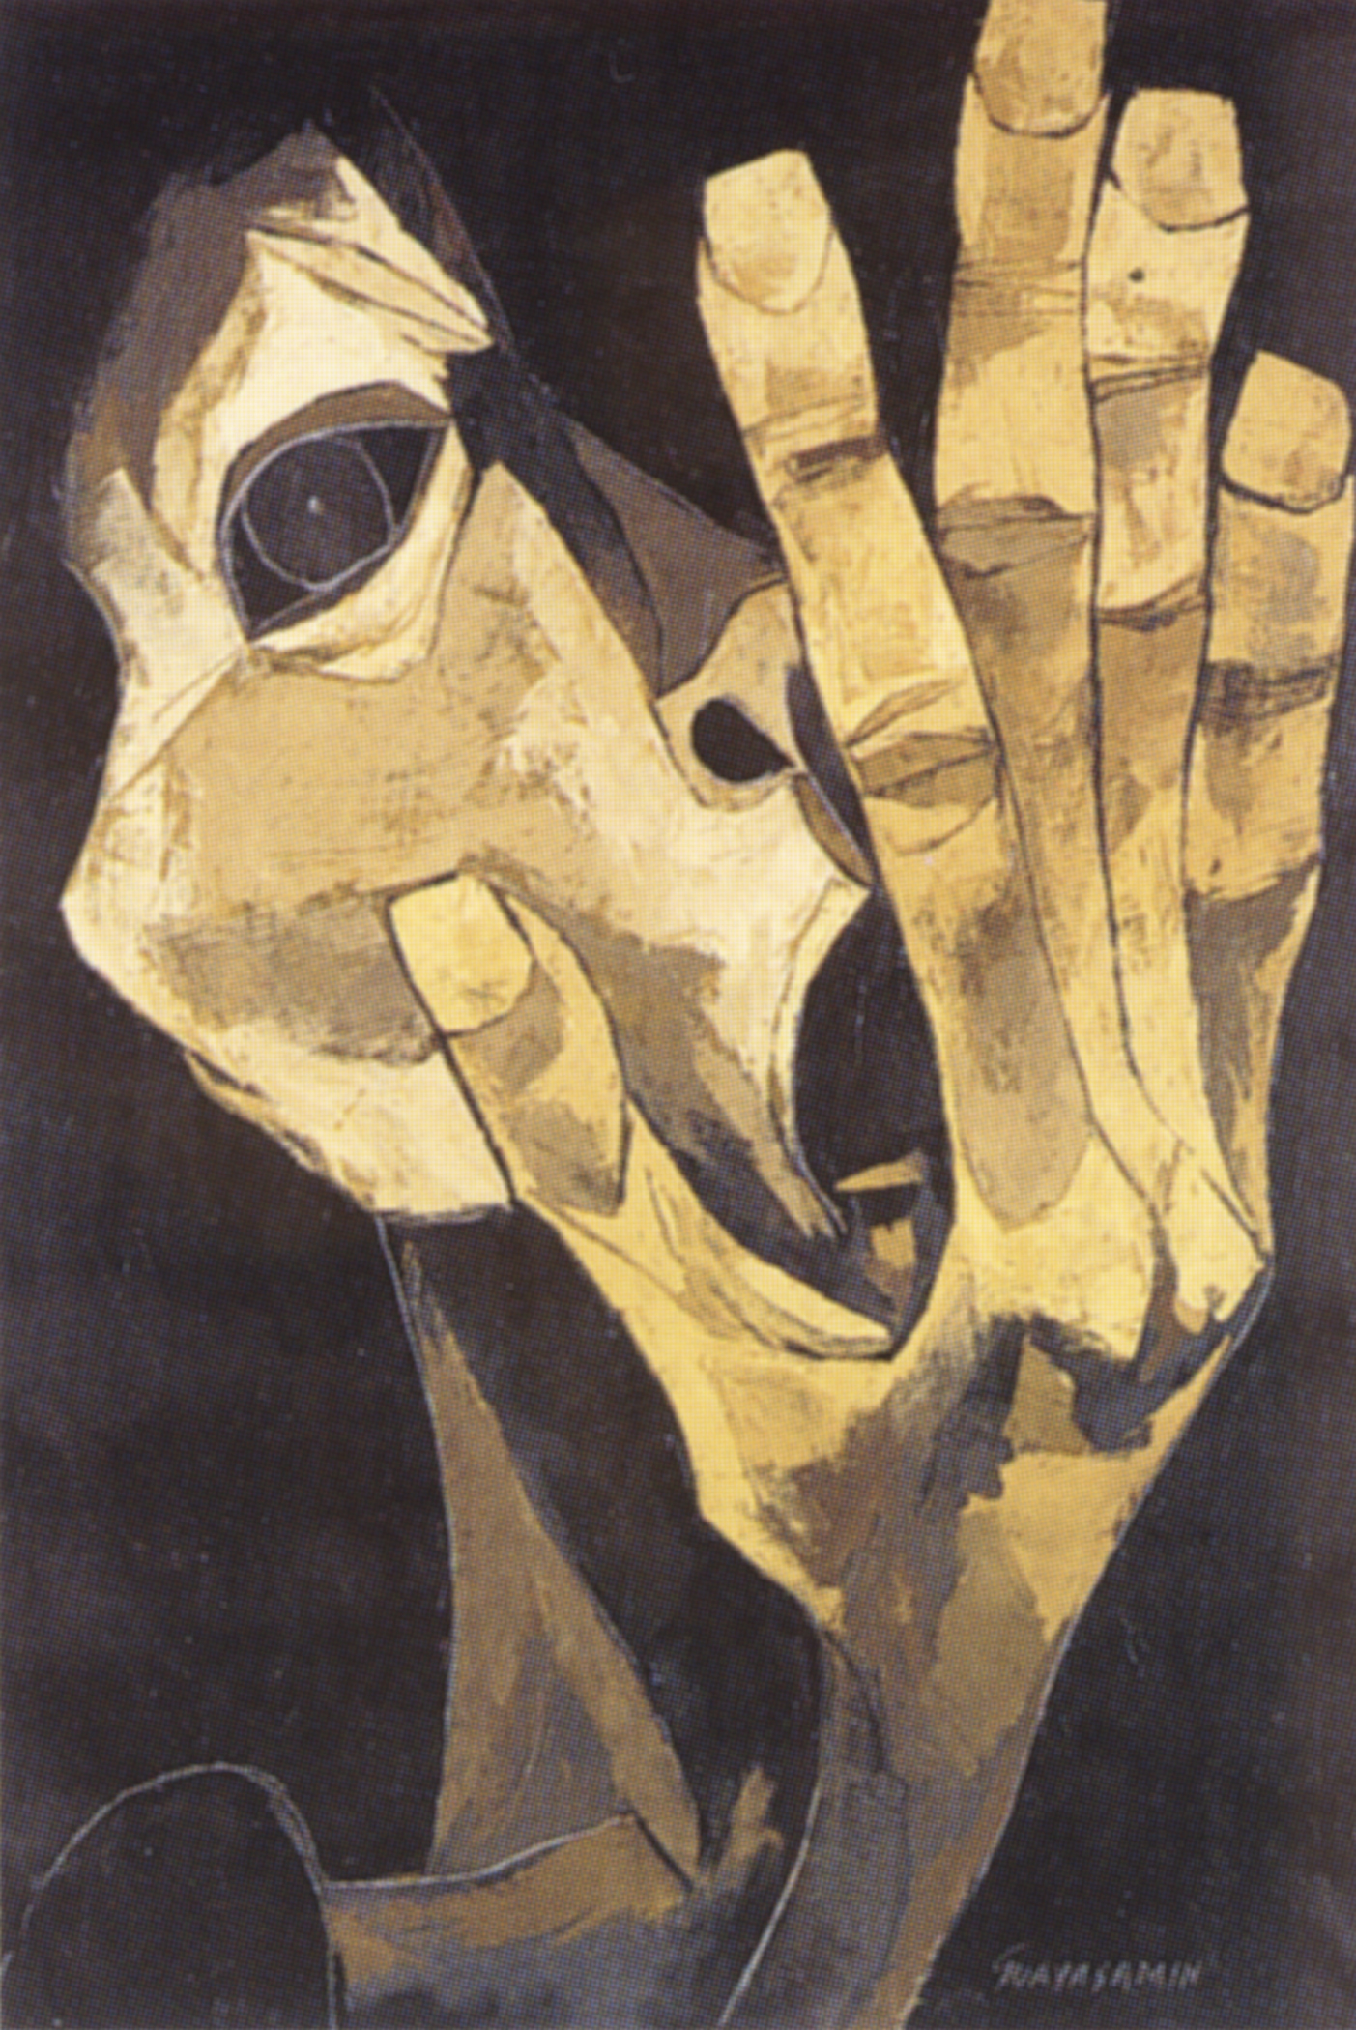
Oswaldo Guayasamín’s collection of works presents many themes that can serve as an inspiration for the young creative artist whether that be through language arts or visual and musical arts. The following activities will assist in preparing the students to view the exhibition and appreciate the art of Oswaldo Guayasamín.

Language Arts: narrative writing, vocabulary, oral presentations
Visual Arts: photography, drawing, exhibition analysis
Musical Arts: emotions in music (aesthetics)
Vocabulary: narrative, exhibition, expressionism, emotion

Hands are one of the most expressive parts of the human body (in fact, second only to the face). Guayasamín studied hands extensively, and created 12 expressionist paintings of hands expressing terror, hope, begging and tenderness in his Manos de la Protesta (Hands of Protest) series. Hands are also prominently displayed in many of his other paintings such as El Grito I (The Cry I).
El Grito I (The Cry I), 1983
Oil on canvas, part of triptych
51-1/4” x 35-7/16”

Materials needed:
Camera (digital or Polaroid works best) Drawing tools
3x5 unlined note cards CD player

Pre-visit activity, Elementary:
- Introduce the 12 paintings of hands by Guayasamín. Discuss elements of art.
- Introduce the idea of expressionism in art and music, two of the various ways of expressing our emotions.
- Distribute 3x5 cards with different emotive states to each student. Then ask the students to draw or somehow visually express the emotion on their card. The various emotions may be taken directly from Guayasamín’s themes (see The Themes of Oswaldo Guayasamín informational lesson), or you may ask students to contribute their own ideas.
- Have students present their drawings to the class and ask the class to guess the portrayed emotion.
- (optional) Select three pieces of music for the children to listen to and ask them to define the emotion they feel is represented in the pieces. Discuss emotions in music.

Post-visit activity, Elementary:
Have students describe in writing their favorite part of the museum visit.

Pre-visit activity, Secondary:
Have each student write a short story about different ways to express emotions. They can experiment with first and third person narratives as well as past and present tenses. While the students are writing, play various pieces of music that express differing emotions. Once they are done, ask the students if the music affected their writing and how.

Post-visit activity, Secondary:
- Select various works of art from the Guayasamín website for students to view.
- Co-operative work: Create small groups of three or four students to create their own hand images. Pass out cards representing various emotions.
- The students will take pictures of their own and each other’s hands expressing the theme on the card. Students will also select a piece of music that reflects the emotions in their hands.
- Have students present their pictures to the group while playing the music in the background. Their audience may first try to guess the expression of the hands and explain their interpretation. The group will then reveal their card and the creative process behind their composition.

Applicable Sunshine State Standards:

LA.5.2.1.1 - demonstrate knowledge of the characteristics of various genres

LA.5.4.1.2 - write a variety of expressive forms that employ figurative language, rhythm, dialogue, characterization, plot, and/or appropriate format.

LA.5.4.2.1 - write in a variety of informational/expository forms.

LA.6.2.1.1 - identify the characteristics of various genres as forms with distinct characteristics and purposes.

LA.6.4.1.2 - write a variety of expressive forms that employ figurative language, rhythm, dialogue, characterization, and/or appropriate format.

LA.6.4.2.1 - write in a variety of informational/expository forms.

LA.7.2.1.1 - identify and analyze the characteristics of various genres as forms with distinct characteristics and purposes.

LA.7.4.1.2 - write a variety of expressive forms that according to the type of writing employed, incorporate figurative language, rhythm, dialogue, characterization, plot, and appropriate format.

LA.7.4.2.1 - write in a variety of technical/informational forms.

LA.8.4.1.2 - write a variety of expressive forms that according to the type of writing employed, incorporate figurative language, rhythm, dialogue, characterization, plot, and appropriate format

LA.8.4.2.1 - write in a variety of informational/expository forms.

LA.8.5.2.2 - use effective listening and speaking strategies for informal and formal discussions, connecting to and building on the ideas of a previous speaker and respecting the viewpoints of others when identifying bias or faulty logic.

LA.910.4.1.1 - write in a variety of expressive and reflective forms that use a range of appropriate strategies and specific narrative techniques, employ literary devices, and sensory description.

LA.910.4.3.1 - write essays that state a position or claim, present detailed evidence, examples, and reasoning to support effective arguments and emotional appeals, and acknowledge and refute opposing arguments.

LA.1112.4.1.1 - write in a variety of expressive and reflective forms that uses a range of appropriate strategies and specific narrative techniques, employs literary devices, and sensory description.

LA.1112.4.3.1 - write essays that state a position or claim, present detailed evidence, examples, and reasoning to support effective arguments and emotional appeals, and acknowledge and refute opposing arguments.

VA.A.1.1 - The student understands and applies media, techniques, and processes.

VA.B.1.1 - The student creates and communicates a range of subject matter, symbols, and ideas using knowledge of structures and functions of visual arts.

VA.C.1.1 - The student understands the visual arts in relation to history and culture.

VA.D.1.1 - The student assesses, evaluates, and responds to the characteristics of works of art.

VA.E.1.1 - The student makes connections between the visual arts, other disciplines, and the real world.

VA.A.1.2 - The student understands and applies media, techniques, and processes.

VA.B.1.2 - The student creates and communicates a range of subject matter, symbols, and ideas using knowledge of structures and functions of visual arts.

VA.C.1.2 - The student understands the visual arts in relation to history and culture.

VA.D.1.2 - The student assesses, evaluates, and responds to the characteristics of works of art.

VA.E.1.2 - The student makes connections between the visual arts, other disciplines, and the real world.

VA.A.1.3 - The student understands and applies media, techniques, and processes.

VA.B.1.3 - The student creates and communicates a range of subject matter, symbols, and ideas using knowledge of structures and functions of visual arts.

VA.C.1.3 - The student understands the visual arts in relation to history and culture.

VA.D.1.3 - The student assesses, evaluates, and responds to the characteristics of works of art.

VA.E.1.3 - The student makes connections between the visual arts, other disciplines, and the real world.

VA.A.1.4 - The student understands and applies media, techniques, and processes.

VA.B.1.4 - The student creates and communicates a range of subject matter, symbols, and ideas using knowledge of structures and functions of visual arts.

VA.C.1.4 - The student understands the visual arts in relation to history and culture.

VA.D.1.4 - The student assesses, evaluates, and responds to the characteristics of works of art.

VA.E.1.4 - The student makes connections between the visual arts, other disciplines, and the real world.

