8 November 2017
9:45 – 10:15 AM: Registration

10:15 – 10:30 AM: Welcome and Opening Remarks: Richard Shusterman (Director of the Center for Body, Mind, and Culture), and Michael Horswell (Dean of Arts and Letters)

10:30 – 12:00 PM: Panel 1: Bodies of Communication
Chaired by: Brian McConnell, Florida Atlantic University
Steven F. Geisz, University of Tampa
“Daoist Body Practice as Philosophy: Cultivating Virtue, Transmitting Content, and Philosophical Communication”

Takao Aoki, Hiroshima University, Japan
“Cool Virtue: The Aesthetics of Coldness in Japanese Ritual Practices of Self-Cultivation”

Bradley Douglas Park, St. Mary’s College of Maryland
“‘Mineness’ is Not Enough: ‘Here-ness,’ ‘Now-ness’ and the Calibration of Subjectivity”

12:00 – 2:00 PM Lunch

2:00 – 3:30 PM: Panel 2: Modern Bodies
Chaired by: Kenneth Holloway, Florida Atlantic University
Zhu Guohua, East China Normal University, Shanghai
“The Modern Transformation of Body Writing: A Case Study of Sinking”

Wang Feng, East China Normal University, Shanghai
“Body Perception in Virtual Reality”

Tao Guoshan, East China Normal University, Shanghai
“Body as Cultural Capital: On Aesthetic Phenomena of Contemporary Chinese People’s Everyday Life in the Consuming Society”

3:30 – 4:00 PM Coffee Break

4:00 – 5:30 PM: Panel 3: Training and Ritual
Chaired by: Noemi Marin, Florida Atlantic University
Gao Yanping, Chinese Academy of Social Sciences, Beijing
“The Invisible Body Behind Chinese Calligraphy: Performance and the Ethics of Self-Cultivation”

Jiyun Bae, Hiroshima University, Japan
“Somaesthetics in the Early History of Korea: Educational Scope of Hwarang”

Emily James, University of Edinburgh
“Taming the Tension: How Models of Embodied Skill Explain the Practice of Yoga”

5:45 -6:45 PM: RECEPTION: SCHMIDT GALLERY

9 November 2017

10:30 – 12:00 PM: Panel 4: Bodies in Contexts
Chaired by Christopher J. Voparil, Union Institute & University
Wu Yuyu, East China Normal University, Shanghai
“The Salvation of the Body: Zhang Ailing’s Body Poetics”

Wang Shuguang, University of North Carolina
“‘Analyzing the Expression of Body Consciousness in the Literary Works of Han, Wei, and Jin Dynasties”

Wang Jiajun, East China Normal University, Shanghai
“From Susceptibility to Responsibility: Somaesthetics and the Body of the Other”

12:00 – 2:00 PM: Lunch

1:30 – 3:00 PM: Panel 5: Religious Bodies
Chaired by Marcella Munson, Florida Atlantic University
James Garrison, Scripps College, California
“Chinese and Western Insights into the Rituals of Subject Life”

Robert W. Jones, II, Palm Beach State College
“‘The Body is the Servant of Vice and Virtue’: A Somaesthetic View of Tibetan Culture”

3:00-3:30: Closing Discussion

Conference will be held at
CULTURE AND SOCIETY BUILDING, Room 301

The Center for Body, Mind, and Culture is an interdisciplinary initiative dedicated to promoting research, programming, and teaching of topics concerning the body-mind-culture nexus. The Center’s motivating logic affirms that the three terms constituting its name are essentially interdependent rather than separate entities and that they therefore need to be studied in terms of their interrelations and through interdisciplinary research.
Contact Us
Email: bodymindculture@fau.edu
Web: www.fau.edu/bodymindculture

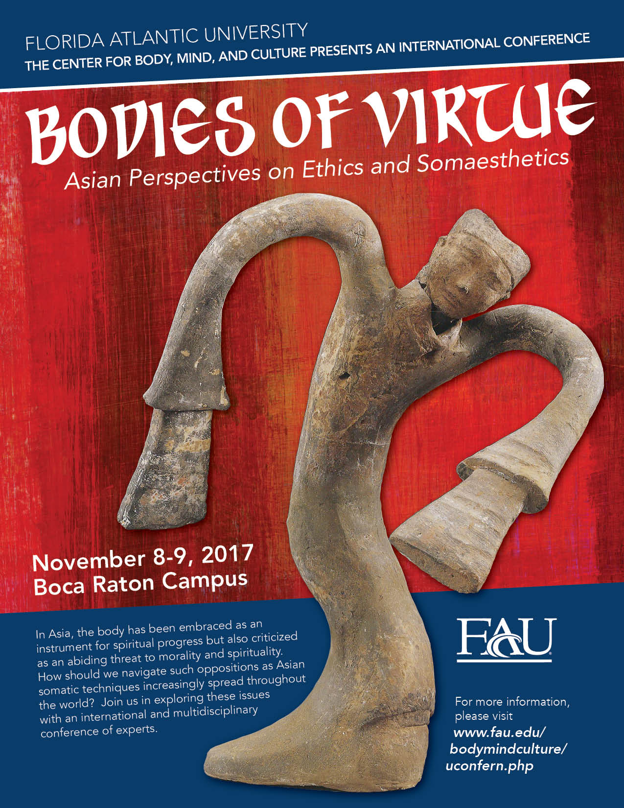

THE CENTER FOR BODY, MIND, AND CULTURE
FLORIDA ATLANTIC UNIVERSITY

