1. Writing Plan Cover Page
☒First Edition of Writing Plan:
☐Subsequent Edition of Writing Plan: (Please Explain)
Please fill in the gray areas on these forms.

Ocean and Mechanical Engineering Programs
WEC Unit Name
Ocean and Mechanical Engineering Department | College of Engineering and Computer Science
Department | College
Javad Hashemi | Professor and Chair, Ocean and Mechanical Engineering
WEC Faculty Liaison (Print Name) | Title
jhashemi@fau.edu | 561 297 3438
Email | Phone

Writing Plan Ratified by Faculty
Date: &/1/2016 | If Vote: | In progress

Process by which Writing Plan was ratified within unit (vote, consensus, other- please explain):

The general plan was discussed verbally in a faculty meeting in the spring of 2016. The written proposal was approved by the WAC committee.

The written proposal has also been sent to the departmental faculty (26 faculty members) through email. A request has been made for a vote. Thus far, 8 faculty members have approved and no rejections. We are waiting for additional votes (voting slow due to summer).

2. Unit Profile: _______________________
Number of Tenured and Tenure-Track Faculty:
18 | Professors
4 | Associate Professors
5 | Assistant Professors
27 | Total

Major(s) Total # students enrolled in Total # students graduating
Please list each major your Unit offers: major of ____547_________ with major AY _____78______

Mechanical Engineering |  | 376 |  | 44
Ocean Engineering |  | 171 |  | 34

WEC Process | Date | Participated / | # invited
Departmental Meeting with WEC | Friday Oct. 23rd | 16/27
Departmental Meeting with WEC | Friday Nov. 13th | 17/27
WEC Team meeting | Thursday Feb. 4th | 6/6
Departmental Meeting with WEC | Friday Feb. 12th | 16/27
Departmental Meeting | April 29 | 15 / 27
Multiple other WEC meetings with departmental reps | Fall and Spring Semesters

WEC liaison, Javad Hashemi, met with the WEC Committee (Joe Su, Edgar An, and Pierre Beaujean) to discuss the implementation plan and the proposal. Also, the initial aspects of the writing across the curriculum plan were discussed in multiple departmental faculty meetings.

3. Signature Page
Electronic signatures may be submitted in lieu of this page. If this page is submitted as a hard copy, please include a print out of the electronic signature chain here.

WEC Faculty Liaison

Javad Hashemi Professor and Chair
WEC Faculty Liaison (print name) Title

6-19-16
Signature Date

Department Head/Chair

Javad Hashemi Professor and Chair
Print Name Title

6-19-16
Signature Date

College Dean

Mohammad Ilyas Professor and Dean
Print Name Title

6-19-16
Signature Date

4. WRITING PLAN NARRATIVE

Executive Summary:

The department of Ocean and Mechanical Engineering became involved with WEC project due to the following reasons:
1-Written communication is of tremendous importance to our field. Engineers must report, catalog, and communicate their findings to their supervisors, supervisees, public at large, and state and government officials. The engineers’ ability to communicate complex concepts in a simple, precise, and easy to understand manner is a crucial ability that must be developed and nurtured during the undergraduate and graduate education at the university. We must produce engineers who are competent in written communication of their ideas, findings, and reports. 2- The Accreditation Board of Engineering and Technology (ABET) considers written communication as a pillar in any engineering education program. ABET promotes the writing across the curriculum concept and requires that all engineering programs continuously evaluate, assess, and improve the writing abilities of their students. We believed that our exercise with WEC will assist us in assessing and evaluating the effectiveness of our strategies in writing communication across our curriculum. 3- Our department is in a process of redesigning its Ocean and Mechanical Engineering curricula. We plan to submit our new curricula for the college and university evaluation in the Fall of 2016. This overhaul of the curricula required a thorough study of the written communication in our curricula and the WEC exercise was selected as an excellent vehicle to achieve this.

In our collaborative efforts with the WEC Team, we first focused on a detailed study of the perceived importance of a writing-enriched curriculum and our current strategies among our faculty, students, and alumni. The WEC team met with the faculty and discussed the contents of a survey to be sent to the constituencies of the program. The edited and approved survey was shared with faculty students, and alumni and results were collected by the WEC team leadership. The WEC team also evaluated samples of our student writings in various levels and courses. The results were analyzed and reported to the full faculty in a subsequent meeting. This exercise helped the department understand the shortcomings of the current approach in addressing writing across our curricula. The WEC team met with the departmental faculty in a series of meetings to identify the desired writing abilities and desired writing characteristics for Ocean and Mechanical Engineering students. We followed this exercise by identifying the type of writing exercises that would teach and enhance the desired writing abilities. We then discussed where in our curricula (what courses) we should emphasize and nurture various categories of the writing abilities that we had developed. We engaged in a mapping process that would assign introduction, enhancement, and practice of various desired writing abilities to specific courses from the freshmen to senior year of our students’ education. We also developed a rubric for assessment of the achievement of our expected goals. Based on the above study/analyses of our writing across the curriculum efforts in the OME department, The WEC Team and the faculty of the Ocean and Mechanical Engineering department will begin to develop the needed writing enhancement educational materials and implementing the established methodologies and strategies in the Fall of 2016 through Spring of 2018. The following methodologies and strategies were developed to enhance the writing experience and therefore writing abilities of our students in the OME program.

The proposed methodologies include: 1- Development of web-based documentation for the basic requirements in writing laboratory reports, detailed design reports, and technical report. 2- Highlighting the nature and type of written information required in each section of the laboratory, design, and technical reports. Available on the course website. 3- Providing examples of proper and improper writing strategies for engineering reports. These strategies relate to i) effectiveness of communication through precise, succinct, and simple writing styles, ii) following appropriate format and reporting requirements, iii) technical description of components and equipment, iv) balanced and accurate reporting of data, v) unbiased evaluation, analysis, and assessment of data and conclusions. 5- Development of documentation for developing resumes, work memos, email communications, and other appropriate writing communication tools. The proposed strategies include 1- Introduction of individualized and team-based writing assignments in key courses in all years (Freshman to Senior). 2- Focus on evaluation of the writing assignments and providing appropriate feedback to the students. 3- Offering workshops and seminars on importance of written communication in engineering.

Section 1: Discipline-specific Writing Characteristics*

What characterizes academic and professional communication in this discipline?

The Department of Ocean and Mechanical Engineering provides students a broad and hands-on engineering education through coursework in arts and sciences, humanities, and engineering. Our programs appeal to those students who are interested in STEM education and have strong background in Mathematics and Physics. In STEM fields, when admitting students to our programs (or even after they have been admitted) we focus heavily on students abilities and characteristics in mathematics, physics, and technology, and we don’t place as large an emphasis on students ability to communicate in written. However, written communication is a crucial part of an engineer’s daily job. Written communication abilities come into play when engineers write technical reports, proposals, progress reports, final reports, memos, and job-related emails. Unlike other non-STEM fields, the written communication abilities and characteristics of an engineering student deal more with technical writing and use of proper format. In a recent survey of faculty, students, and alumni done by the WEC Team, we were able to identify key characteristics and abilities that need be nurtured in our engineering graduates. First, the importance of writing abilities was determined to be extremely to very important for engineers, Figure 1. Second. It was determined that engineers engage in a variety of writing activities including report writing, cataloging, and communicate their findings to their supervisors, supervisees, public at large, and state and government officials, Figure 2. The survey also helped us identify some of the writing abilities that are crucial for engineers, Figure 3. The engineers’ ability to communicate complex concepts in a simple, clear and concise terms was noted as highly important.

Figure 1. Survey results assessing the importance of writing communication in engineering fields. The survey was completed by students, faculty, and alumni.

Figure 2. Survey results highlighting the type of writing engineers engage in.

As part of our survey, we were also able to identify the writing characteristics that our students, faculty, and alumni deemed important to the engineering profession. The results of the survey were remarkably consistent among various constituencies, Figure 4. The main deviation was that affiliates felt that explanatory characteristics are far more important than that identified by the faculty and students.

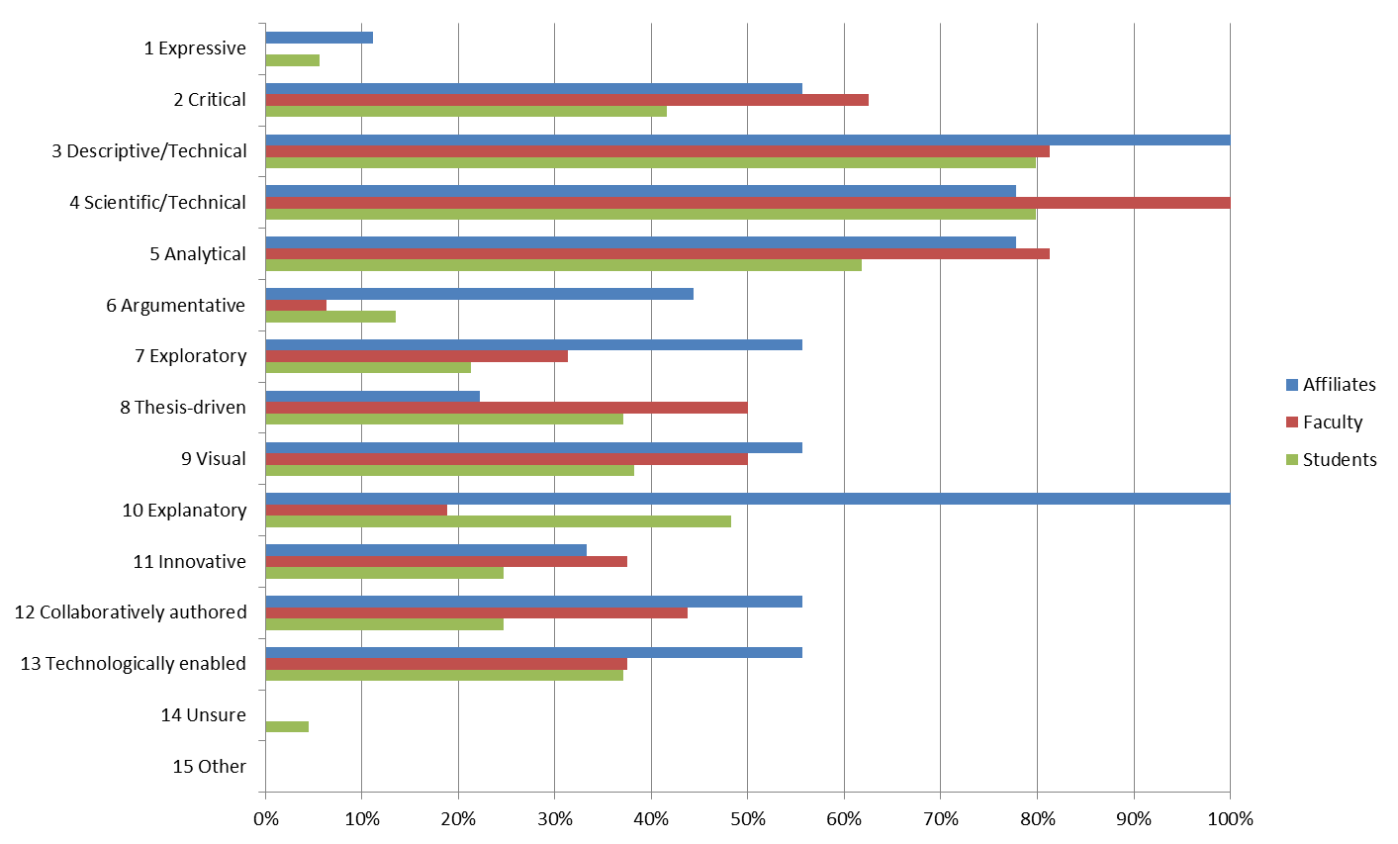
Figure 4. Important engineering writing characteristics identified by the survey results.

Based on the results of the survey and our discussion with the faculty, we have identified key writing characteristics desired in engineers. The following characteristics cover the writing skills that are expected in engineering curricula to accomplish writing and communication competencies:

- Proper use of language: follow proper grammar, punctuation, and spelling.

- Informed and Exploratory: writing based on learned knowledge and gained information and in directed toward exploration of scientific and engineering concepts.

- Clear and Concise: Clear and concise communication of information, no unnecessary words or information; simple writing from a structure point of view (uses short sentences).

- Organized: follows a pre-approved order of presentation of materials.

- Technically and Scientifically Descriptive: shows ability to describe complex topics or components in a descriptive fashion.

- Analytical: presents work based on appropriate knowledge and examples from various sources to support a conclusion.

- Critical (Thesis Driven): Discusses work and conclusions with conviction and authority to form independent judgments.

- Ethical: adept in use and citation of sources. Uses appropriate sources and cites them accurately. Presents writings, conclusions and findings accurately, authentically, and with no bias.

Section 2: Desired Writing abilities* **

With which writing abilities should students in this unit’s (department’s) major graduate?

Based on the results of our survey, Figure 3, and the discussions between the WEC Team and the departmental faculty, we developed a list of desired writing abilities for graduating engineers. The desired writing abilities in Ocean and Mechanical Engineering were categorized into clusters as follows:

Cluster 1: Writing Competence in morphology, Orthography and Syntax (Bloom’s Taxonomy Level: Remember, Understand, Apply)
- Uses proper grammar (nouns, pronouns, verbs, adverbs, prepositions, and conjunctions
- Uses proper punctuation
- Uses appropriate and simple words

Cluster 2: Structure and Formatting (Bloom’s Taxonomy Level: Remember, Understand, Apply)

- Structure / outline / presentation of different types of reports and writings
- Follows a specific structure
- The structure and outline depends on the type of report: lab Reports, design proposals and Final Reports (PDR, CDR), progress reports, technical reports, memos, resumes
- Formatting
- Follows appropriate insertion of equations, figures, and tables
- Uses figure titles and captions properly
- Uses citations/references with proper format
- Presents project planning and Gantt charts when needed

Cluster 3: Communication of Results and Ideas (Bloom’s Taxonomy Level: Remember, Understand, Apply, Analyze)

- Content Organization
- Within each section, organizes content in a bulletined form and in proper order
- Defines all terms
- Expands the writing around the bulleted topics
- Writes in simple, clear, and concise terms
- Uses short sentences
- Follows prescribed length requirement
- Use of figures and tables purposefully
- Presents supporting data in an organized and easy to understand format
- Creates Graphs/tables/figures that are self-explanatory
- Presents a second layer of graphs/tables/figures to formulate a complex summary graph of first layer of results. This work includes choosing an appropriate chart style that fits the nature of the data to be presented.

Cluster 4: Integrity of Presentation (Bloom’s Taxonomy Level: Analyze, Evaluate)

- Accuracy of Statements and Conclusions
- Presents collected data and calculations in a precise and unbiased/unexaggerated manner
- Supports Conclusions by obtained results and based on facts
- Presents error and uncertainty associated with the results
- Provides statistics when necessary using standard error, mean and standard deviation

Cluster 5: Analysis, Interpretation, and Evaluation (Bloom’s Taxonomy Level: Analyze, Evaluate, Create)

I. Explain Observations
- Explains clearly what was measured
- Highlights key observations and measurements
- Explains clearly what units were used
- Explains what associated uncertainty and error is reported

II. Interpret Observations
- Highlights key results
- Explains what the results tell us
- Assesses if the results make sense? If so, reports them; if not, finds out why and reports them.
- Explains if the result answer the question that was posed.

Section 3: Integration of Writing into Undergrad. Curriculum

How is writing instruction currently positioned in this unit’s undergraduate curriculum (or curricula)? What, if any, structural plans does this unit have for changing the way that writing and writing instruction are sequenced across its course offerings? With what rationales are changes proposed and what indicators signify their impact?

Currently, there are no organized writing instruction positioned in the unit’s undergraduate curriculum. With the exception of the general writing courses offered by the English department, there are no guidelines regarding the desired characteristics and abilities of students in engineering. All writing-related education in the Ocean and Mechanical Engineering Department is mostly ad-hoc and instructor dependent. The writing instruction is balanced across different years of the curriculum.

Based on our work with the WEC Team, we have developed a structural plan for changing the way writing instructions are sequenced and presented across our curricula. The tables presented below, Tables I and II, show the courses, the respective years, and the degree to which the clustered abilities will be applied in Mechanical and Ocean Engineering programs, respectively. In each course, we highlight the clusters that are addressed and the level by which it is addressed: E, SB, I. “E” should be read as exposure “SB” as skill building, and “I” as intensive.

Table 1. Writing intensive courses, the respective years in which they are offered, and the degree to which the clustered abilities will be applied in Mechanical Engineering.
Cluster/Course | Freshman
 | ENC 1101, ENC 1102 | Chem. Lab and Phys. I Lab | *Fund. Of Eng.
Writing Competency | I | E | E
Structure and Formatting | SB | SB | E
Communication of Results and Ideas | SB | SB | E
Integrity of Presentation | SB | SB | E
Analysis, Interpretation, and Evaluation | E | SB | E
- Fundamentals of Engineering
Cluster/Course | Sophomore
 | Phys II Lab | Statics
Writing Competency | E | E
Structure and Formatting | SB | E
Communication of Results and Ideas | SB | SB
Integrity of Presentation | SB | SB
Analysis, Interpretation, and Evaluation | E | I
Cluster/Course | Junior
 | Electromechanical Dev. | Exp. Meth. | ME Lab
Writing Competency | SB | I | I
Structure and Formatting | SB | I | I
Communication of Results and Ideas | SB | I | I
Integrity of Presentation | SB | I | I
Analysis, Interpretation, and Evaluation | I | I | I
Cluster/Course | Senior
 | Eng. Des. I | Eng. Des. II
Writing Competency | I | I
Structure and Formatting | I | I
Communication of Results and Ideas | I | I
Integrity of Presentation | I | I
Analysis, Interpretation, and Evaluation | I | I

Table 2. Writing intensive courses, the respective years in which they are offered, and the degree to which the clustered abilities will be applied in Ocean Engineering.

Cluster/Course | Freshman
 | ENC 1101, ENC 1102 | Chem. Lab and Phys. I Lab | Fund. Of Eng.
Writing Competency | I | E | E
Structure and Formatting | SB | SB | E
Communication of Results and Ideas | SB | SB | E
Integrity of Presentation | SB | SB | E
Analysis, Interpretation, and Evaluation | E | SB | E
Cluster/Course | Sophomore
 | Phys II Lab | Statics | OE Lab
Writing Competency | E | E | I
Structure and Formatting | SB | E | I
Communication of Results and Ideas | SB | SB | I
Integrity of Presentation | SB | SB | I
Analysis, Interpretation, and Evaluation | E | I | I
Cluster/Course | Junior
 | Intro to Elec. And Prog.
Writing Competency | SB
Structure and Formatting | SB
Communication of Results and Ideas | SB
Integrity of Presentation | SB
Analysis, Interpretation, and Evaluation | I
Cluster/Course | Senior
 | Eng. Des. I | Eng. Des. II
Writing Competency | I | I
Structure and Formatting | I | I
Communication of Results and Ideas | I | I
Integrity of Presentation | I | I
Analysis, Interpretation, and Evaluation | I | I

The above structures and plans for implementation, once fully approved by the respective programs, assure us that the students will be exposed to all clusters of abilities and will do so to various levels starting from the freshman year and ending with senior year. This will allow us to impart a smooth and well organized progression in improving the writing communication skills of our students.

Section 4: Assessment of Student Writing

How does this unit currently communicate writing expectations (see section 1 &2) to undergraduate students? How satisfied is the unit faculty that students are adequately familiar with these expectations? How satisfied is the unit faculty that student writers are successfully meeting the identified expectations by the time they graduate? Why? If less than satisfied, what plans does the unit propose for closing the gap?

Currently, there are numerous writing communication experiences in both programs. However, the writing abilities expectations are currently communicated through the instructor in charge and in an ad-hoc manner, no formal rubric is applied. There is no consistency in expectations and the assessment method which currently depends entirely on the instructor needs improvement. We need a more uniform approach to writing across the curriculum activities.

The unit faculty are not at all certain or satisfied that students are adequately familiar with writing abilities expectations. As mentioned before, the assessment methods needs to become more organized and consistent among instructors. For instance, the faculty have rated the perceived strength of students in various writing related activities, characteristics, and abilities, Figure 5. The results are surprising as a large percentage are reporting N/A in activities that should be highly relevant to our graduating engineers. Also, the “satisfactory” responses need significant improvement. Based on the disparity of the data presented in Figure 5, we must do a better job in identifying and strengthening key characteristic and abilities in our students.
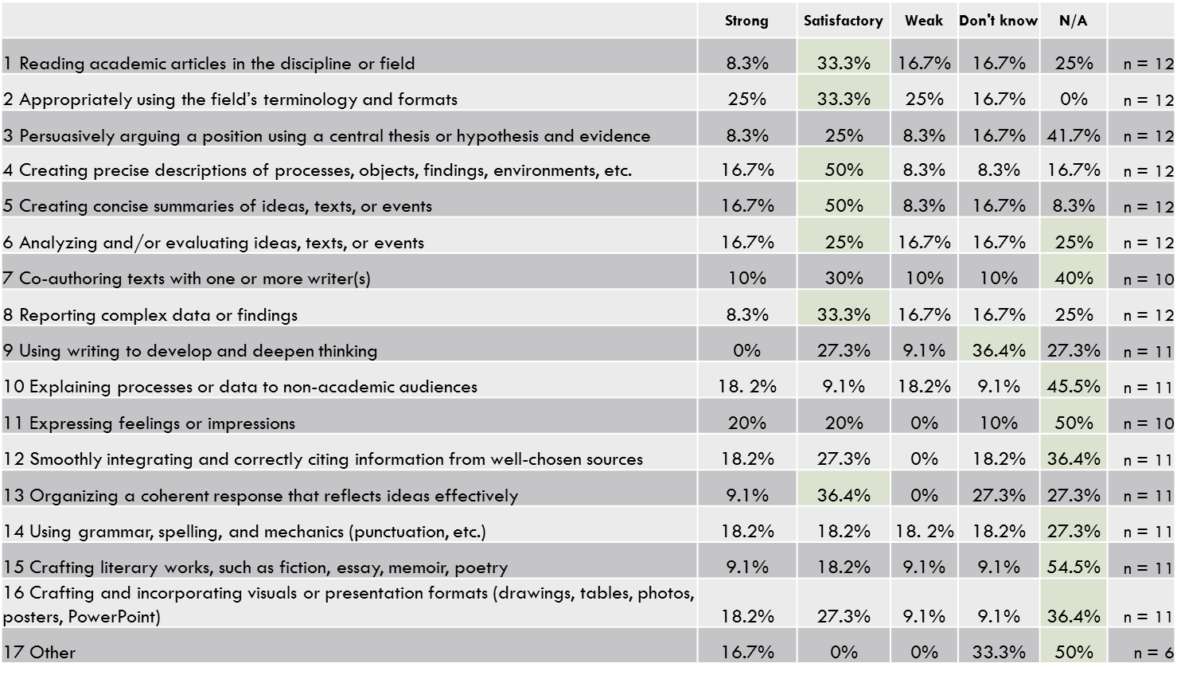
Figure 5. Faculty rating of the perceived strength of writing in our students as related to various characteristics and abilities.

Overall, At this point, it is difficult to assess whether the graduated students meet the identified expectations by the time they graduate. Currently we are certain that we expose the students to various writing experiences ranging from one-page commentaries to extensive laboratory, design, and technical reports. But there is no organized approach or an assessment tool in place to examine the major writing abilities gained by the students. For instance, we have highlighted the abilities that our affiliates find important for their company hires in engineering, Figure 6; however, we cannot say for certain that our graduates are proficient in these abilities and to what level.

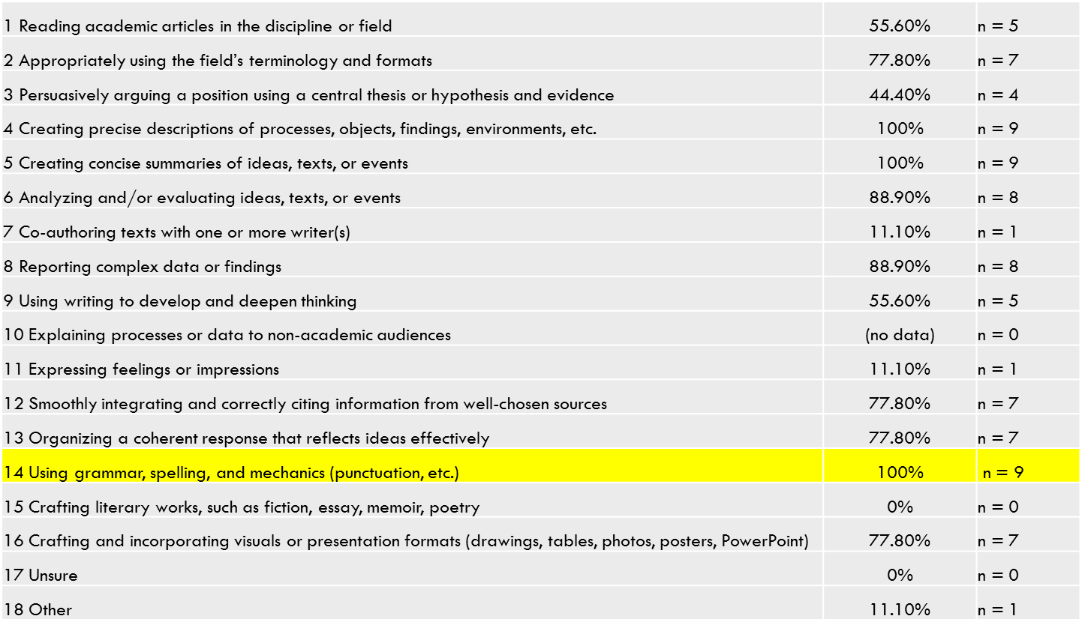
Figure 6. Abilities expected in engineering graduates hired by our affiliates.

Overall, we can highlight the strengths and deficiencies in our current writing communication requirements in our curriculum as follows:
Strengths:
- Various writing experiences currently exist
- These writing experiences require various levels of expertise and student engagement ranging from simple essays, to laboratory reports, major design reports, and technical reports
- We currently assess if all students are exposed to writing experiences
- We also assess our student’s writing performance by performing alumni, faculty, and student surveys
Weaknesses:
- Currently, students are not explicitly acquainted with the characteristics and abilities that they need to master as related to writing communication
- Currently major writing experiences are not well-distributed across the curriculum. For instance, in the ME program most writing experiences are in the senior year and in the OE program more writing experiences are required
- Currently, neither of the programs has a list of writing characteristics or abilities that they seek in students. All expectations are general, ad-hoc, and instructor dependent
- The existing assessment process does not assess specific abilities but only the exposure
- The expectations vary from instructor to instructor

In order to address the above perceived deficiencies and weaknesses, we propose the following steps:
- Follow through with the structural changes for the curriculum and plans proposed in section 3.
- Prepare writing characteristics and abilities documents for distribution to students in all writing intensive classes
- Develop web-based educational tools that will help students learn about how to start writing a report, how to format reports, how to present engineering measurements, how to write conclusions. This web-based material will be available to all students at the time they take the writing intensive courses.
- Prepare a rubric for assessment for different types of written documents.
- Create workshops for faculty to discuss assessment and how it is done based on the identified characteristics and abilities
- Provide feedback to the students regarding their level of proficiency in various abilities

In addition, the following rubric addressing measures has been developed to evaluate the desired writing abilities, Table 3. An identification of levels in student performance, necessary to score student work, is proposed.

Table 3a. Rubrics for assessment of desired abilities in engineering writing.
Desired Abilities | Levels of Performance
 | High Level | Moderate Level  (minimal level of acceptance) | Low Level  (not acceptable) | Measures
1. Writing Competence in morphology, Orthography and Syntax  Uses proper grammar, punctuation, and sentence structure. | Student uses proper grammar (nouns, pronouns, verbs, adverbs, prepositions, and conjunctions. Student uses proper punctuation. Student uses appropriate and simple vocabulary (for engineers this is a major issue). | Grammar, punctuation, and vocabulary is mostly properly used but the overall writing is not fluent. | Grammar, punctuation and use of vocabulary is poor. Writing is disfluent. | Special grade on writing competence in essays, lab, design, and technical reports.  >90 high  80-89 Moderate  <70 Low
2. Structure, Formatting, and Presentation of Work:  Demonstrates critical awareness of how a laboratory, design, or technical reports is structured, organized, and presented. | Student establishes in-depth awareness of 1) key information to be presented, 2) type of content to be presented in each section 3) order of presentation, 4) appropriate use of figures, tables, and graphs. | Student establishes moderate awareness of 1) key information to be presented, 2) type of content to be presented in each section 3) order of presentation, 4) appropriate use of figures, tables, and graphs but there are deficiencies in presentation. | Student shows gaps in awareness of what information needs to be presented, in what order, and the use of tables and figures are random without a plan. | Grade on a quiz related to the structure and formatting of lab, design, and technical reports:  >90 high  80-89 Moderate  <70 Low
3. Content Organization, Communication of Results and Ideas:  Demonstrates ability to organize appropriate content related to each specific section highlighted in the report. Communicates the information in an organized fashion that is easy to follow. | Student establishes knowledge of content (what goes into abstract? Introduction? etc.) and shows ability to convey that knowledge in a coherent, simple, and precise manner. This should be evidenced through definition of terms, precision in writing, proper use of figures, tables, and charts, and content organization. | Student establishes knowledge of content but there are logical flaws in presentation of materials and the presentation is not precise. | Student shows limited or no understanding of the knowledge of content. Presentation of materials is random and disorganized. | Overall grade on lab, design, and technical reports::  >90 high  80-89 Moderate  <70 Low

4. Integrity of Presentation:  Demonstrates the ability to examine collected data for accuracy and precision, analyzes the data to determine the final result(s), and presents the data without bias. | Student checks collected data and results for accuracy and precision. Presents the data in an unbiased manner through appropriate use of mathematics and statistics. Makes intermediate conclusions based on the facts and results. | Student reports data and results for accuracy, presents the data in an unbiased manner but intermediate conclusions are not based on the results. | Student reports data without checking for accuracy and precision, skews and manipulates the collected data, and makes erroneous conclusions not supported the facts. | Section grade on the results portion of the lab, design, and technical reports.  >90 high  80-89 Moderate  <70 Low
5. Analysis, Interpretation, and Evaluation:  Demonstrate the ability to analyze, interpret, and evaluate the measurements, calculated results, and findings of the report. | Student shows the ability to explain what was measured with associated uncertainty, successfully analyzes and manipulates the collected data to determines the final results,  explains the observations, highlight main results, analyzes and interprets the results, makes final conclusions, and assess if conclusions makes sense. | Student shows the ability to explain what was measured with associated uncertainty, successfully analyzes and manipulates the collected data to determines the final results,  explains the observations, highlight main results. But the student has problems analyzing and interpreting the results to make final conclusions, and assess if conclusions makes sense. | Student shows limited ability to explain what was measured with associated uncertainty, cannot analyze and manipulates the collected data to determine the final results. | Section grade on the conclusion portion of the lab, design, and technical reports.  >90 high  80-89 Moderate  <70 Low

Table 3b. Alternative rubrics for assessment of desired abilities in engineering writing.

 | 1  Beginning or incomplete | 2  Developing | 3  Accomplished | 4  Exemplary | Weights
Abstract/Summary | Several major aspects of the experiment are missing, student displays a lack of understanding about how to write an abstract | Abstract misses one or more major aspects of carrying out the experiment or the results | Abstract references most of the major aspects of the experiment, some minor details are missing | Abstract contains reference to all major aspects of carrying out the experiment and the results, well-written | 0
Introduction | Very little background information provided or information is incorrect | Some introductory information, but still missing some major points | Introduction is nearly complete, missing some minor points | Introduction complete and well-written; provides all necessary background principles for the experiment | 14
Experimental Procedure | Missing several important experimental details or not written in paragraph format | Written in paragraph format, still missing some important experimental details | Written in paragraph format, important experimental details are covered, some minor details missing | Well-written in paragraph format, all experimental details are covered | 11
Results:  data, figures, graphs, tables, etc. | Figures, graphs, tables contain errors or are poorly constructed, have missing titles, captions or numbers, units missing or incorrect, etc. | Most figures, graphs, tables OK, some still missing some important or required features | All figures, graphs, tables are correctly drawn, but some have minor problems or could still be improved | All figures, graphs, tables are correctly drawn, are numbered and contain titles/captions. | 11
Discussion | Very incomplete or incorrect interpretation of trends and comparison of data indicating a lack of understanding of results | Some of the results have been correctly interpreted and discussed; partial but incomplete understanding of results is still evident | Almost all of the results have been correctly interpreted and discussed, only minor improvements are needed | All important trends and data comparisons have been interpreted correctly and discussed, good understanding of results is conveyed | 14
Conclusions | Conclusions missing or missing the important points | Conclusions regarding major points are drawn, but many are misstated, indicating a lack of understanding | All important conclusions have been drawn, could be better stated | All important conclusions have been clearly made, student shows good understanding | 5
Spelling, Grammar, Sentence Structure | Frequent grammar and/or spelling errors, writing style is rough and immature | Occasional grammar/spelling errors, generally readable with some rough spots in writing style | Less than 3 grammar/spelling errors, mature, readable style | All grammar/spelling correct and very well-written | 5
Appearance and Formatting | Sections out of order, too much handwritten copy, sloppy formatting | Sections in order, contains the minimum allowable amount of handwritten copy, formatting is rough but readable | All sections in order, formatting generally good but could still be improved | All sections in order, well-formatted, very readable | 40

Section 5: Summary of Implementation Plans and Requested Support

Based on above discussions, what does the unit plan to implement during the period covered by this plan? What forms of instructional support does this unit request to help implement proposed changes? What are the expected outcomes of named support? What kinds of assessment support does this unit request to help assess the efficacy of this Writing Plan? What are the expected outcomes of this support?

We have accomplished the following tasks, thus far:

- Desired engineering characteristics and abilities have been identified (WEC Team and Departmental Faculty)
- A new curriculum structure has been proposed and discussed in the ME program with writing intensive courses identified at various levels ranging from Freshman to Senior. The faculty will evaluate and vote on this new curriculum in the Fall. The OE program is also considering changes to the writing intensive course structures.
- The clusters of abilities have been mapped to the writing intensive courses

Future steps to be completed through funding of this proposal:
- Complete the implementation of writing intensive courses into the curriculum by securing final approval at the department level. (Fall of 2016)
- Prepare educational materials regarding engineering writing, structure and formatting of reports, desired characteristics, and desired abilities for students in each writing intensive course. (Fall of 2016)
- Prepare web presentation of the developed materials. (Fall of 2016)
- Develop new evaluation and assessment procedures for writing-intensive projects, lab reports, design reports, technical reports, and essays. This includes grading each assignment based on the cluster of abilities defined in the rubric. (Fall of 2016)
- Present the materials developed and the assessment procedure to the faculty. Gather input and modify accordingly. Secure faculty approval for this stage. (spring 2017)
- Apply the modified materials to the writing intensive classes, gather data. Keep all student writing projects. (spring 2017)
- Give lectures to students in writing intensive classes related to desired characteristics and abilities in engineering writing. (spring 2017)
- Continue applying the new tools to classes in Fall of 2017, gather data. Keep all student writing projects. (Fall 2017)
- Analyze the data. Follow the students’ progress from one writing intensive course to another. (Fall 2017)
- Compare writing samples under this program (treatment group) with previous years’ writing samples (control group). (Fall 2017) We will collect and save all writing samples and student records for future comparison from Spring 2017 for comparison with Fall 2017 performance of the same students. See Step 8.
- Present the data to the WEC Team and departmental faculty. (Fall 2017)
- Based on the results, modify the process and repeat. (Fall 2017)
Tentative two-year implementation plan:

Semester | Activities:  Instructional and Assessment Support | Personnel & Material | Requested Support*
Fall 2016 | 1. Implementation of the structural changes to the curriculum.  2. Development of new assessment procedure.  3. Preparation of on-line materials for structure and format of lab, design, and technical reports.  4. Revision of rubrics: Ongoing revision of measures to evaluate desired writing abilities. | -Departmental Subcommittee  -WEC Team  -WEC Research Fellowship for a graduate student (or WEC Research Assistant) | - Support for WEC research fellow at $4500 per semester for Fall  -Software for development of online materials $500
Spring 2017 | 1.Writing and Reading  Workshop for students and faculty  2.Writing and Reading  Assessment Workshop for faculty  3. Apply the new evaluation and assessment process to writing intensive courses at all levels. | -Faculty in charge of courses  -WEC Subcommittee  -Research Fellowship  -Industry experts | - Guest Speakers: $500  - Support for WEC research fellow at $4500 per semester for Spring of 2017
Fall 2017 | 1. Continue apply the new evaluation and assessment process to writing intensive courses at all levels. Follow the students that were exposed to this approach in Spring of 2017. | -Faculty in charge of courses  -Research Fellow to assist with implementation of new evaluation and assessment processes | - Support for two WEC research fellows at $4500 per semester for Fall of 2017
Spring 2018 | 1.Collecting data from faculty and Teaching Assistants on WEC implementation plan and student progression  2.Curriculum mapping & analysis of writing assignments and rubric, synthesis of data and presentation of data | - Faculty in charge of writing intensive courses  -Research Fellow | Support for two WEC research fellows at $4500 per semester for Fall of 2018.
Two-year plan (Fall 2015- Spring 2017) |  | REQUEST SUPPORT/ TOTAL: $20,000**
*Request support cannot include faculty salary support
** the research fellow will assist in development of materials and web based delivery

Section 6: Process used to create this Writing Plan

How, and to what degree, were stakeholders in this unit (faculty members, instructors, affiliates, teaching assistants, undergraduates, others) engaged in providing, revising, and approving the content of this Writing Plan?

The faculty members, students, and affiliates of our department have been involved in the initial writing plan development process through participation in surveys and departmental meetings with the WEC Team. The faculty will be involved in the implementation (those who are in charge of the writing intensive courses) and overall evaluation (departmental meetings of all faculty) of all materials. The faculty understand that this process is of value to our future ABET accreditation processes.

The students will be directly involved as they will be the subject of our implementation, evaluation and assessment tools. The final report of this project will be sent to our affiliates for their input.

Section 7: Student Learning Outcomes

Briefly, please describe the ways that the ideas contained in the Undergraduate Writing Plan address the University’s student learning outcomes.

The WEC implementation plan in Ocean and Mechanical Engineering addresses various University student learning outcomes presented in the FAU 2015-20125 Strategic Plan. Specifically, under the strategic actions and initiatives, three prominent items are i) promote student scholarship, ii) Promote excellence in educational experience, and iii) elevate the levels of student success beyond graduation. One of the foundations of all of these strategic actions is the ability of a student to communicate. As a result, our efforts here will have a tremendous impact on FAUs plans to improve the quality of education of STEM graduates. In addition, improving the ability to write will help students perform better in their undergraduate research activities and reporting of such activities. To a certain extent, improving writing skills will improve learning since writing is a higher order skill by itself.

The department will enhance its educational process in order to improve the writing skills in students. If our efforts improve the writing abilities of our students, we will create graduates that are not only technical proficient but also outstanding from a written communications point of view. In a sense we are producing a more complete graduates. This will improve ours students’ chances of securing better jobs and performing better when they are on the job; in other words it elevates the level students’ success beyond the graduation.

