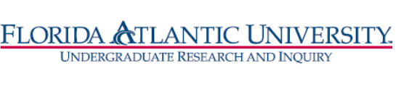
Florida Atlantic University
Undergraduate Research Curriculum Committee
Thursday, February 11, 2021
WebEx meeting from 12:15 to 1:00 pm

- Approve January 14, meeting minutes

- RI Certificate
Members: Dan Meeroff, Nancey France, Tricia Meredith, DCW
Chair: T. Meredith
- Updates
- RI Fast Track – Extension approved by UUPC 2/1/2021

